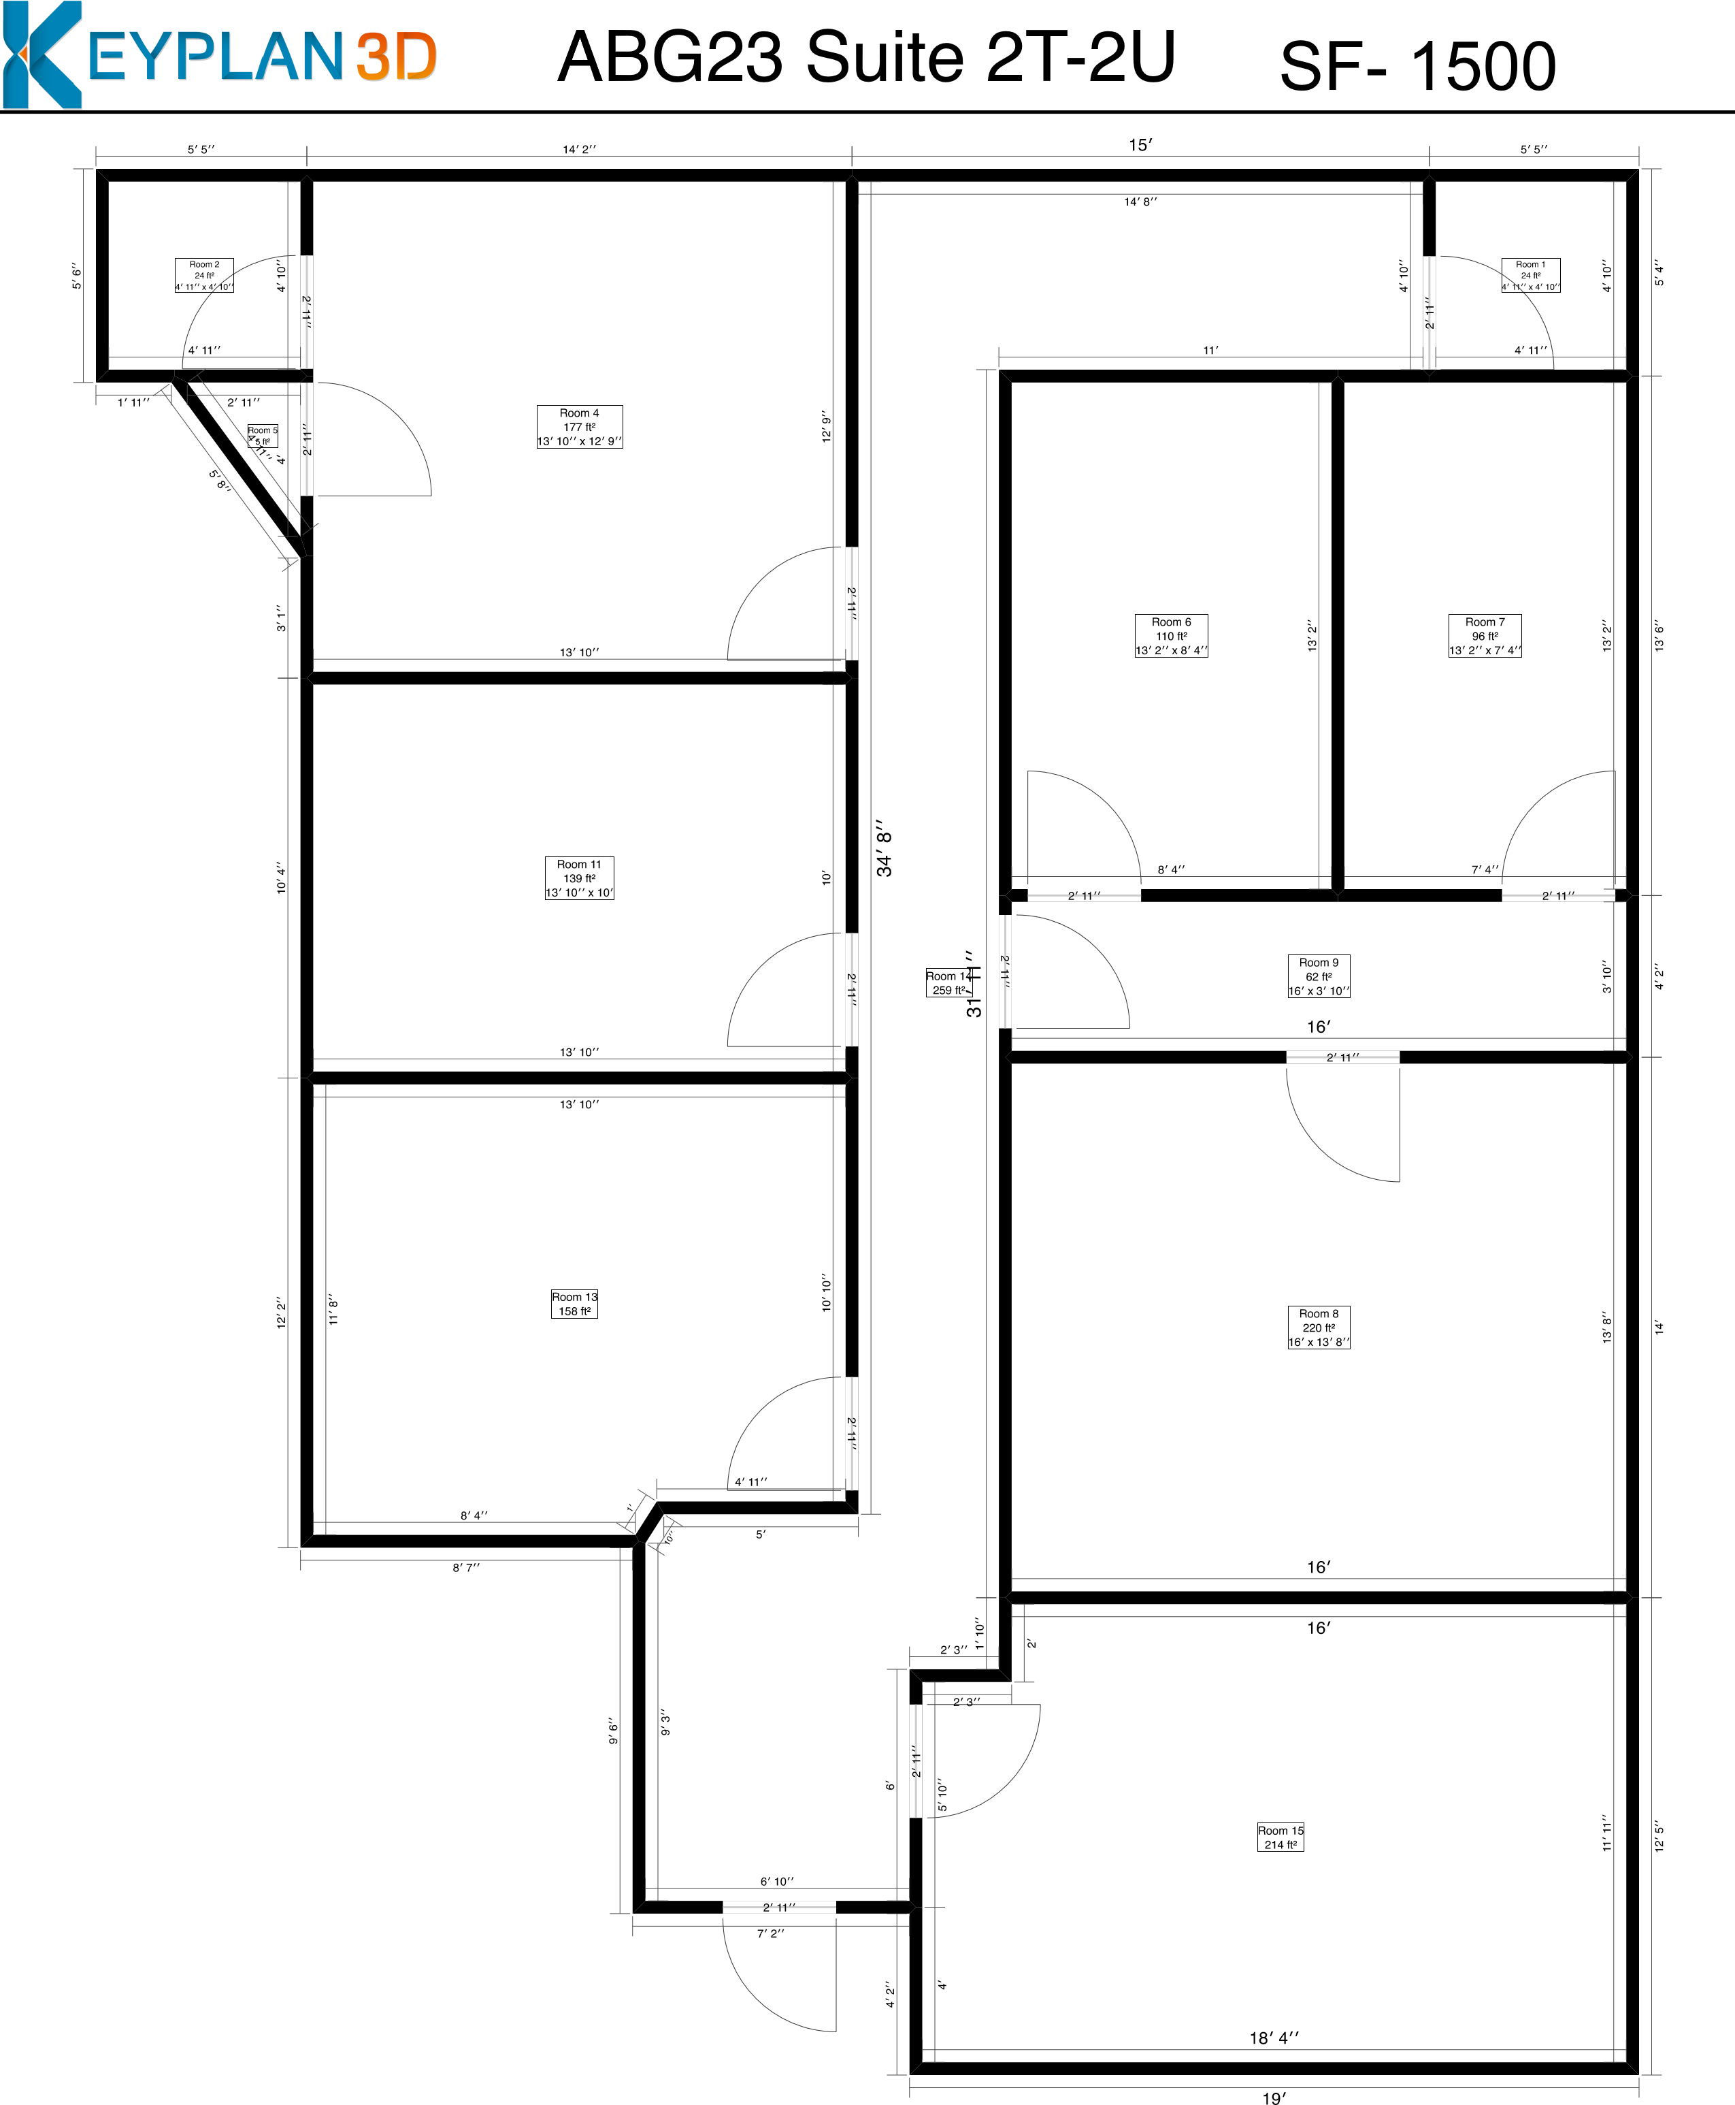
3_{′ 3′′} Created by : www.keyplan3d.com
1600 SQFT

