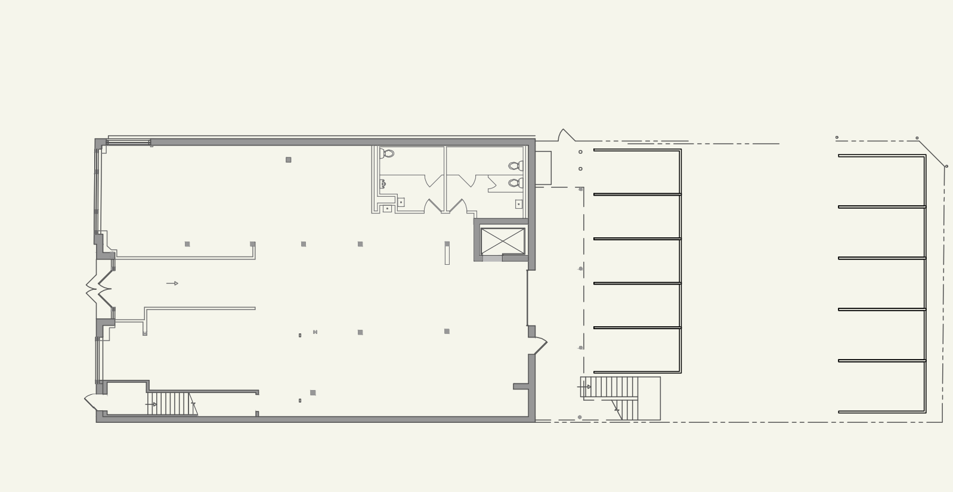
RAMP UP
OUTDOOR
ROLL UP SPACE DOOR
UP
UP
CRENSHAW BLVD

