27 Oaks Office Building
2702 N. Loop 1604 E | San Antonio | Texas | 78232

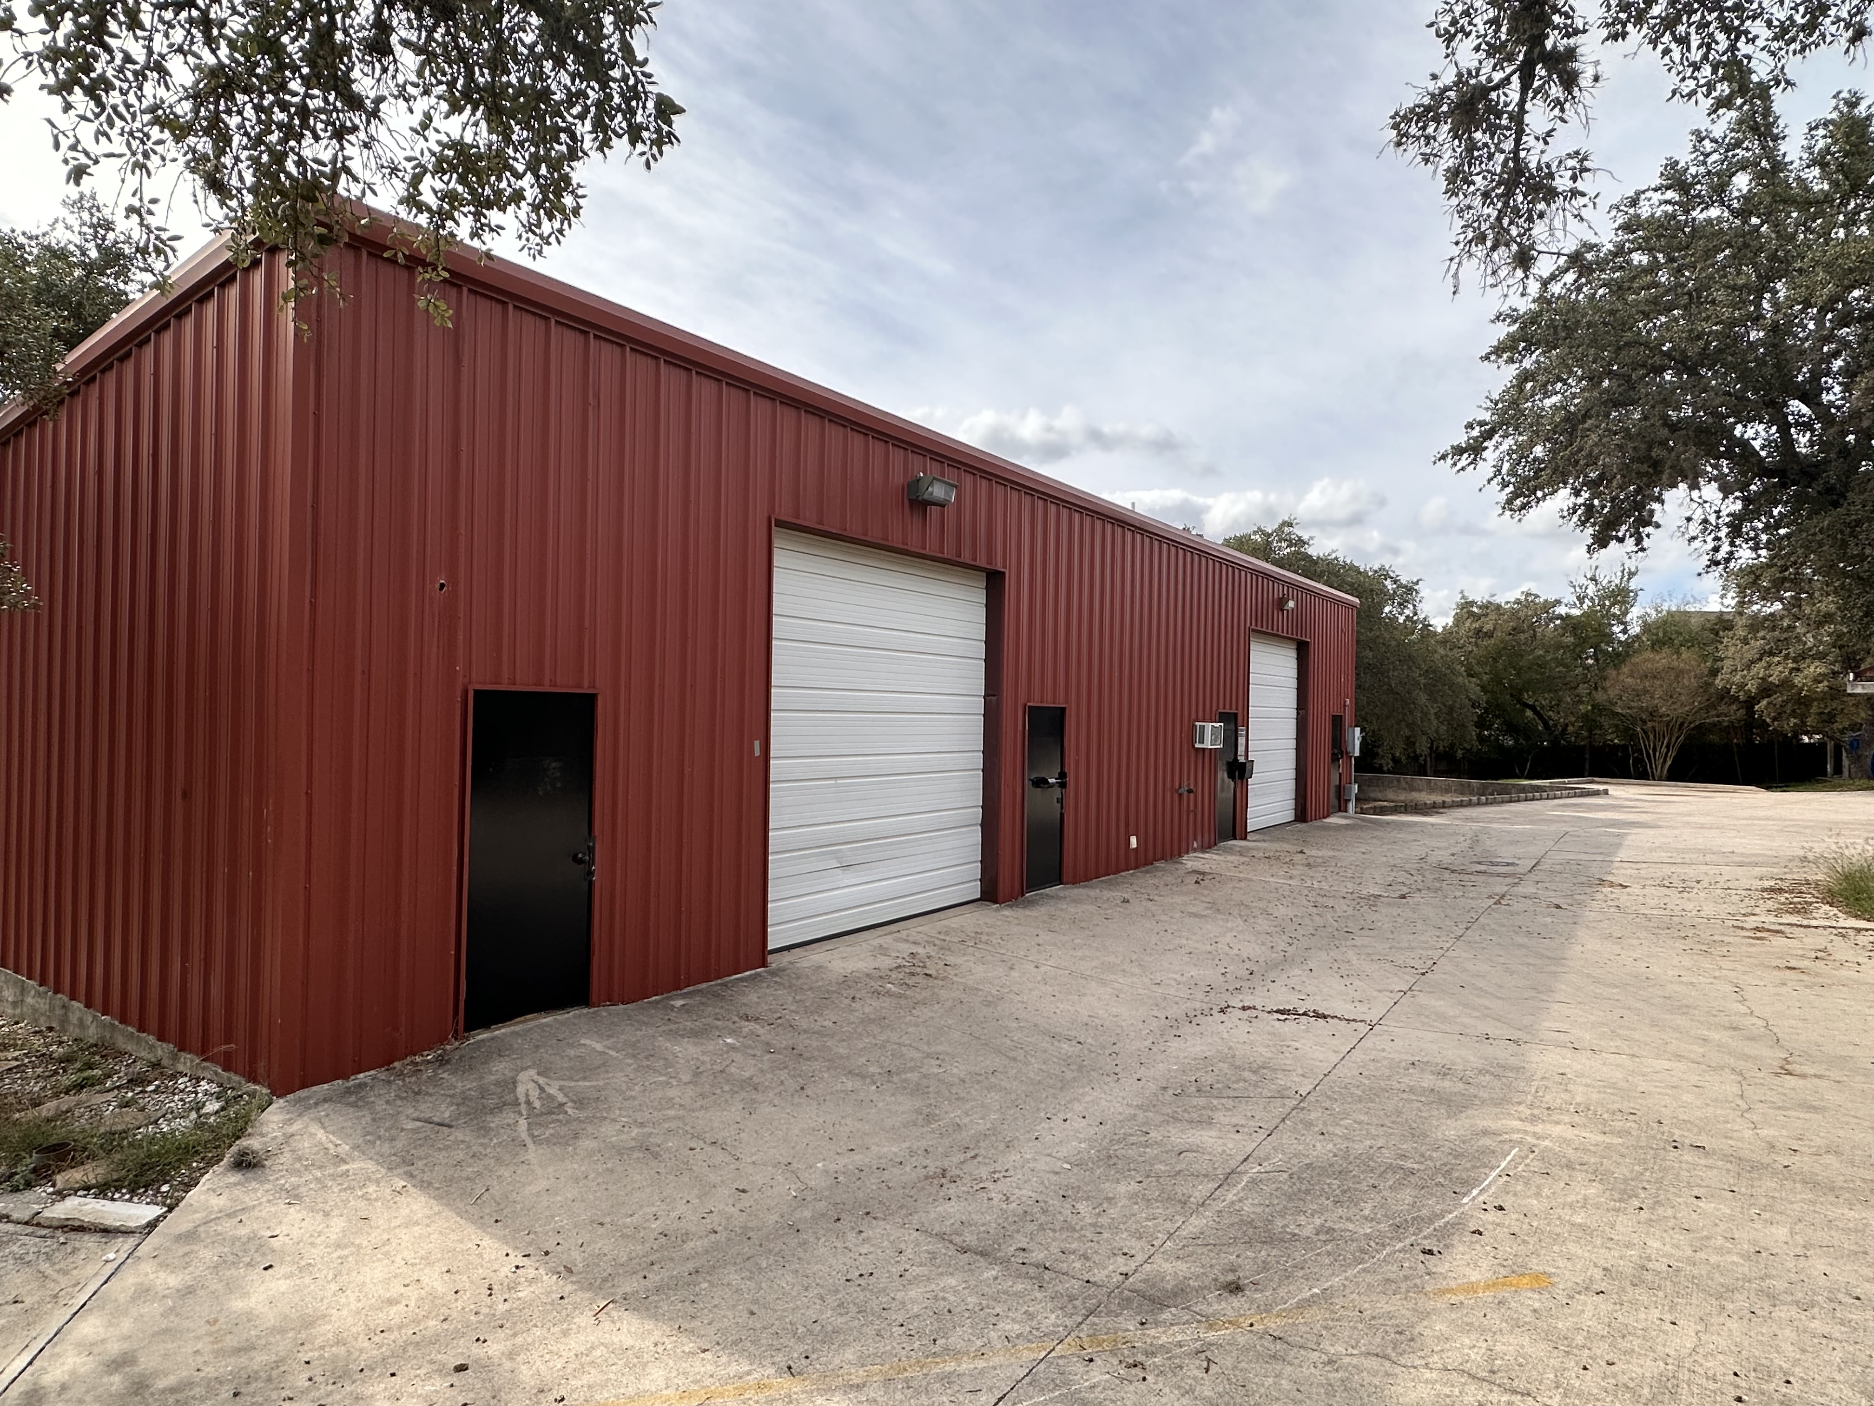 |  | • Park-like grounds with 27 Oak trees  • In-suite thermostats – Tenant controls a/c and heat.  • Urban Vibe  • Generous Parking  • Flexible Lease Terms  Call Owner: Jim Ahern  (210) 410-2170  Call Property Manager: Claire  Kuresa  (210) 316-1916
Suite 301 – 1325 square feet, up to 2000 square feet of loft storage space available, in-suite restroom & kitchenette, private front & rear entrances, flexible floor plan, easy access to loop 1604 and near highway 281 North, reserved parking, janitor service included.

■ To schedule a showing or for more information, please contact Jim (Owner) at (210) 410-2170 / jahern@acornland.com or Claire (Property Manager) at
(210) 316-1916 / ckuresa@acornland.com
■ Will cooperate with brokers

