Sackville Place Business Centre, 44-48 Magdalen Street, Norwich NR3 1JU
Contact: Shiv: 07308752533
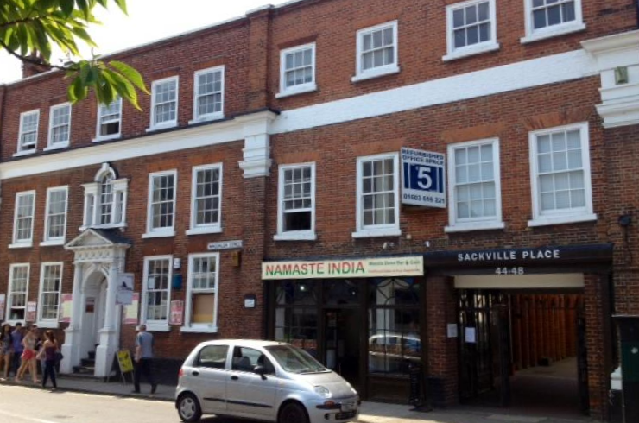
Available Space | Approx. size (sq ft) | Desk Recommendation | Price Per Month  (NO VAT)
Ground Floor
Suite 7 | 270 | 5 | £450
Suite 11 | 270 | 5 | £450
First Floor
Suite 105B | 210 | 2 | £380
Suite 106A | 205 | 2 | £380
Suite 111 | 283 | 5 | £450
Suite 112 | 283 | 5 | £450
Suite 113 | 283 | 5 | £450
Suite 114 | 283 | 5 | £450
Suite 115 | 283 | 5 | £450
Suite 117 | 630 | 10 | £1200
Suite 118 | 168 | 2 | £380
Second Floor
Suite 201 | 310 | 8 | £650 (available from June 25)
Suite 206 | 270 | 5 | £450
Suite 207 | 270 | 5 | £450
Suite 209 | 270 | 5 | £450
Suite 210 | 270 | 5 | £450 (available from June 25)
Suite 211 | 245 | 4 | £380 (available from June 25)
Suite 212A | 140 | 1 | £220
Suite 213 | 270 | 5 | £450 (available from June 25)
Suite 218F | 220 | 2 | £380
Suite 221 | 630 | 10 | £1200 (available from June 25)
Suite 222 | 670 | 15-20 | £1600 (available from June 25)
Suite 218E | 285 | 4 | £ 380 (available from June 25)
Third Floor
Suite 305 | 120 | 1-2 | £220 (available from June 25)
Suite 308 | 120 | 1-2 | £220 (available from June 25)
Suite 311-312 | 295 | 5 | £480 (available from June 25)
Suite 313-314 | 410 | 8-10 | £700 (available from June 25)

Description:
Sackville Place is a small period property located in the north of the City Center.

Transport:
The bus station is 10 minutes away by foot and the railway station less than 15.

What does the above price include?
- Rent
- Service & Maintenance Charges
- Communal cleaning
- Basic furniture

Additional Costs
- Parking if available (£50.00 per month)
- Business rates are not included although many offices should qualify for 100% rates relief but please rely on your own enquiries
- Super-fast fiber Internet as per requirement and choice of provider
- Extra furniture can be arranged at a cost

