


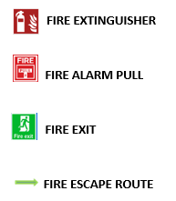

E
A
S
T
W
E
S
T

S O U T H
N O R T H
STAIRS
STAIRS

