Ralph Bernascone
Jennisons
Nep Town Road
Henfield, West Sussex BN5 9DY

Tel: 07717 576337
Email: salesandlettings@whiteover.co.uk

Slinfold8
FACTORY/WAREHOUSE

3,500 SQ.FT. APPROX.

UNIT 2, BUILDING THREE, MAYDWELL AVENUE,

SLINFOLD, WEST SUSSEX RH13 0AS

TO LET ON NEW SUB-LEASE

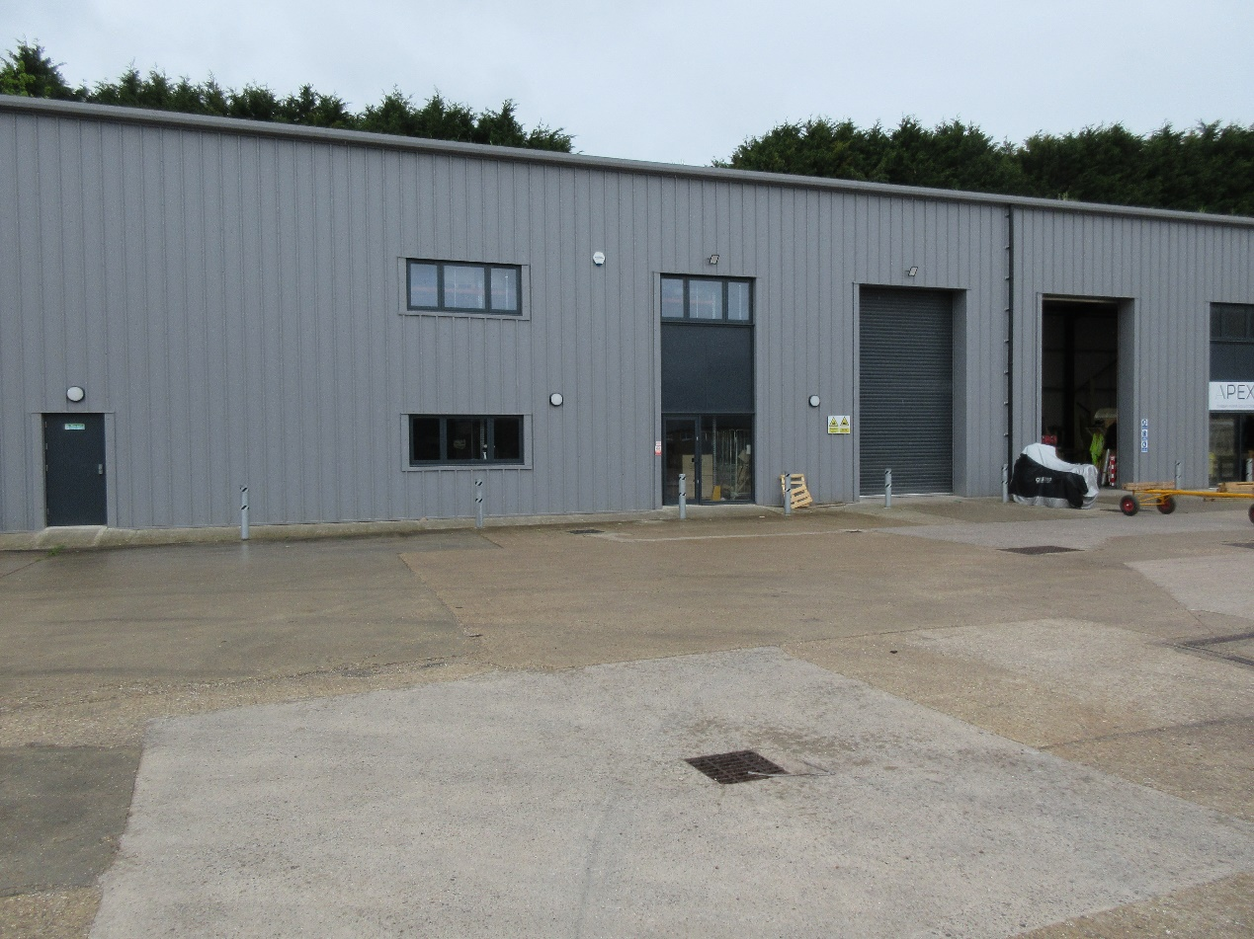

Location: The property is situated off Stane Street, A29 approx
4 miles west of Horsham and the A24. The A281
Guildford to Horsham road is approx. 2 miles.

Description: Comprises a very modern unit (built 2022) on a steel portal
Frame with a fully insulated roof.

Amenities:
- 7.4 metres (24 feet) headroom approx.
- Electric loading door
- 70 kva 3 phase power
- 24 hours inside the building
- 6 car spaces
- Lighting (LED)

N.B. Deliveries/loading/unloading between the hours of 7.30am & 8pm
Monday to Friday, 7.30am to 1pm on Saturday with none allowed on
Sunday/public holidays.

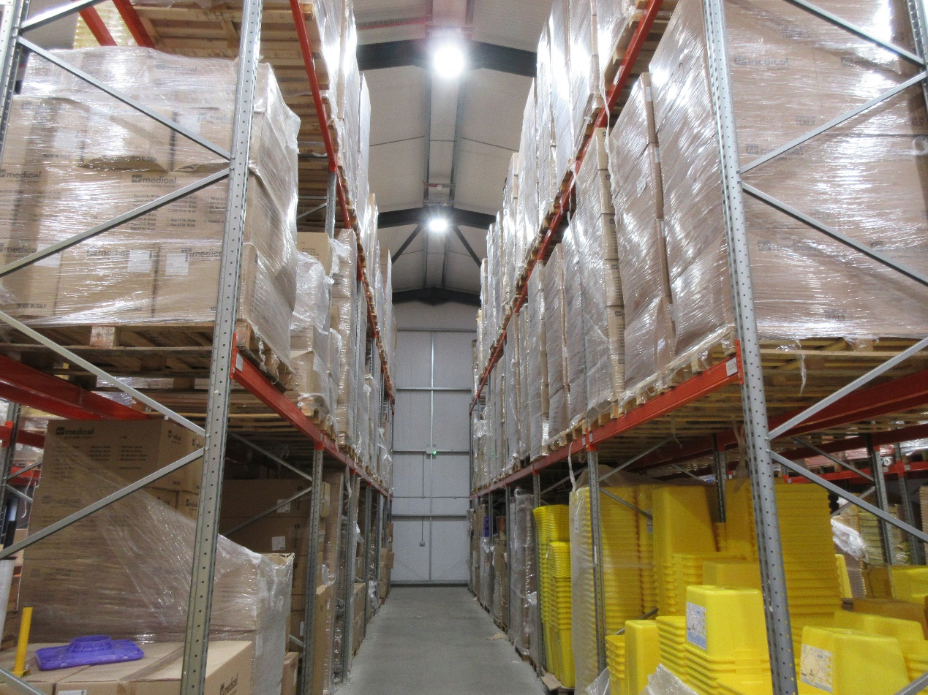

Floor Areas: 3,500 sq.ft.

Lease: A new five year sub-lease on a full repairing and insuring basis,
the lease to be outside the provisions of the Landlord & Tenant
Act 1954.

Rent: £42,000 (fourth two thousand pounds) per annum exclusive
+ VAT.

Service Charge: A service charge will be levied for the upkeep of the estate road
and site landscaping.

EPC: The rating is 40B, valid until November 2032.

Rateable Value: £39,250 (payable £19,700).

Legal Costs: Each party to be responsible for their own legal costs.

Viewing: Through Ralph Bernascone 07717576337.

Subject to Contract

