F o r L e a s e
Pratt’s Mill Shopping & Office Center
Corner Fairview Avenue & Old Farm Road Prattville, Alabama

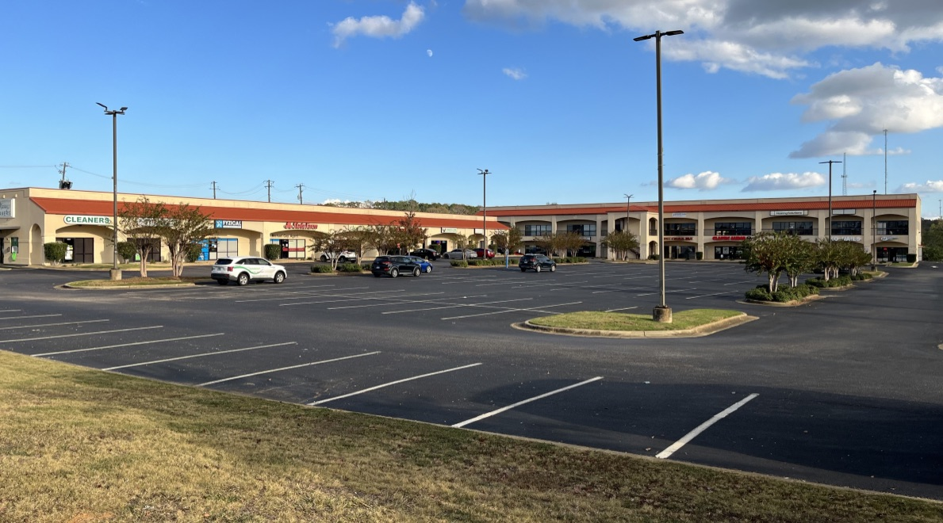
Suite 2082
1,200 SF
Suite 2092
2,500 SF

Suite 2092: Size: 2,500 SF
Rent: $3,125.00 / month ($15.00 / SF)
T I C: $ ± 573.00 / month: ($ 2.75 / SF) Includes water, sewer, trash
Utilities: Tenant pays for electricity, telephone, internet

Suite 2082: Size: 1,200 SF
Rent: $1,500.00 plus NNN charges
Utilities: Tenant pays for electricity, telephone, internet

Parking: 254 Parking Spaces or a 170:1 Parking Ratio which is excellent

Signage: Excellent sign exposure on mansard of building and on the Pylon sign facing Fairview Avenue.

Location: The Corner of Fairview Avenue and Old Farm Road is the 1st Signaled Intersection west of I-65. Directly across Fairview Ave from the Long Lewis Ford

PMSC Management, David Derbes 985-264-2990
dvd@pmscmgt.com
dsderbes@gmail.com

File: dropbox: PM Flyer for Lease Unit 2092 & 2082 1-26-25

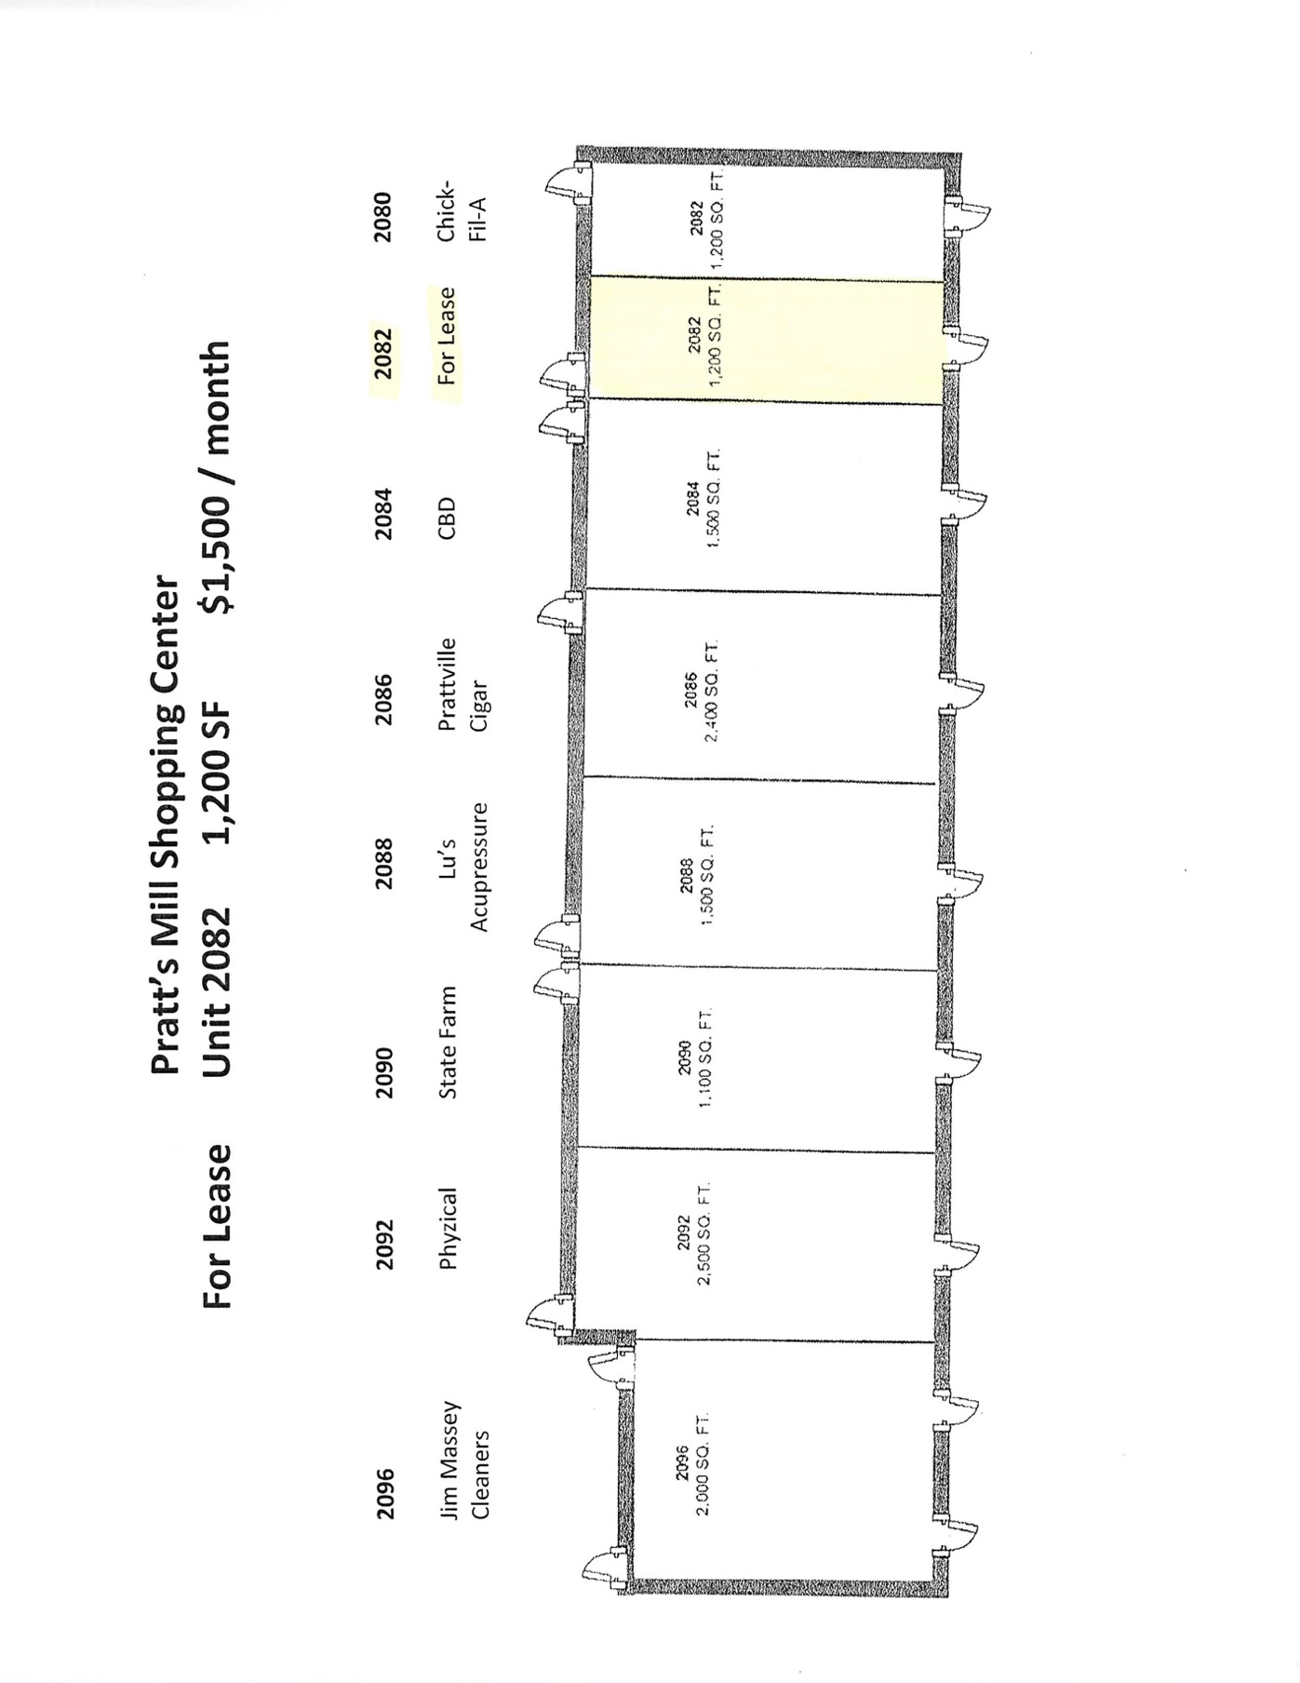

Site Plan
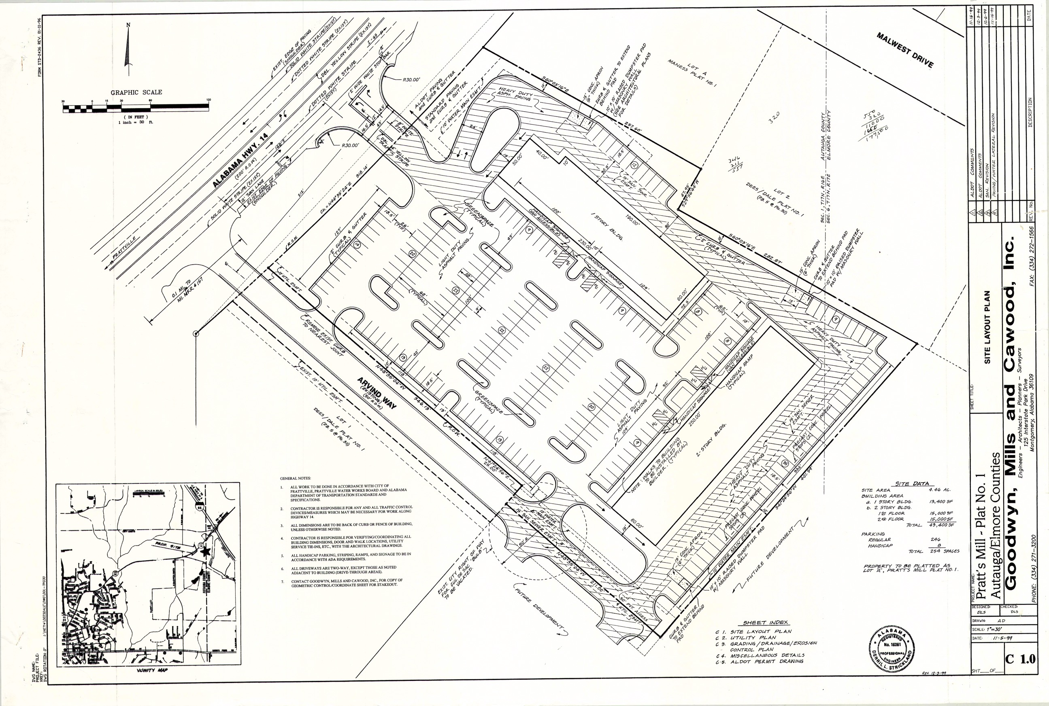

FLOOR PLAN
SUITE 2092 – 2,500 SF

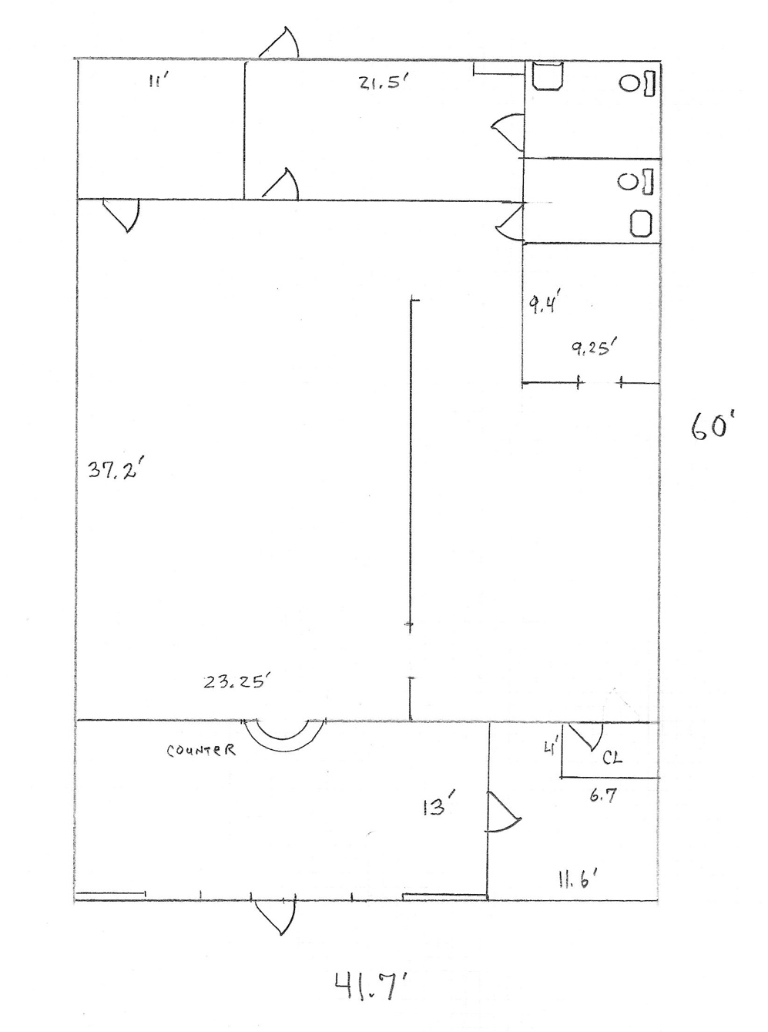

Some changes to front waiting area and front office are not noted on this floor plan

