- WATERWORKS OFFICES & MARINA
1800 WESTLAKE AVENUE NORTH
SEATTLE, WA 98109

SUITE 00-303

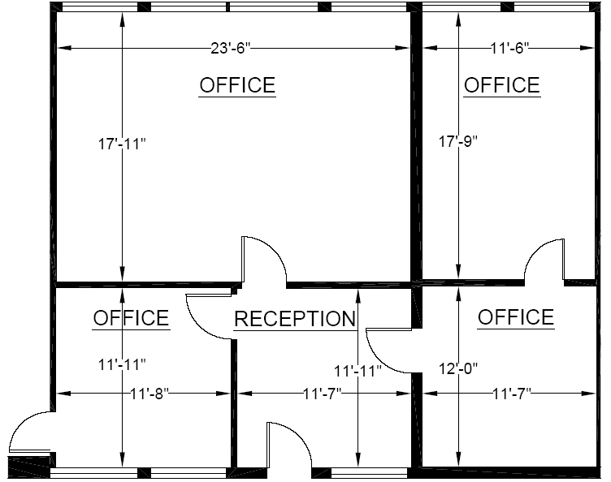

Rentable: 1,221 sq. ft.
(As measured March 2002)

