Commercial / Industrial Lease Opportunity
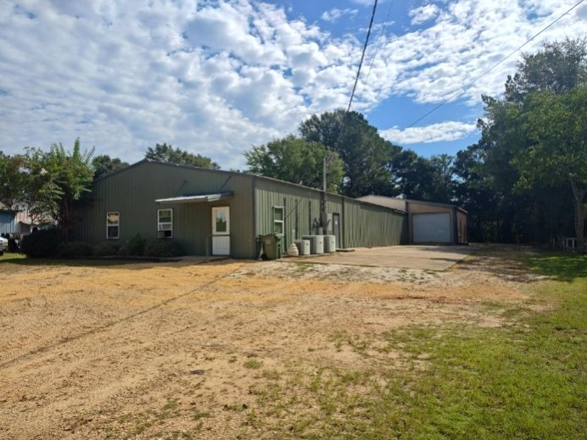
506 N Conecuh St, Greenville, AL 36037
Offered by ALASEASON HOLDINGS LLC
This newly renovated commercial/industrial space offers:
- - Approximately 6530 square feet of total area
- - 800 square feet of modern office space
- - 3 restrooms for convenience
- - Large truck access for industrial operations
- - Close proximity to Interstate 65 exit 130
Lease Terms:
- - 1–3-year Lease
- - $3650 negotiable per lease term
For inquiries or to schedule a viewing, please contact:
Joe Norwood
Greenville, AL 36037
gcnorwoodj@gmail.com
📞 334-525-0511

