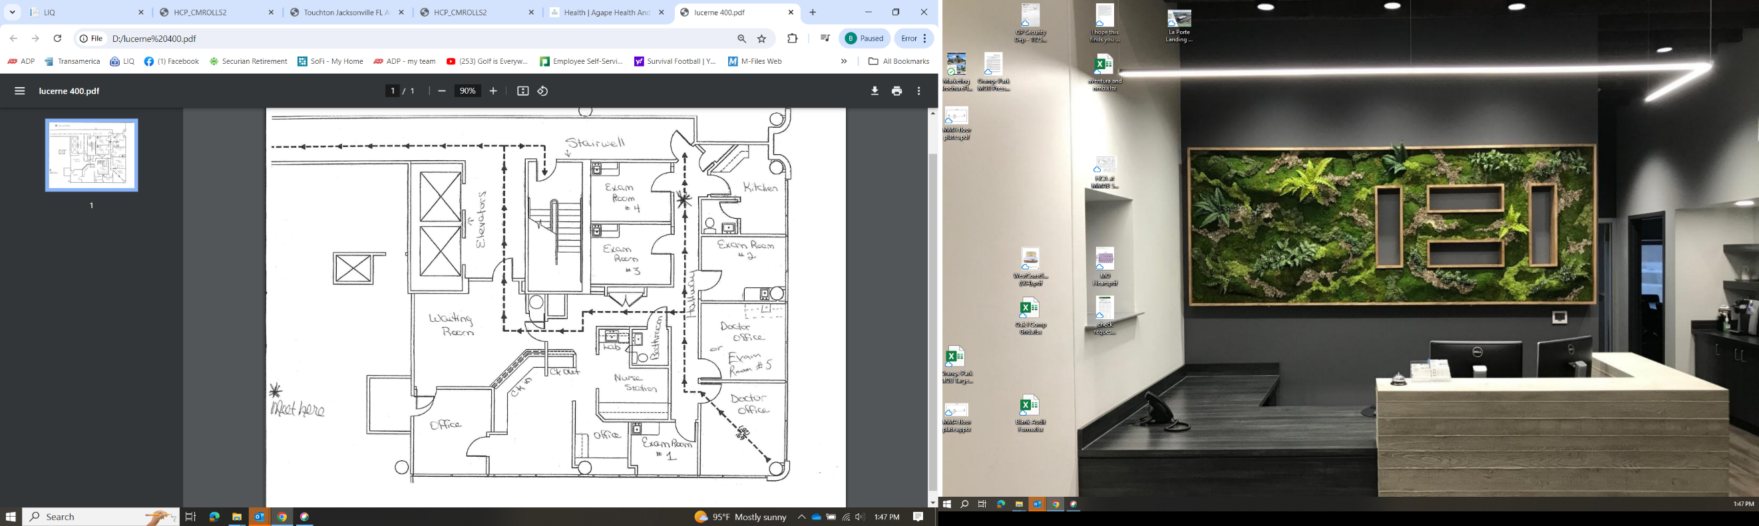
Lucerne Medical Plaza
100 W. Gore St., Orlando, FL
Suite 400 – 2,481 RSF

