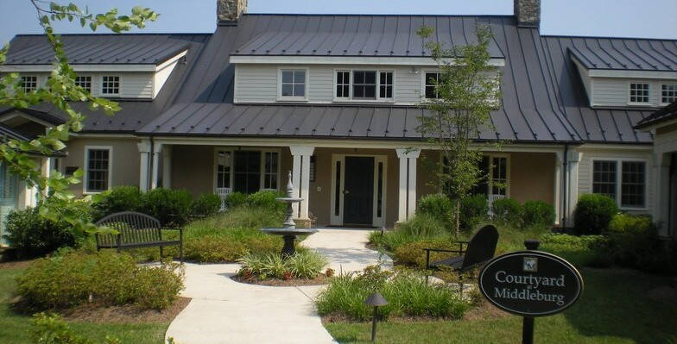
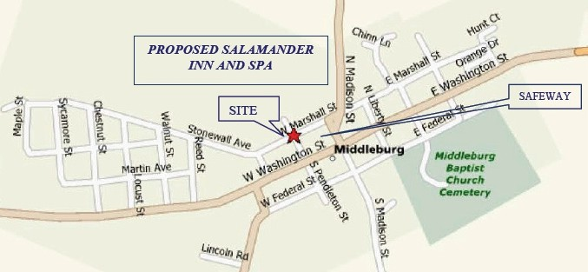

FOR SALE
10 N PENDLETON ST. MIDDLEBURG, VA

PROPERTY SNAPSHOT:
Inquire about pricing.
7,000 SF Total | 2,000 SF Available Free-Standing Building
Covered Parking User or Investor

LOCATED IN THE HEART OF OLD TOWN!
One street away from Route 50 and less than a two-minute walk from grocery stores, shopping, restaurants & more!

CONTACT INFORMATION
Brian Petruska | 703-819-1768 | bpetruska@petrusgroupus.com
The Petrus Group

