LEASING OPPORTUNITY
This attractive building and grounds are uniquely suited for Engineering /surveying, Design / build or Architectural firms. Many other uses are easily accommodated.
Call Deb cell 908-705-2266.
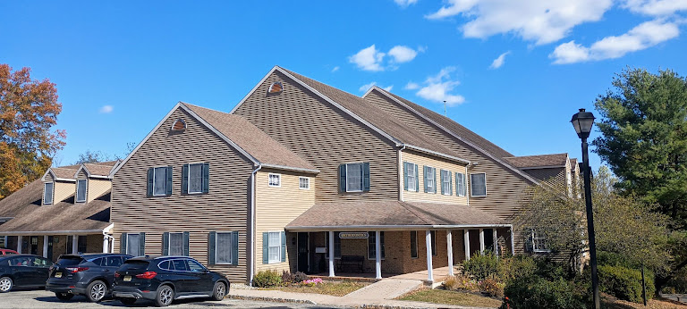
This facility developed by an engineering firm for their own use is now available for lease. Low cost to users for premium space and use-ability Available in various sizes and configurations.Building has 3 floors totaling 9000 sq ft. All or part open
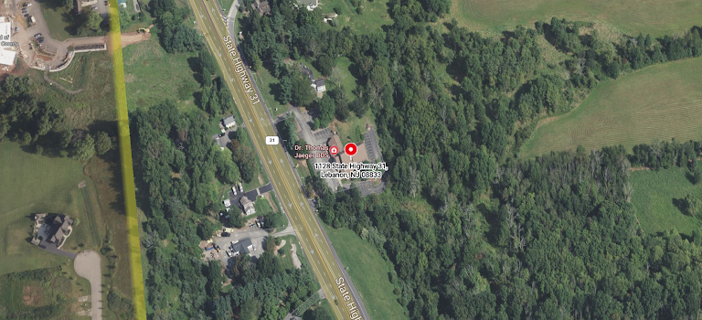
Floor 1 class A office space 3000 sq, 2 floor class a office space 3000 sq ft., Truck height. loading dock and field crew shop at walkout basement level.
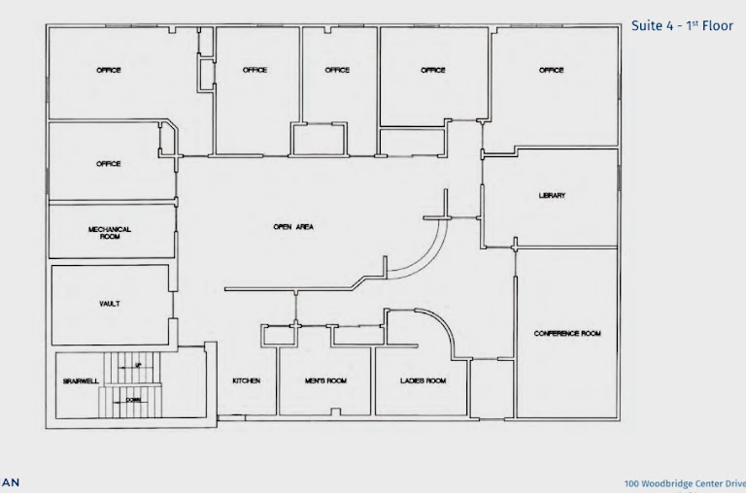
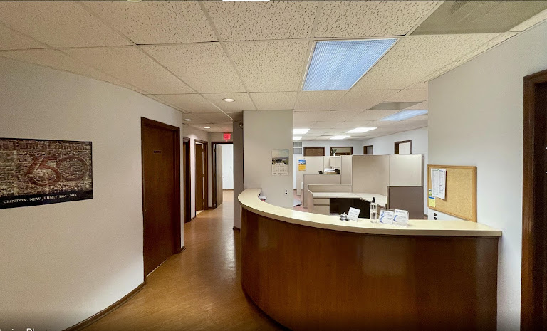
Fully finished move in condition saves set-up costs.Large conference room, executive offices, ready to move in!

