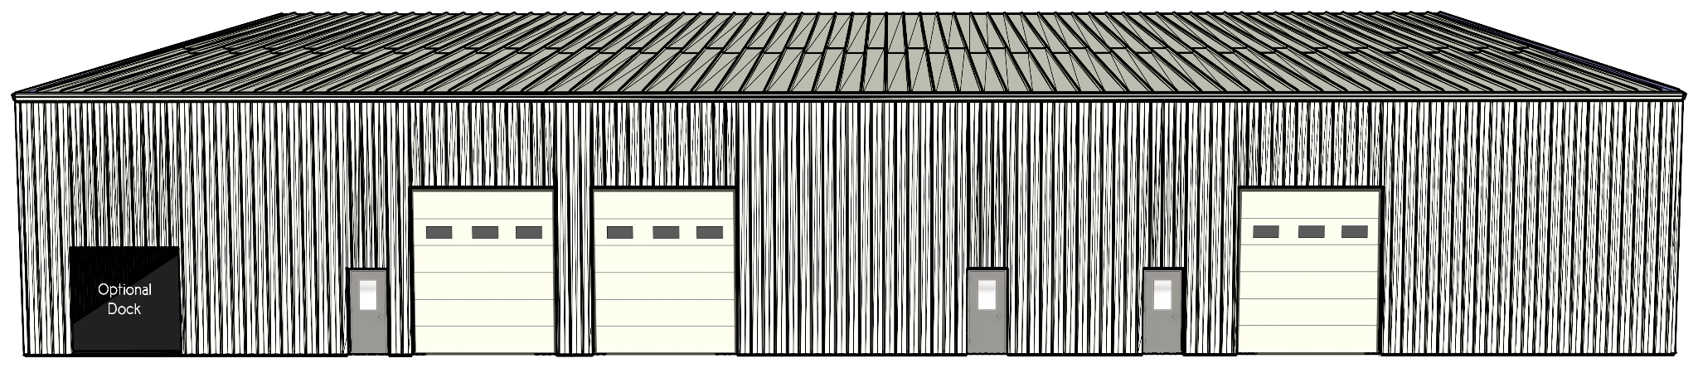
*Architectural Model
Commercial Warehouse Space
Available for Lease

• Up To 8,000 square feet
• 22 foot high ceilings
• Brand new, fully insulated
• Address: 100 Harwood Court
• Great location in south Lincoln,
with easy access to the bypass
• Available starting July 31, 2025

Contact: Charlotte Ralston
charlotte@runutsco.com

