
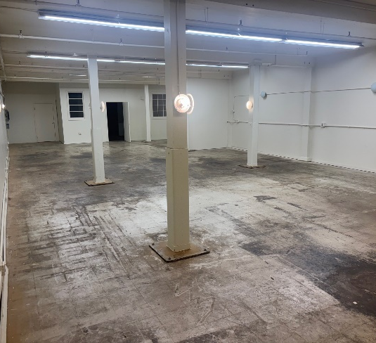
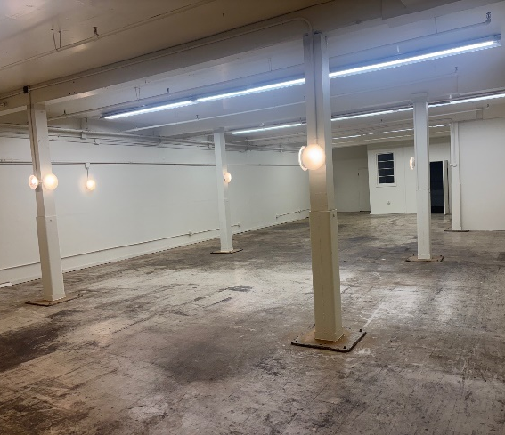
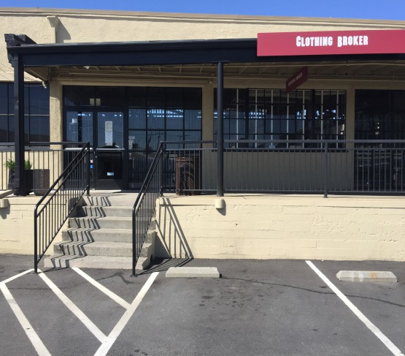

Wide Open Space Good Lighting Parking at the Door
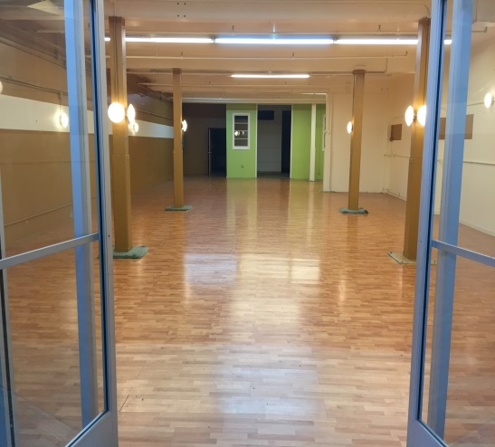
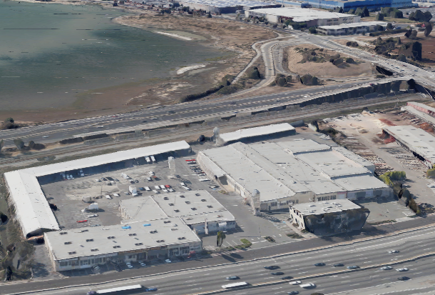
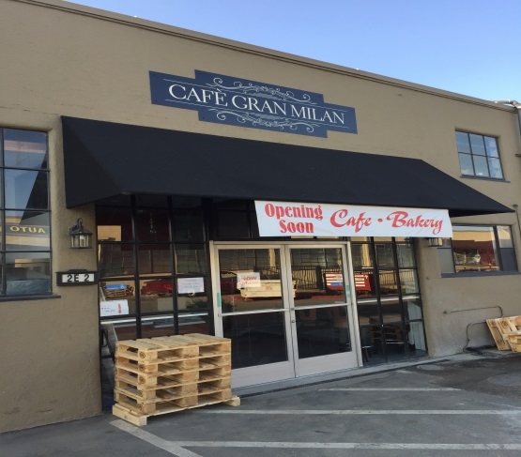

S.F. Bay





Glass Entrance Covered to Corridor Facing 255,000+ Captive Cars/day Yummy On-site Deli!
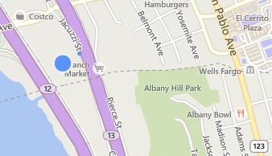

SECURE STORAGE SPACE FOR LEASE
BART

5327 Jacuzzi Street #3-J: ±2,634 Sq. Ft.
Site!

Open Storage or Activity Space featuring:

- Glass Storefront - Open Space
- Off Street Parking - Nearby Restrooms in Building
- On Site Cafe - Recently a Dance Studio

Drive-in and Dock-high Loading for Versatility

Half-mile from BART!

72 ¢ psf Monthly Net + 42¢ CAMS.

FOR FURTHER INFORMATION PLEASE CONTACT Peter McNally 510/848-6007
CITY | Richmond Bayside | LISTING CO. | McNally Realty Advisors
ADDRESS | 5327 Jacuzzi Street | LISTING AGT. | Peter McNally
CROSS ST. | Interstate 80/Central Ave. | PHONE # | 510/848-6007
SPACE AVAIL. | 2,634 Sq. Ft. | LIST DATES | 2/26
PRICE | $3,000 / month all-in | DRE # | 982919
PROP. TYPE | Office/R&D/Activity | FEE TO S.O. | 3% gross rents
Information Herein Deemed Reliable but not Guaranteed.

