MEDICAL OFFICE SPACE
FOR LEASE
ON THE
ST. PETER’S HOSPITAL
CAMPUS

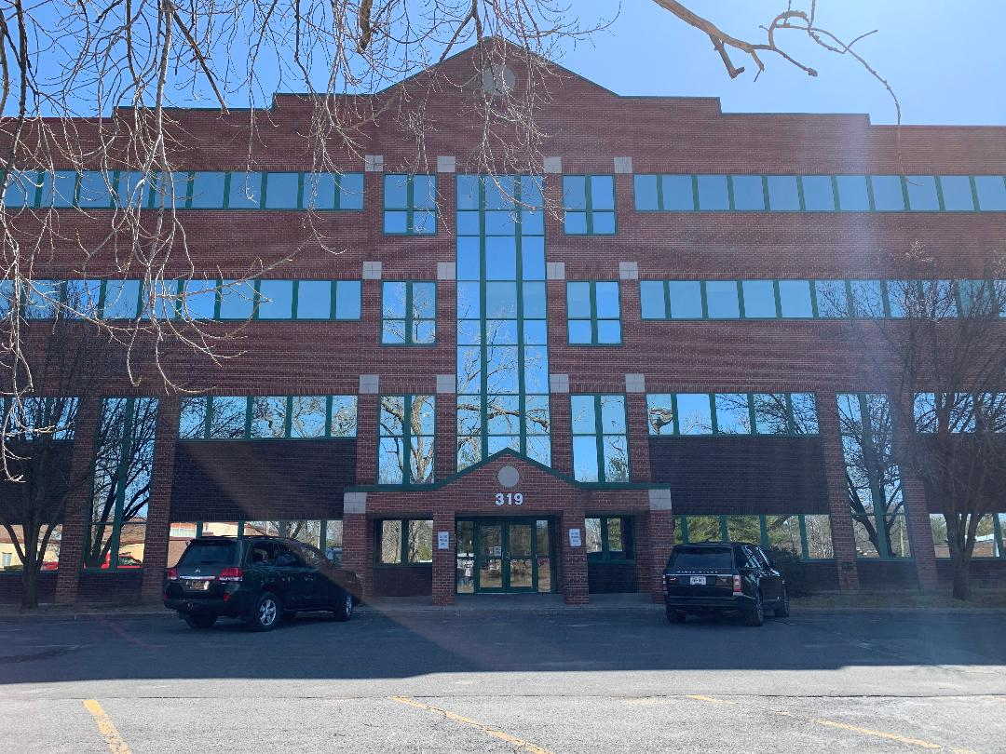

MERCYCARE MEDICAL CAMPUS CENTER
ALBANY, NY
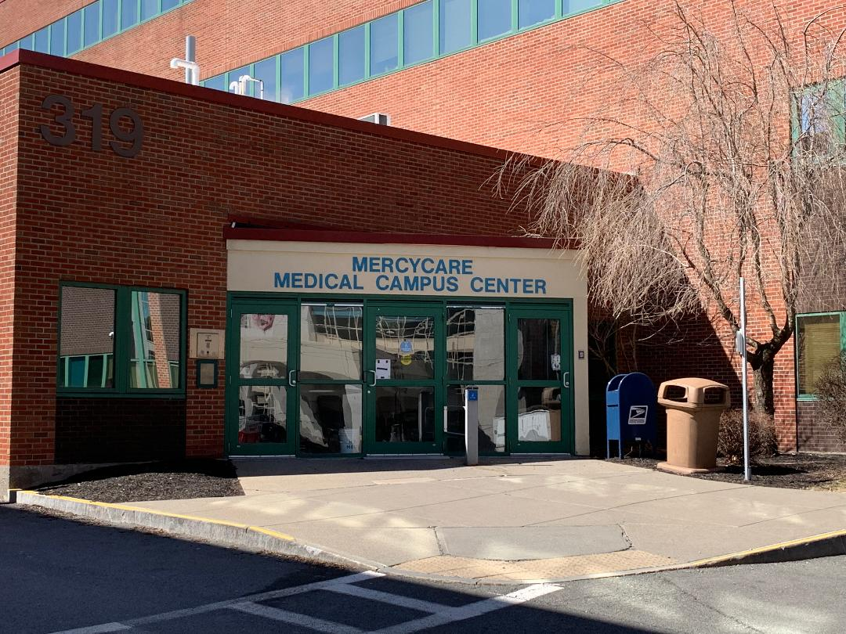

Prime Medical Office Space for Lease 2402 sq. ft. in Mercycare Medical Office Building
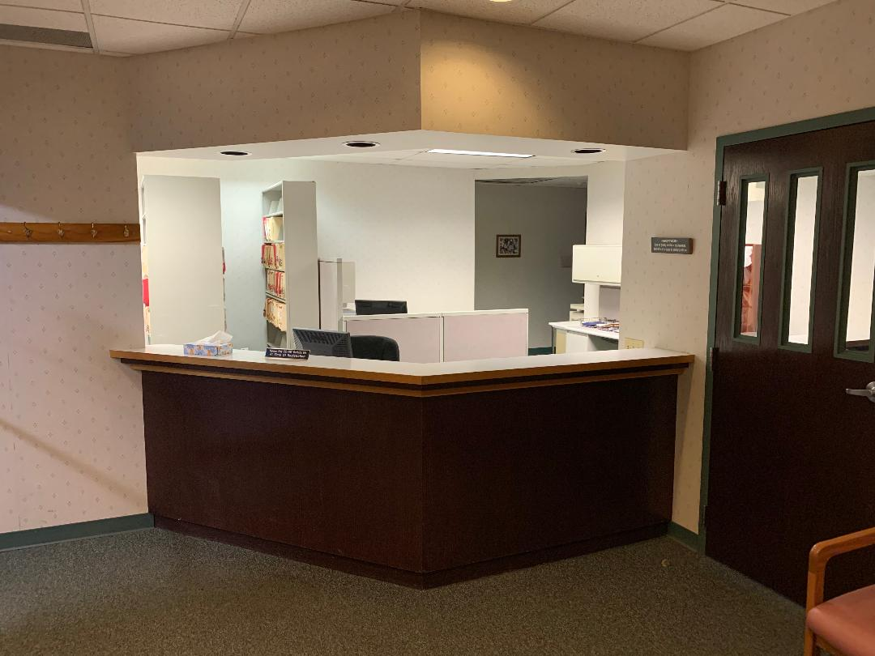
Seize this rare opportunity to lease a medical office suite with option to buy in the highly sought-after Mercycare Medical Office Building, conveniently located on the campus of St. Peter’s Hospital—ranked the #1 hospital in the Capital District by U.S. News & World Report 2024-2025.
Office Features:
✅ Spacious & Functional Layout – 2,402 sq. ft. on the 3rd floor with easy elevator access
✅ Welcoming Waiting Area – Comfortably seats 14 patients
✅ Efficient Workflow Design – Reception area, 5 exam rooms (all with sinks), including one large enough for minor procedures
✅ Dedicated Consultation & Lab Space – 3 consultation rooms + in-office lab for performing in office labs as U/As, UCGs, fingerstick blood work, and microscopy
✅ Accessibility & Convenience – Break/Lunch room, Two ADA-compliant restrooms and ample storage space
Unmatched On-Campus Benefits:
🌟 Ideal for Medical, Ob/Gyn & Surgical Specialties – Immediate access to St. Peter’s Hospital makes it easier for providers who frequently utilize hospital services, perform procedures or round on patients.
🌟 Seamless Hospital Connectivity – See patients in the ER, conduct hospital rounds and consults, and return to your office between surgeries without the hassle of commuting.
🌟 Flexible Scheduling Advantage – If your surgery time is bumped or delayed, you can conveniently return to your office and see patients while waiting.
Prime Location Perks: 🚗 Exclusive Provider Parking – Private lot for physicians & nurse practitioners
🅿️ Ample Free Patient/Employee Parking – Convenient three-story parking garage directly behind the building
🏥 High Referral Potential – Located within a thriving medical community with strong hospital integration
This medical office is perfect for specialists who want efficiency, convenience, and direct hospital access. 📞 Don’t Miss Out! Contact us today at 518-441-9918 to schedule a tour.

