
13284 Pond Springs Road
Condo Suite 301
Offices For Lease/Sublease/Sale

Reception, 4 Offices, Kitchenette, Restroom &
Attic Storage
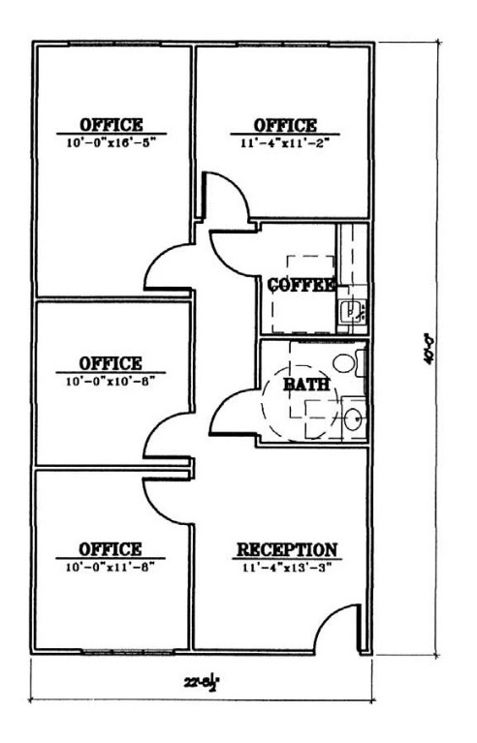
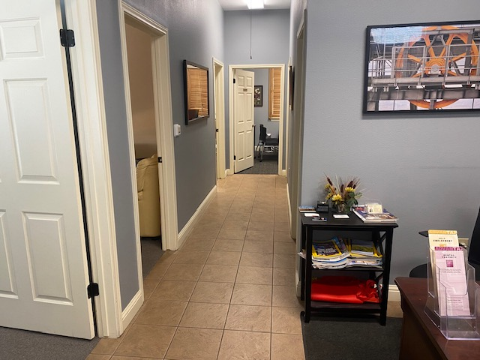

Condo: 892 Square Feet with 4 offices, Reception, Kitchen, Restroom
*All Offices Have Windows * See Layout Above
Sublease: ±692 Square Feet with 3 offices, Reception, Kitchen, Restroom & One Office Occupied (me)
Pricing…
Sale: $335,000.00 *
Lease: $1,800.00/month + E/J * Sublease: $1,500.00/month Gross

Please Direct Inquiries to:

Paul Ott, Broker
(512) 219-7777 Office/Mobile

