- WATERWORKS OFFICES & MARINA
1800 WESTLAKE AVENUE NORTH
SEATTLE, WA 98109

SUITE 00-204

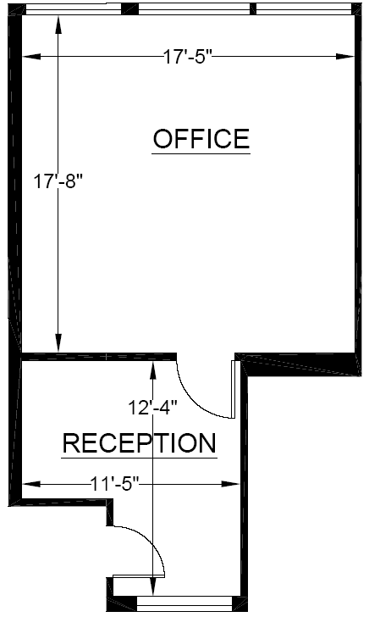

Rentable: 494 sq. ft.
(As measured March 2002)

TEMPERATE PARADISE PROPERTIES, LLC
PHONE: 206-851-0036

