Acme
1026 C Atlanta Avenue, Decatur, GA 30030
1400 sq ft
Available April 1, ,2025

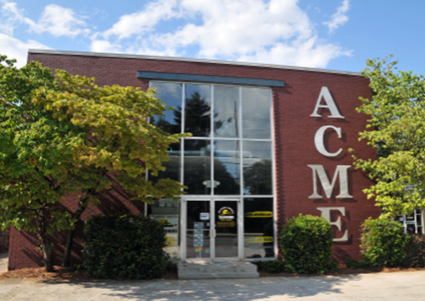

$18.00 psf NNN, approx. $8.02 psf in p/t including CAM TAX INS, and HVAC
Electric and Gas not included
Property/Space Features
- Located near City of Decatur shopping and restaurants
- Parking at immediate front of building
- Industrial look, hardwoods and high exposed ceilings
- 2 private offices, front entry office area, Restroom w/shower
Kitchen area

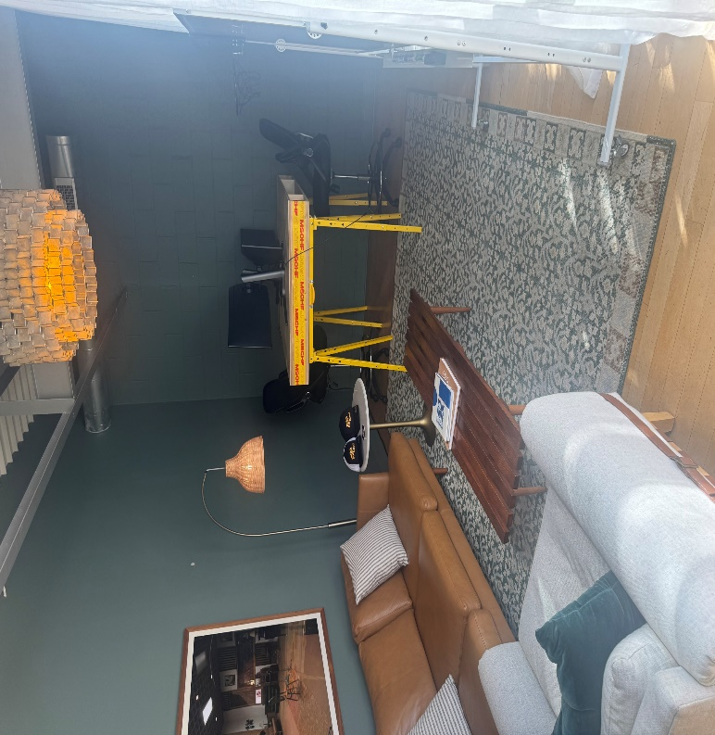
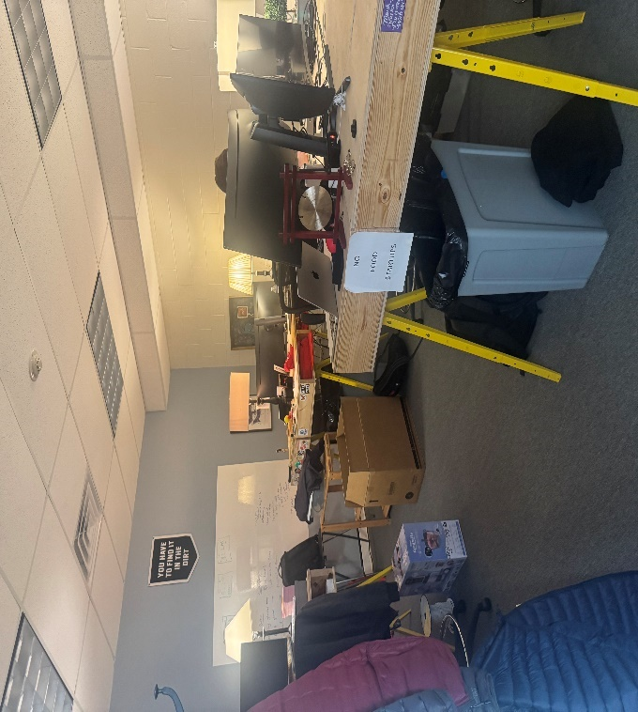
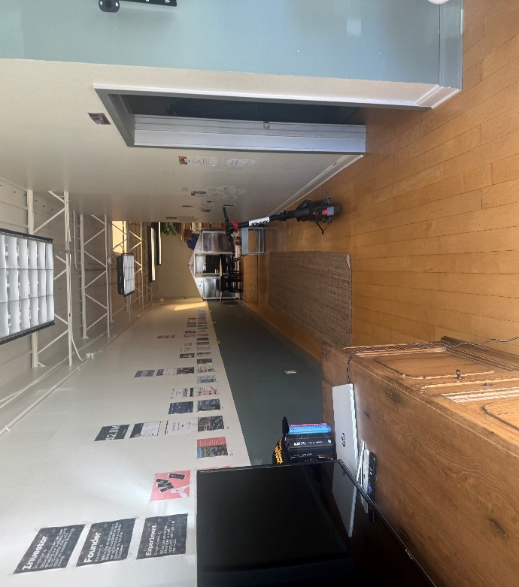
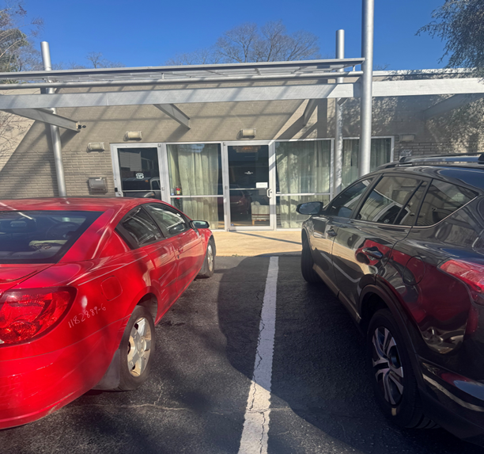

Leasing requirements-
  - Personal guarantee required
  - Personal credit score of 675 or more required
  - First month’s rent and security deposit due at lease signing
  - RENT + CAM + UTIL+ TI + HVAC replacement fee= monthly payment
Broker Commission:
  - Brokers to be paid ½ of first month’s rent with 5% residual.
  - Brokers must make first contact with EDS Leasing office for commission to paid on executed leases by EDS. If EDS shows the tenant the property first, tenant will be responsible for Broker’s commission.

