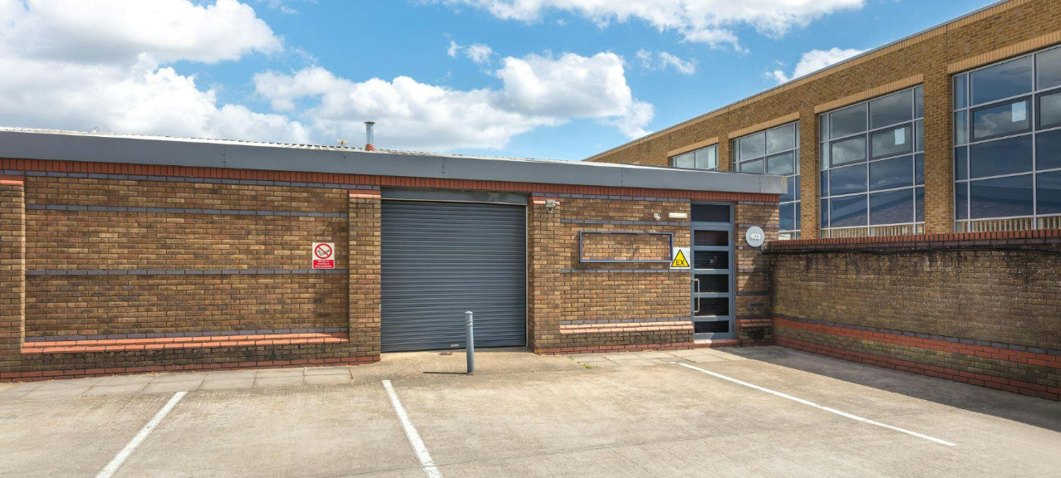

TO LET – 610 sq ft Enterprise unit
Industrial Unit available on Slough Trading Estate.
403 Montrose Avenue, SL1 4TJ

Industrial Enterprise unit available, 403 Montrose Avenue, SL1 4TJ

Location
- This unit is available on the established and well managed Slough Trading estate.
- The area provides access to large labour pool
- Excellent public transport links with proximity to both Slough Station and Burnham Station, allowing travel to central London in 20 minutes.
- Proximity to the M4 Motorway with central London only 23 miles away

Description
The unit is available on an enterprise lease which provides flexible lease terms and the opportunity to move into a larger unit on the estate.
The property comprises a single unit with 610 sq ft of total floorspace with an eaves height of 2.75m. The unit has a roller shutter door and 3 phase electricity. It is also highly connected with fibre internet access. It has an EPC rating of C.

Tenure
The plots are available by way of a new lease on terms to be agreed.

Rent
Available on application to the marketing agents.

Business Rates
The plots have not yet been assessed and further information will be provided.

Legal Costs

Each party is to be responsible for their own legal costs incurred in the transaction.

VAT
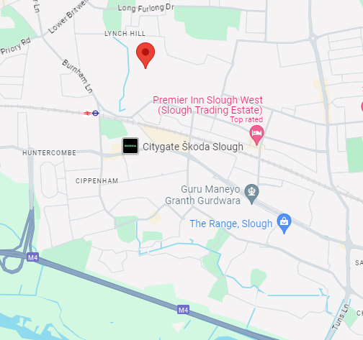
VAT will be charged at the standard rate.

Area | Sq Ft | Sq M
Total | 610 | 56.70

Get more information

Chris Proctor
+44 (0)7798690234
Chris.Proctor@avisonyoung.com

Saffron Harding
+44 (0) 7786419663
Saffron.Harding@avisonyoung.com

Avison Young hereby gives notice that the information provided either for itself, for any joint agents or for the vendors lessors of this property whose agent Avison Young is in this brochure is provided on the following conditions:

Sam Vyas
+44 (0)7962362708
Sam.Vyas@avisonyoung.com

Will Seagon
+44 (0)7765055020
William.Seagon@avisonyoung.com

- The particulars are set out as a general outline only, for the guidance of intending purchasers and/or lessees and do not constitute an offer or contract, or part of an offer or contract.
- All descriptions, dimensions and references to this property’s condition and any necessary permission for use and occupation, and any other relevant details, are given in good faith and are believed to be correct. However, any intending purchasers or tenants should not rely on them as statements or representations of fact but satisfy themselves of their correctness by inspection or otherwise.
- No person in the employment of Avison Young, or any joint agents, has any authority to make or give any representation or warranty whatsoever in relation to the property or properties in this brochure.
- All prices quoted are exclusive of VAT.
- Avison Young shall have no liability whatsoever in relation to any documents contained within the brochure or any elements of the brochure which were prepared solely by third parties, and not by Avison Young.
Anti-Money Laundering: To comply with our legal responsibilities for Anti-Money Laundering, it will be necessary for the successful bidder to provide information necessary to complete these checks before the deal is completed. Information required will include:
- Corporate structure and ownership details.
- Identification and verification of ultimate beneficial owners.




- Satisfactory proof of the source of funds for the Buyers / funders / lessee.

avisonyoung.com


