Commercial Property Network, Inc.
29 Emmons Drive, Suite F-40, Princeton, NJ 08540
Ph: (609) 921-8844 Fax: (609) 924-9739
www.cpnrealestate.com

RESTAURANT-RETAIL / FOR SALE OR LEASE, Ewing NJ

Location: 811 Parkway Avenue, Ewing Township, NJ @ 3-way lighted intersection

Building: 3200/SF – Currently International House of Pancakes

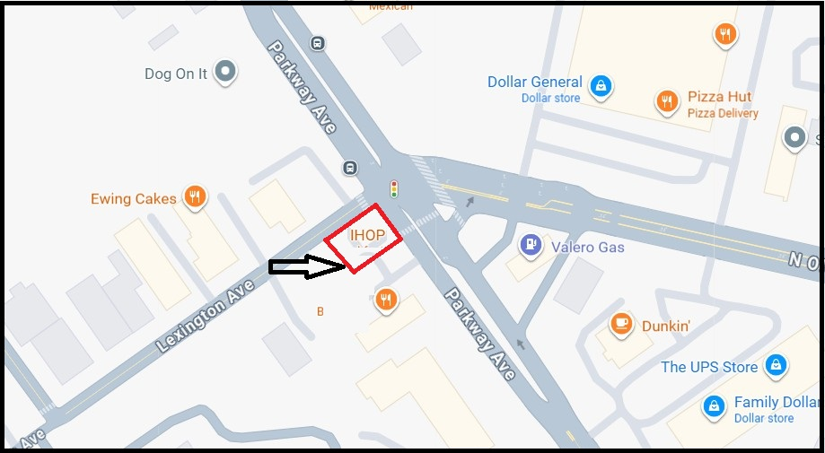

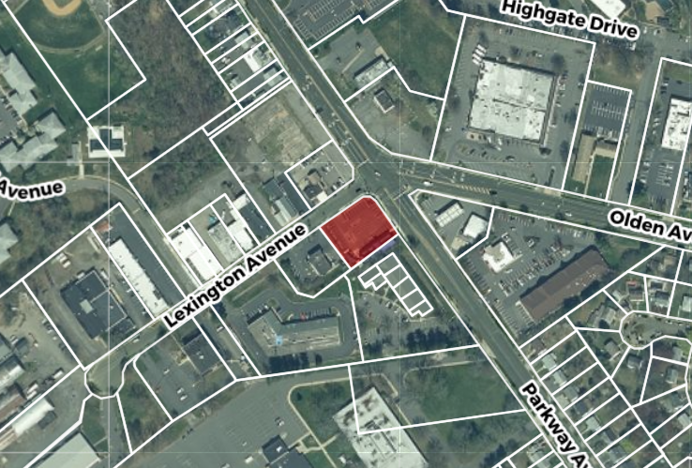

Lot Size: .53 acres

Uses: Variety of retail uses permitted

Utilities: Public sewer, water, electric, gas and cable

Comments: Move in opportunity
At corner of 3 roads
Significant signage
Ample parking
Could be Turn Key, Breakfast/Lunch Restaurant
Close to New Housing, Ewing High School, and many
Retail Sites.

Taxes: $27,270 (2024)

Lease Price: Negotiable, subject to term, work, financials, etc.

Sale Price: $1,200,000.00

Contacts: Al Toto, Senior Vice President
totocpn@aol.com, 609-658-3828

William Barish, Founder/Broker
bbarish@cpnrealestate.com 609-731-6076

