

D&N Commercial Real Estate
Oklahoma City, Oklahoma
_____________________________________________________________________________________
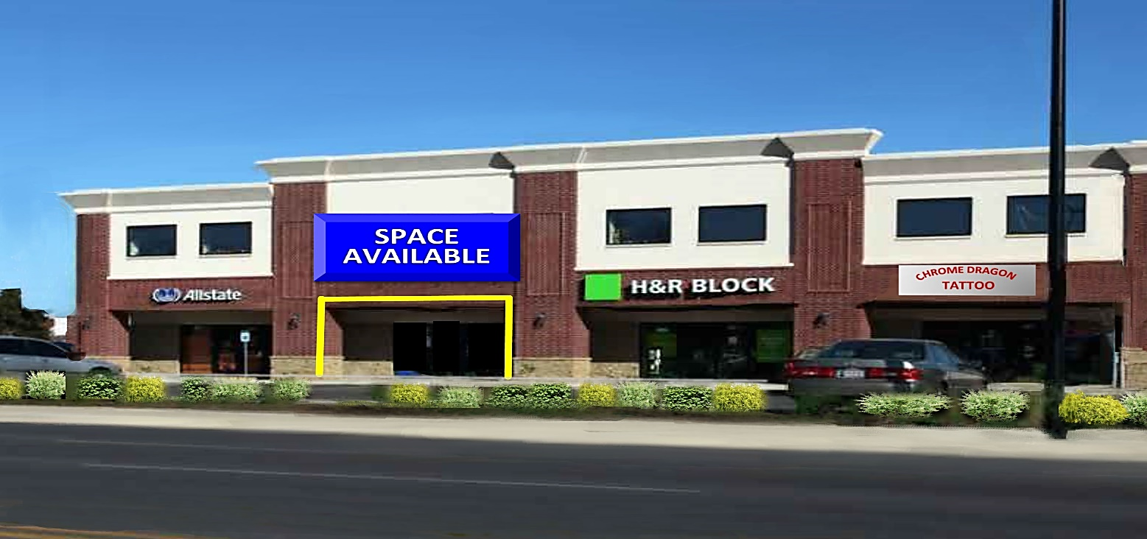
INCENTIVES OFFERED
Building #2
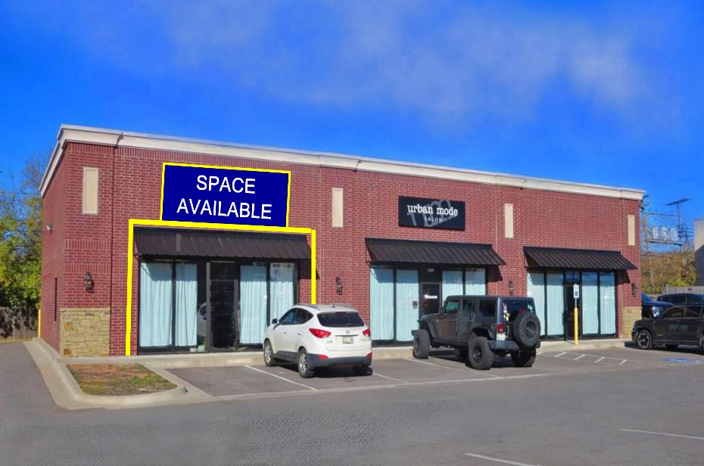
Building #1

RETAIL/OFFICE SPACES
FOR LEASE Oklahoma City, OK 73107

LOCATION: Building #1: 2531 N.W. 23rd Street, Suite #100
Available: 1,200 SF (Building: 3,200 SF)
$1,400/00/Month – Plus Utilities

Building #2: 2519 N.W. 23rd Street, Suite #130
Available: 1,250 SF (Building: 10,440 SF)
$13.00 PSF/YR NNN

HIGHLIGHTS: • Busy, well maintained neighborhood center facing 23rd Street corridor high
Visibility
• Great long term tenant base with Urban Mode Salon, Allstate, CSI,
H&R Block, Chrome Dragon Tattoo, & Little Caesars.
• Located one block from Shepherd Mall Business Center.
• One mile from OCU & popular Uptown District, Plaza District
• Ample parking

TRAFFIC COUNT: 21,414 vehicles per day.

ZONING: C-3, Commercial

TERMS: 3-5 Year

FOR ADDITIONAL INFORMATION CONTACT: Debi New (405)-821-7104
dncommercial22@Gmail.com
The information contained herein has either been provided by the property owner or obtained from sources deemed reliable but not guaranteed. Prospective Buyers/Tenants should carefully verify items of income and expense and all other information contained herein. D&N Commercial Real Estate makes no warranties or representations, expressed or implied as to the accuracy or sufficiency of the information. All reference to square footage provided by County Assessor

