

“NEIGHBORHOOD” RESTAURANT/BAR
627 A East College Avenue, Decatur, GA 30030
2200 sq ft

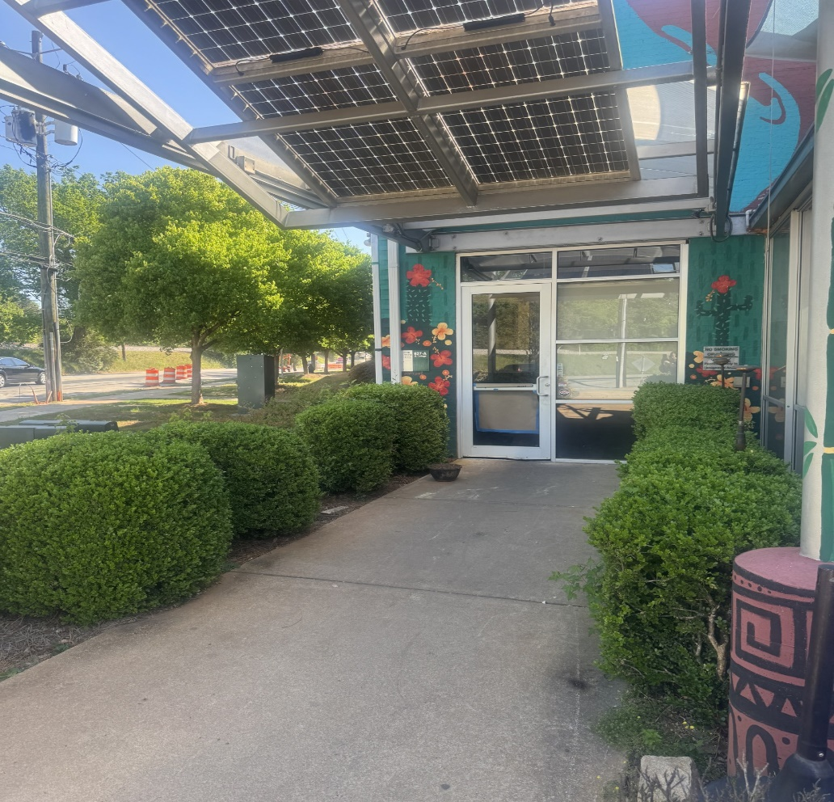

Rental Rate
1800 sf $26.00 psf NNN
400 sf (patio) $14.00psf NNN
Approx. 8.13 psf in p/t including CAM TAX INS, TRASH, Utilities not included

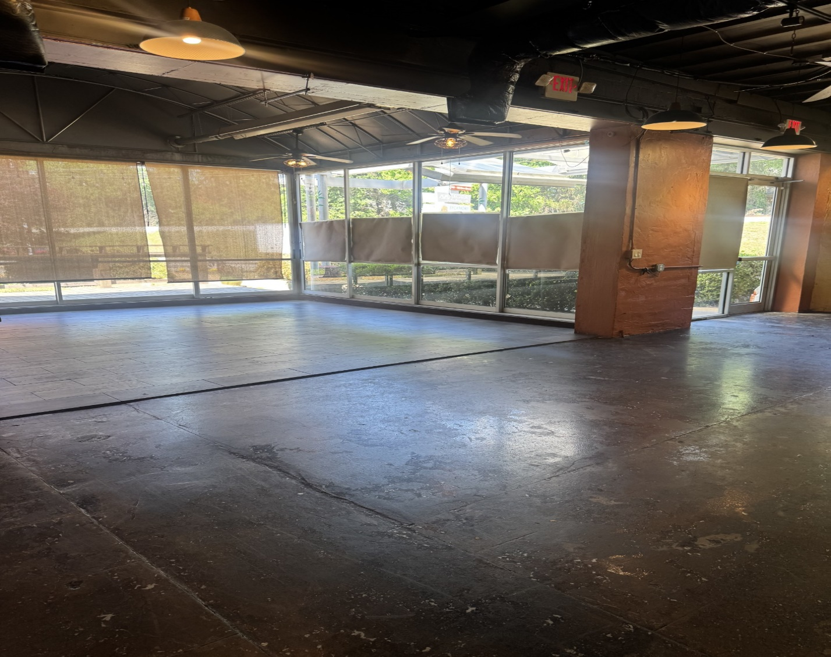

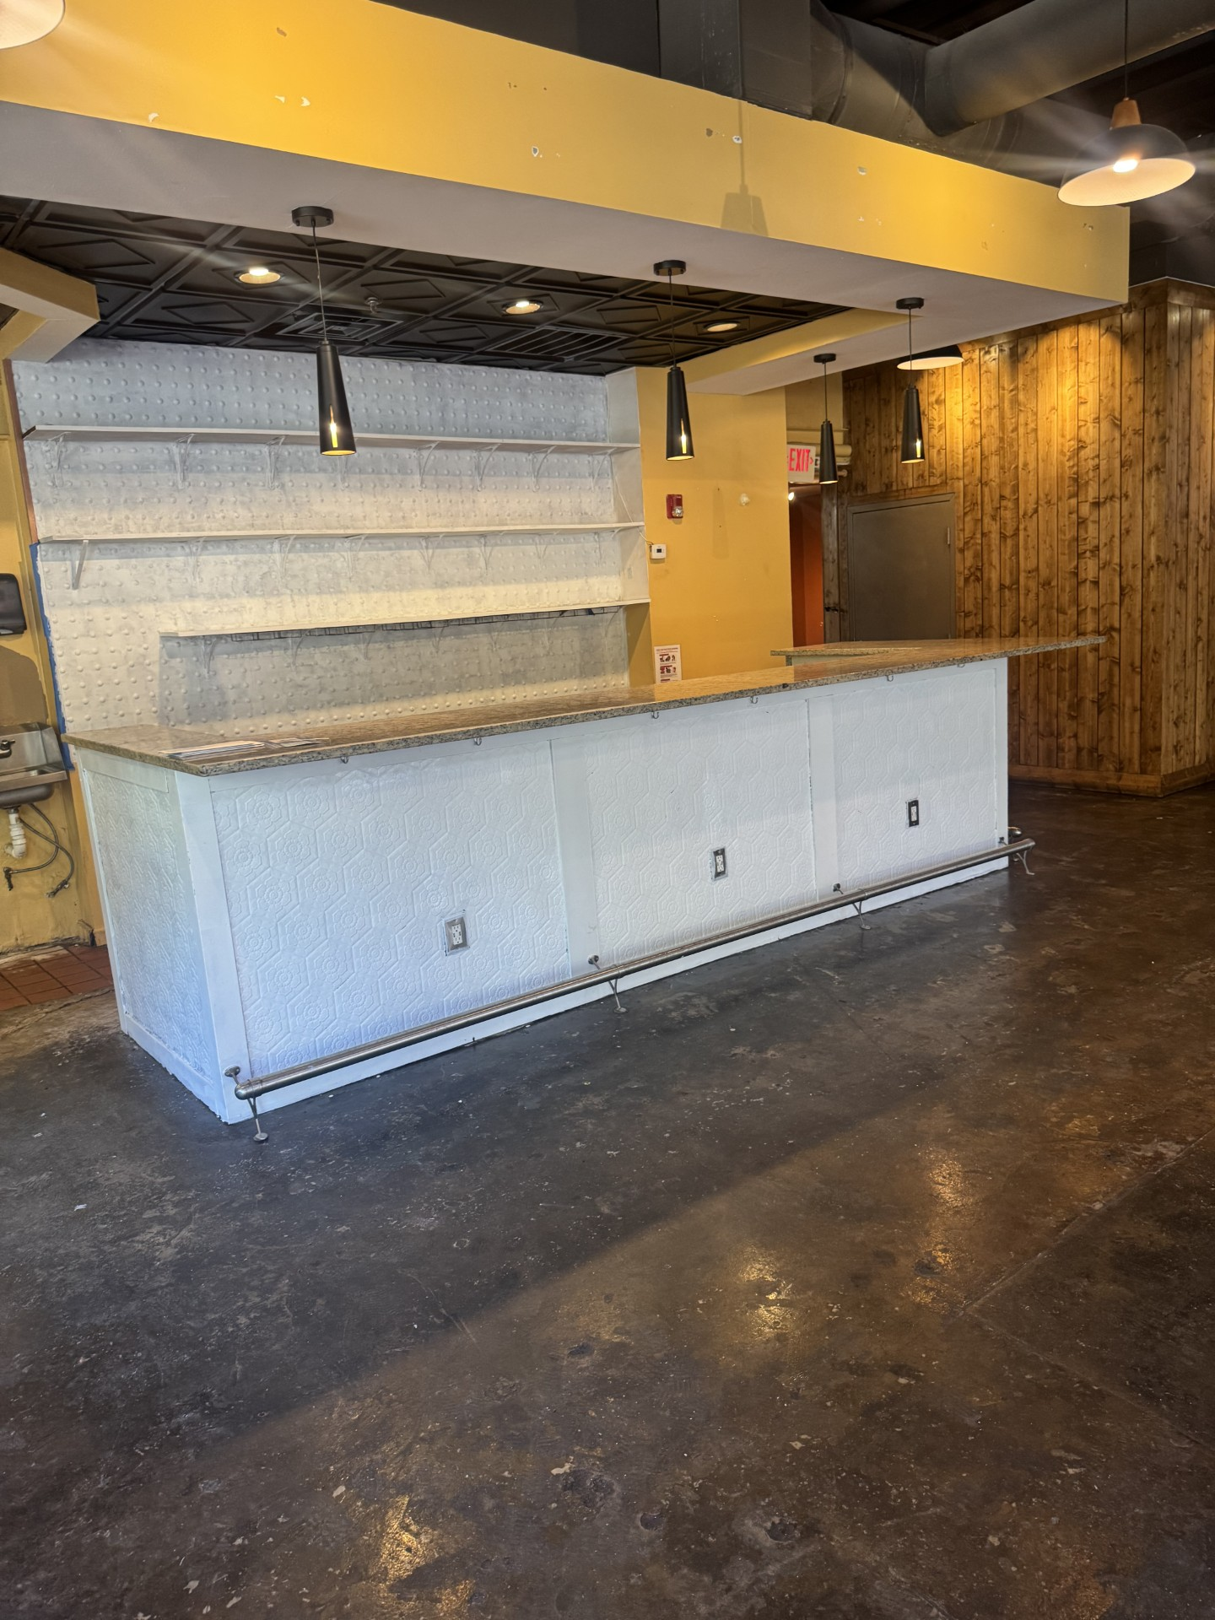
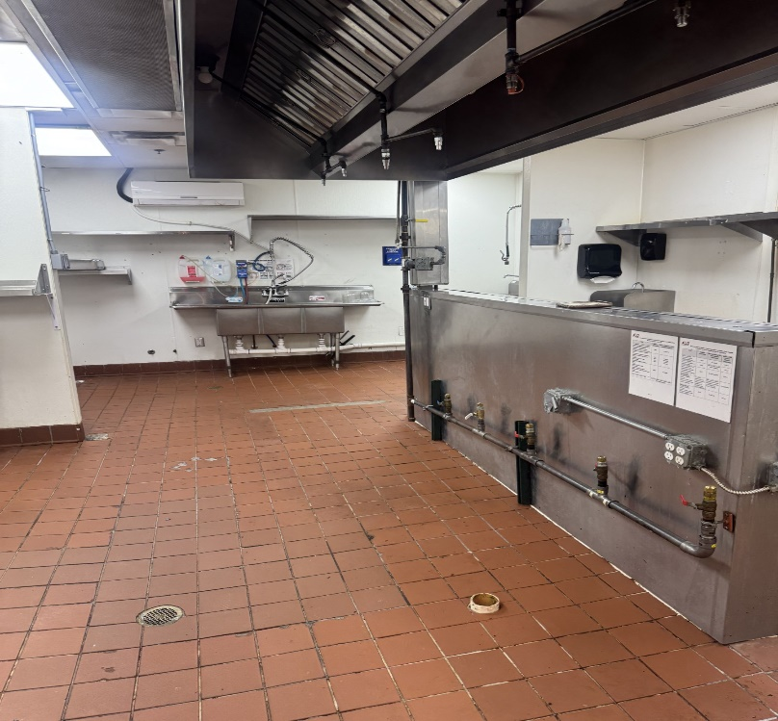
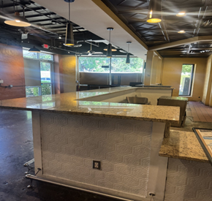

Property Features
- Join the City of Decatur Restaurant Scene with fabulous location and welcoming “vibe”
- Vent hood, 1500 gal grease trap, walk-in refrigerator
- Two Restrooms
- Great outdoor patio seating
- Abundant Parking as well as immediate parking in front of the building
- Over 1000 apartments within walking distance, including 370 Mixed-Use residential apartment building under construction next door
- One Block from Avondale MARTA Train Station
Leasing requirements-
  - Personal guarantee required
  - Personal credit score of 675 or more required
  - First month’s rent and security deposit due at lease signing
  - RENT + CAM + UTIL+ Trash = monthly payment

Broker Commission:
  - Brokers to be paid ½ of first month’s rent with 5% residual.
  - Brokers must make first contact with EDS Leasing office for commission to paid on executed leases by EDS. If EDS shows the tenant the property first, tenant will be responsible for Broker’s commission.

