216 Little Falls Road, Unit #8

Cedar Grove

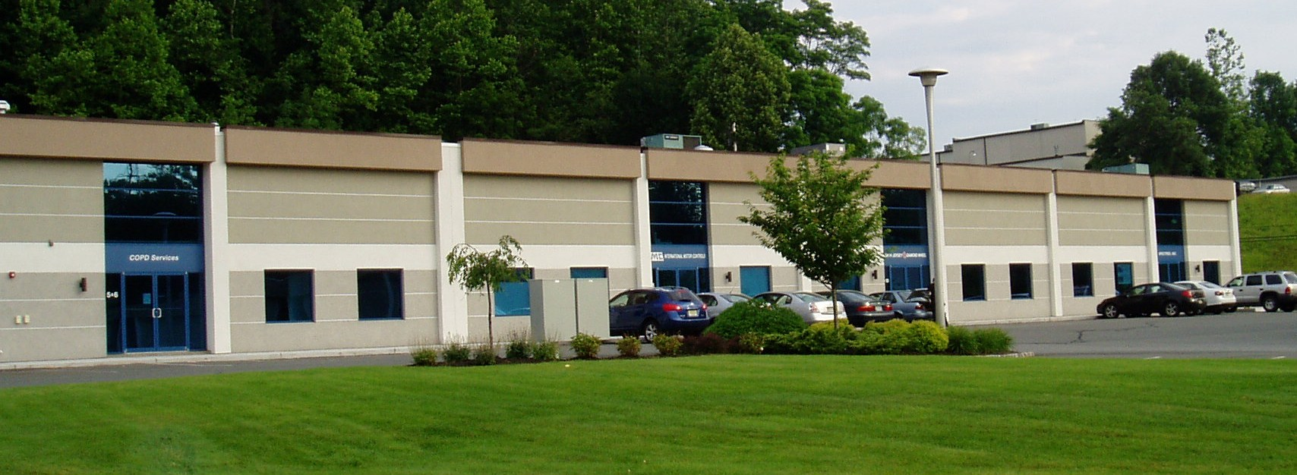

Size: 3,169 Square Feet

Office: 700+ Square Feet

Ceilings: 16’ Height

Loading: 1 Tailgate

Heat: Gas

Rent: $18.00/sq ft Net

Tax & CAM: Approx. $4.75/sq ft

$6,007.90/Month plus utilities

All information is from a source deemed to be reliable, however, No warranty or representation, express or implied, is made to the accuracy of the information contained herein, and same is submitted subject to errors, omission, change of price, rental or other conditions, withdrawal without notice, and to any special conditions imposed by our principals and clients.

