The Conrad Group, Inc. 330 Libbey Industrial Pkwy_{Weymouth, MA}
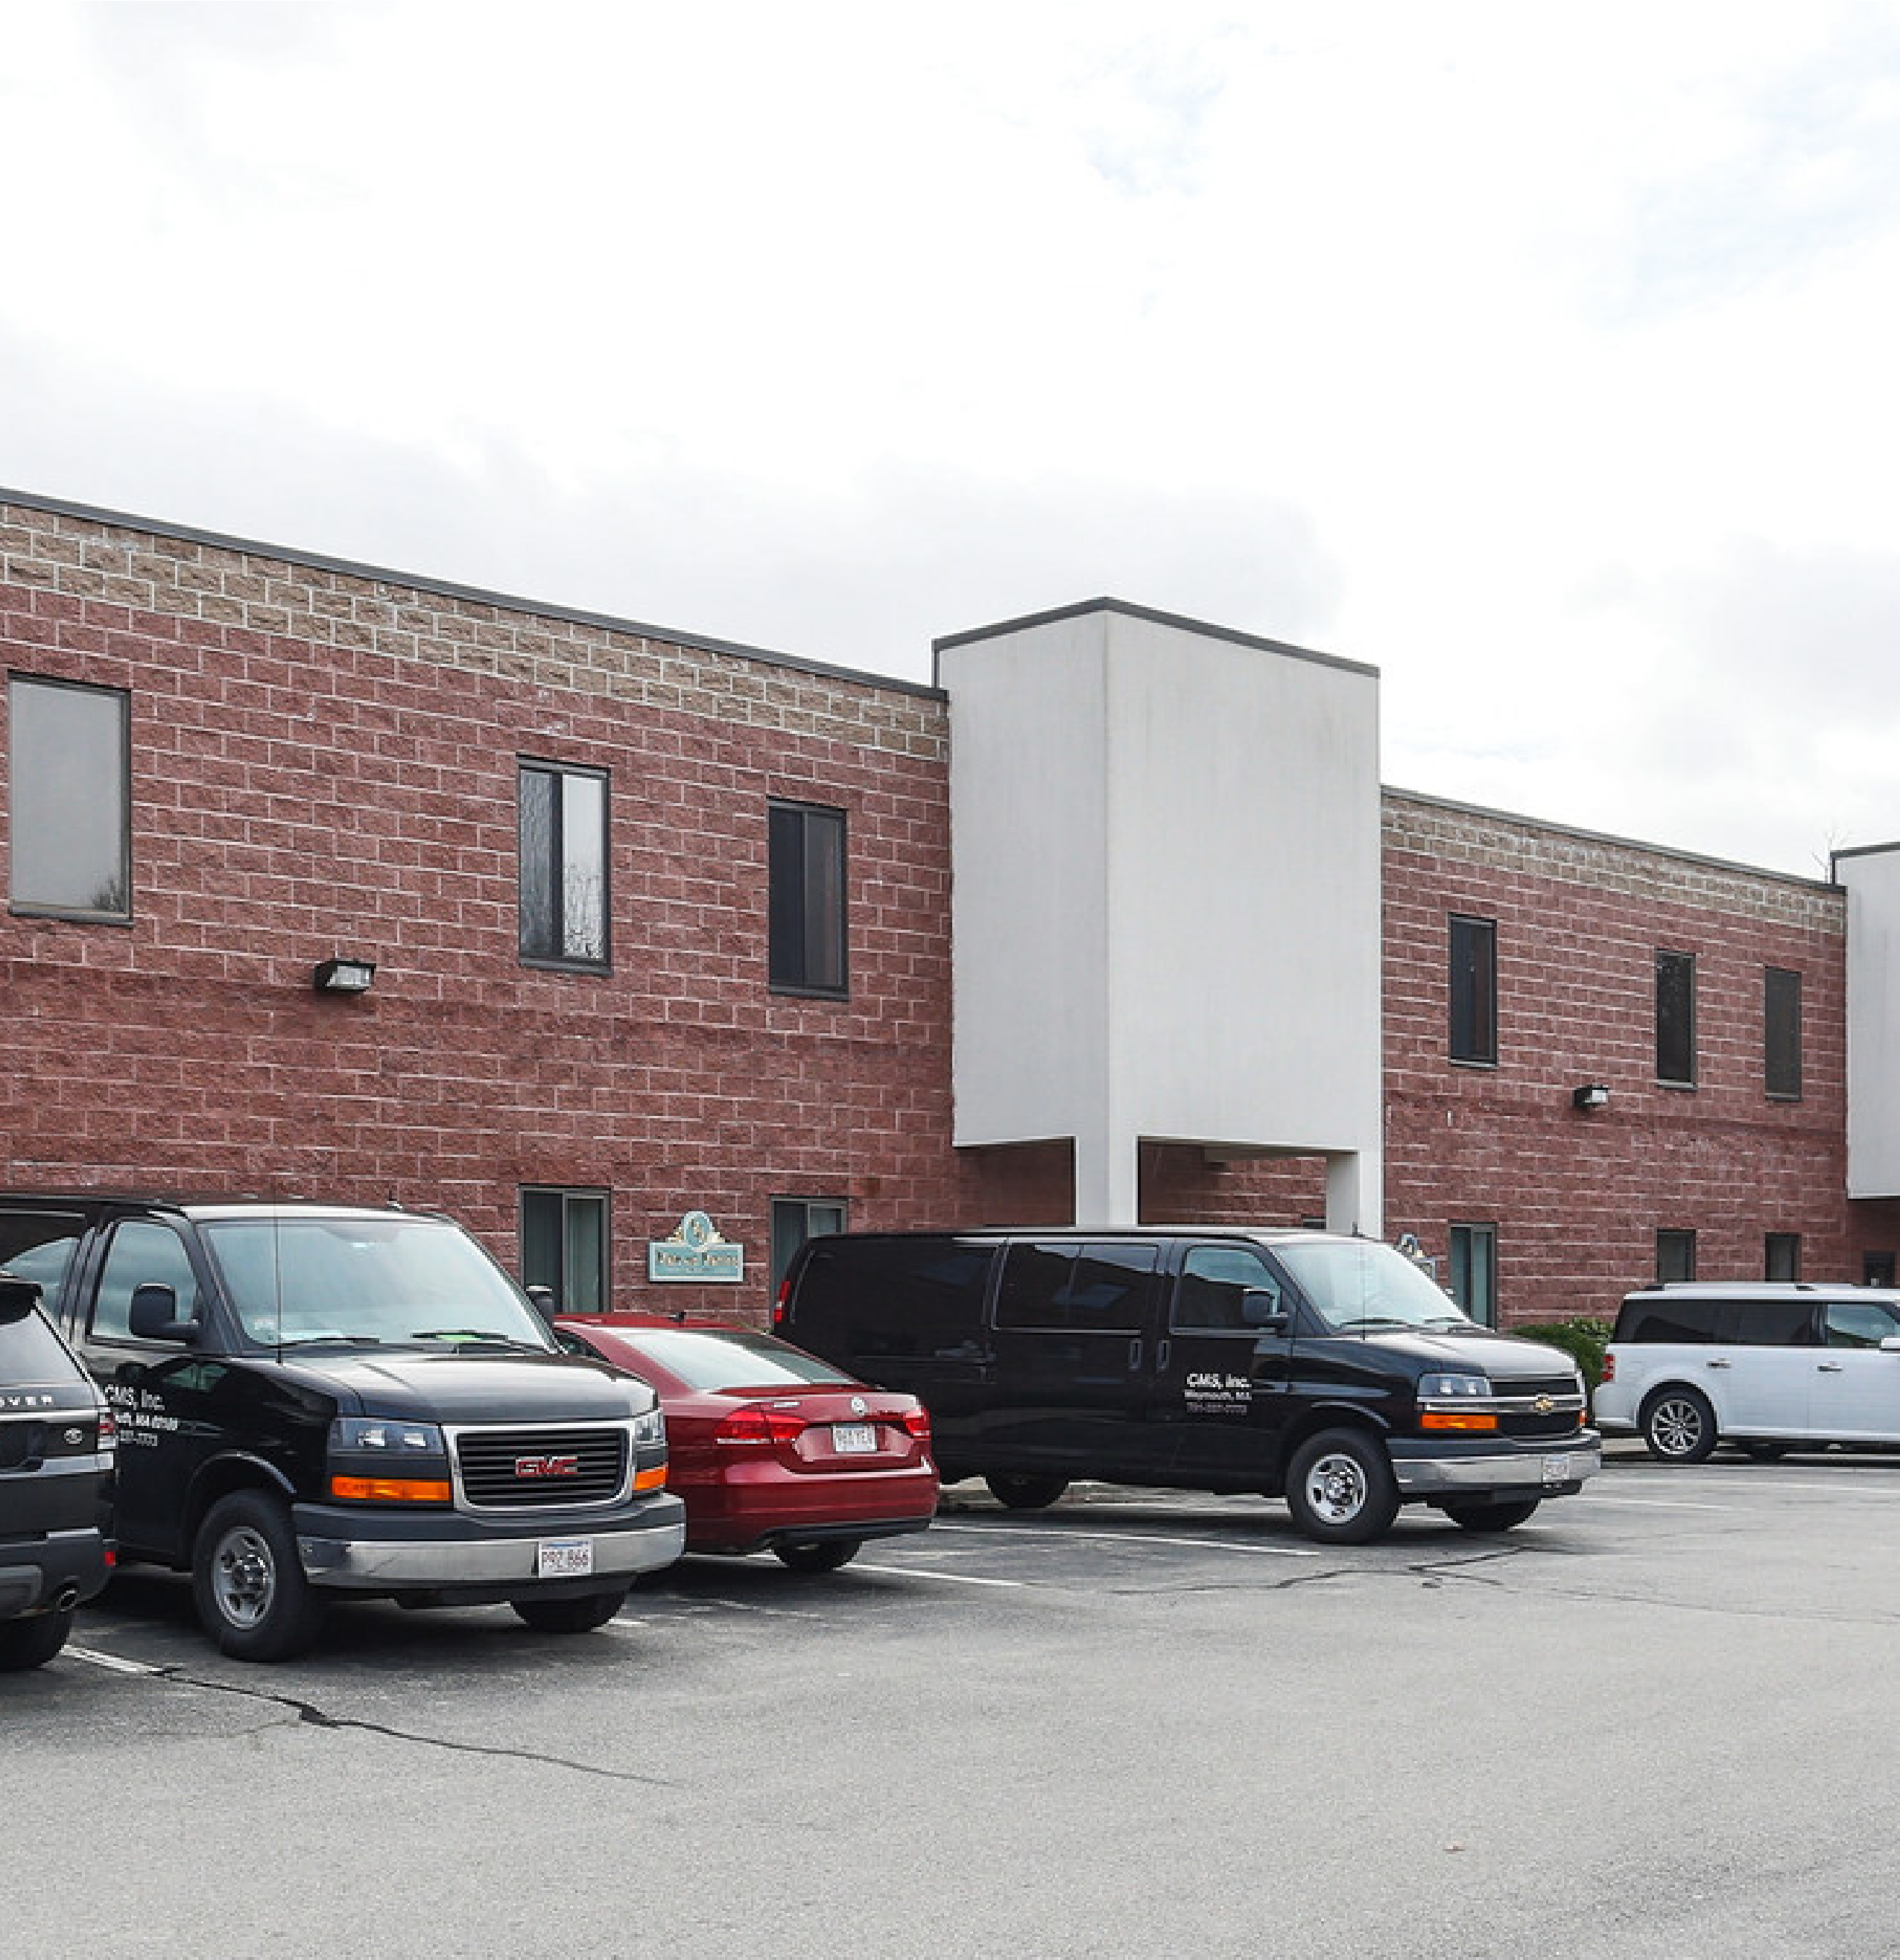
Commercial Real Estate Services
FOR ADDITIONAL INFORMATION:
Disclaimer: All information is from sources deemed
reliable, however no representation is made as to its
accuracy and same is subject to prior sale, rental or
removal from the market without notice.
James McEvoy
(781) 249-9225
jhmcevoy@earthlink.net

FOR LEASE
Loading | 1 Dock Door
Ceiling Height | 20’ Clear
Sprinkler | Wet Pipe
Construction | Steel Frame; Brick & Concrete Block
Column Spacing | 30’ x 50’
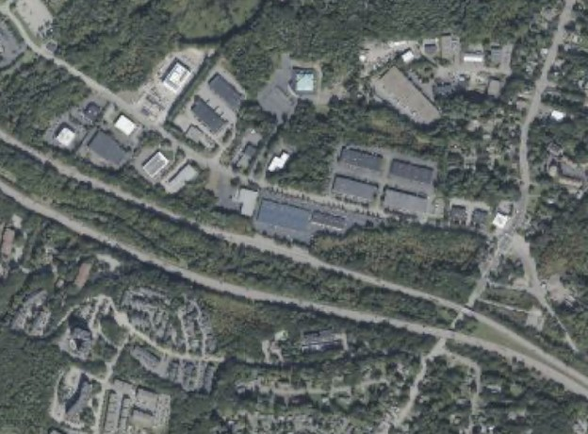

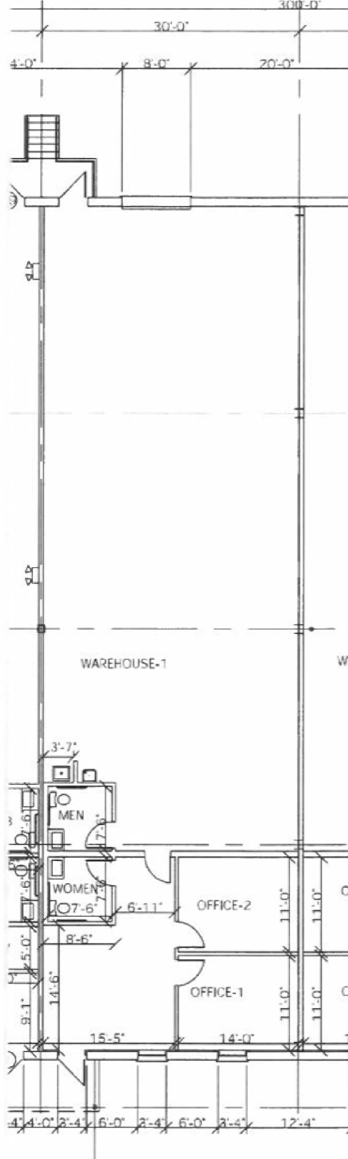
Total SF Available 3,000 + SF
Floor Plan
P.O.P. (Planned Office
Zoning
Park)

