Park House 1-4 Park Terrace, Worcester Park, Surrey KT4 7JZ
Zara – 07868711014 / 02089613211
zara@cygnetproperties.co.uk

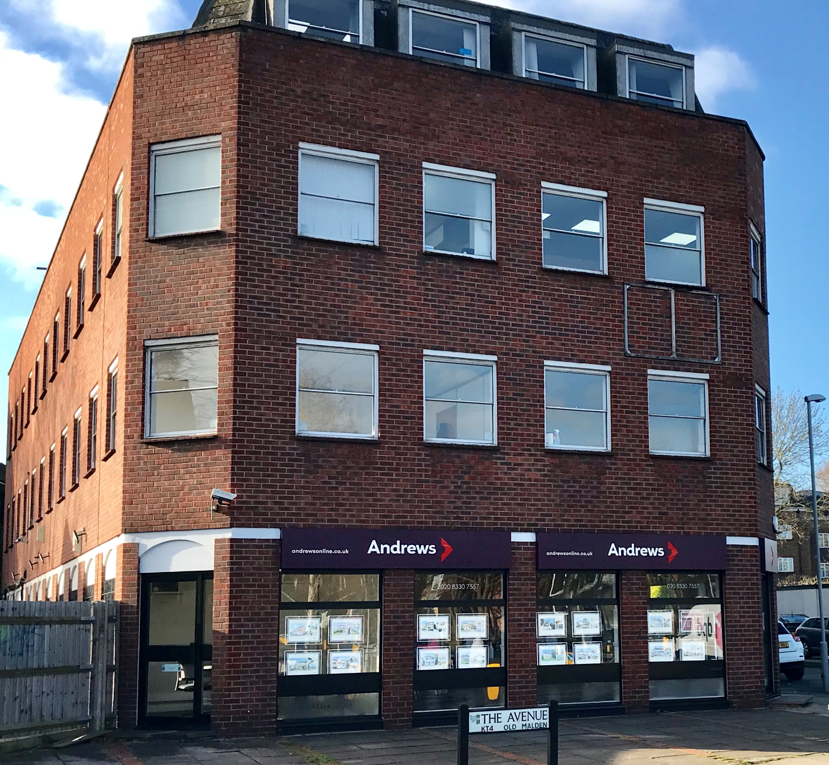

Available Space | Approx size (sq ft) | Desk Recommendation | Price Per Month ex VAT
First fl room 1(suite3) | 150 | 3 | £500.00
First floor Room 7(suite 3) | 100 | 2 | £300.00
Second floor suite 1 (suite 5) | 150 | 3
First Floor room 6 (suite 4) | 200 | 4 | £550.00
Second Floor suite 4 (suite 5)A | 100 | 2 | £300.00
Third Floor Room 1 (suite 7) | 195 | 4 | £540.00
Third Floor (suite 3) 8c | 276 | 5 | £759.00

Description: This property has a local feel accommodating a range of small and larger businesses and charities from the area. There is a lift serving the building as well as a car park to the rear. The floors are partitioned to provide a combination of open-plan accommodation as well as a number of cellular offices and communal kitchens.

Transport: The building is prominently located on the junction of The Avenue with the A2043 Central Avenue / Malden Road immediately opposite Worcester Park mainline station.

What does the above price include?
- Rent
- Electricity
- Service & Maintenance Charges
- Communal cleaning

Additional Costs
- Business rates are not included although many offices should qualify for 100% rates relief but please rely on your own enquiries

