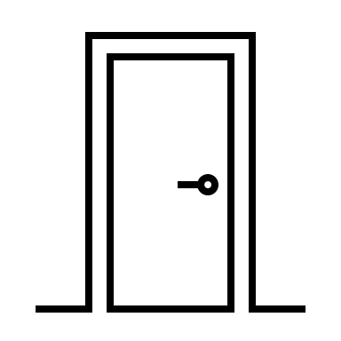

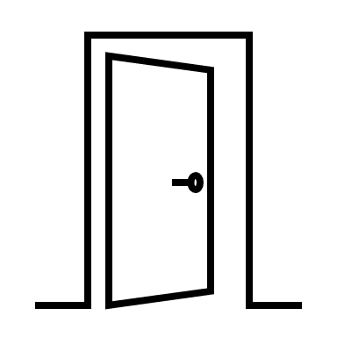

Base Rent: $1,800.00 ($2.40/ sf)
NNN: ($0.00/ sf)
Total $1,800.00 ($2.40/ sf)

Cal-Tex Mgmt. LLC
Jose Perez • (626)660-7541
Cren-Star • Suite #107 • 750 SF
31’
24’

