
7686 W. 88th Ave * Arvada, CO 80005
✉ sambrown@brown-associates.com
📞303-938-9946

MISSION COMMONS * Westminster, CO 80005
Brew Pub or Brewery Approved Lease Space
4410 square foot LEASE SPACE, Pre-approved for Brewery or Brew Pub, Existing Bar and Bathrooms, High Ceilings; opportunity for patio and maybe roof-top patio.
Mission Commons is a shopping Center consisting of approximately 130,000sf of building space and 14.68 acres of land with approximately 839 parking spaces.
The Center is located on the west side of Wadsworth Parkway between 88th and 90th. These intersections are very busy as Wadsworth has a traffic count of approximately 60,000 cars a day.
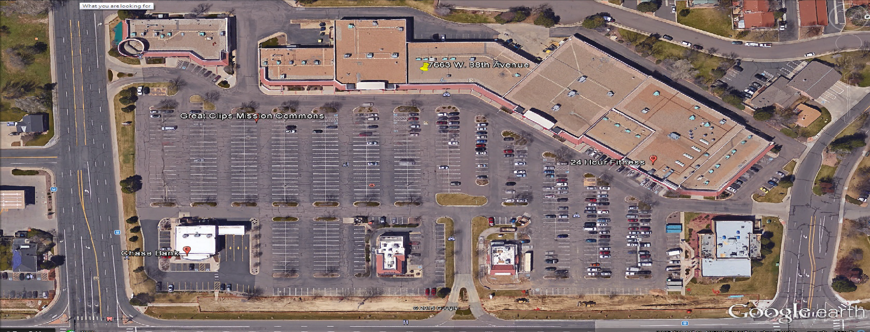

THIRTEEN NATIONAL AND REGIONAL ANCHOR TENANTS INCLUDE:
Planet Fitness
Big Five Sporting Goods
America's Best Contacts & Eyeglasses
Dunkin Donuts
Chase Bank
Burger King
Marco’s Pizza
CD Wings

Sam Brown - direct line 303-284-9686

