

145 New Street Suite BC
Decatur, Ga 30030
1000 sq. ft.

Unit Details
Approx. 1000 sq ft warehouse space
Air Conditioned
1 bathroom
Drive-in dock door
Conveniently located 1 mile from Downtown Decatur/Decatur Square
One block from Avondale Marta Train Station
$1500 rent/mo/NNN Cam, Tax, Insurance, & HVAC approx $521 Electric and Gas responsibility of TT; Water included in Cam
Total Monthly rental Amount $2021.00
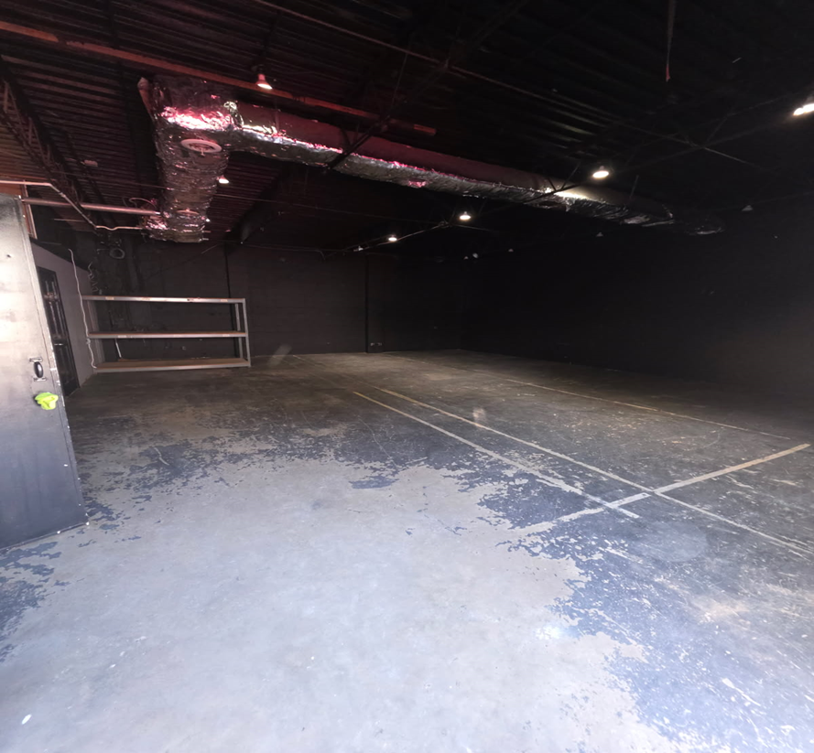

Leasing requirements:
- Personal guarantee required
- Personal credit score of 675 or more required
- First month’s rent and security deposit due at lease signing
- RENT + CAM + UTIL+ TI + HVAC replacement fee= monthly payment

Broker Commission:
*Brokers to be paid ½ of first month’s rent with 5% residual.
**Brokers must make first contact with EDS Leasing office for commission to paid on executed leases by EDS. If EDS shows the tenant the property first, tenant will be responsible for Broker’s Commission.

