

OFFICE AVAILABLE

6666 HARWIN DRIVE, Suite 655,
Houston, Texas 77036

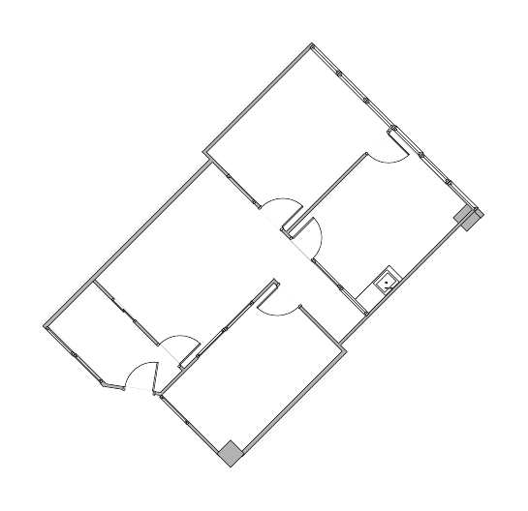

713.337.1130
marla@curocom.com

