FOR SALE / LEASE
INDUSTRIAL CONDO END CAP UNIT
4,328 SQ. FT.
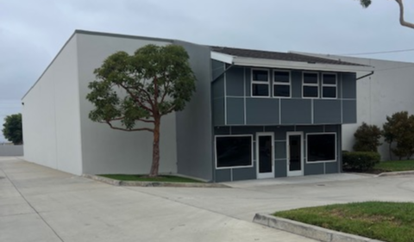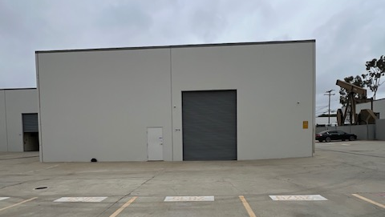
2829 GUNDRY AVE., SIGNAL HILL, CA 90755

IDEAL FOR “CAR GUY” OR HEAVY STORAGE

- Heavy Power 600 Amps + (Verify)
- 1,080 Sq. Ft. Steel Mezzanine with Steel Staircase and Hydraulic Lift
- Custom Black Stone Lobby and Downstairs Bathroom
- Warehouse Restroom and Kitchen
- Upstairs Office with Coffee Bar
- Warehouse Pedestrian & Roll up Door
- Available in 30 or Sixty Days

FOR SALE: 3,328 Footprint & One Second Floor Office x $375.00 = $1,248,000.00
1,080 Steel Mezzanine x $100.00 = $ 108,000.00

$1,356,000.00

FOR LEASE: 3,328 + 1,080 = 4,408 x $2.00 = $8,816.00 (Gross NO CAM)


Sojka-Nikkel Commercial Realty Group, Inc. Joseph J. Sojka, Broker
(310) 534-8000

