
To Let
Self-Contained Mezzanine Floor E-Class Office Premises Only
Ground Floor Storage area Not included
Four Dedicated Parking Spaces
Excellent Semi Industrial Location – Easy Access to Reading Town Centre
Circa 1980sq.ft / 184M²
Available From 1st October 2025

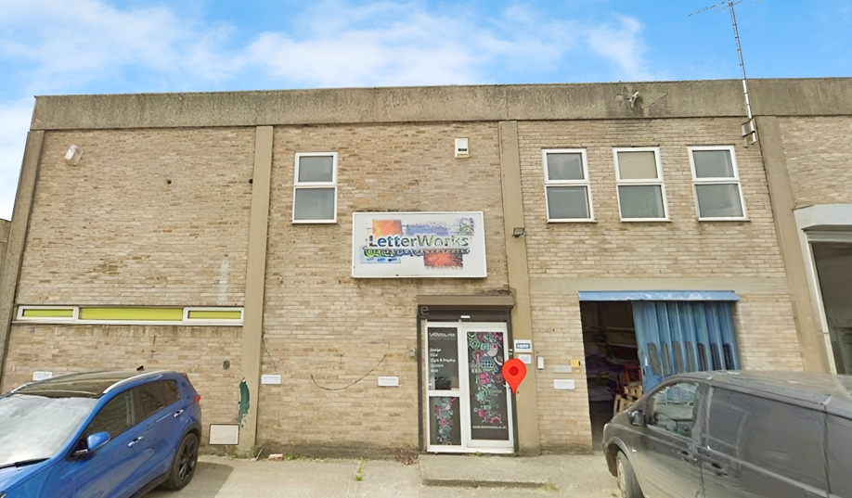 | 65 Loverock Rd,  Reading, Berks,  RG30 1DZ

📍 Location
The premises are situated on Loverock Road, a well-established commercial and semi-industrial area within easy reach of Reading town centre. The location benefits from excellent access to the A33 and A4, providing convenient connections to Junctions 11 and 12 of the M4 motorway, and onward links to the national motorway network. Reading mainline railway station is approximately 1.5 miles to the east, offering fast and frequent services to London Paddington and beyond.

🏢 Premises Description

The commercial premises is accessed via its own self-contained entrance, with stairs leading up to the mezzanine level. To the left, there are male and female WC facilities along with a fully fitted kitchenette. To the right, the accommodation opens into a spacious open-plan office area, incorporating a separate glass-partitioned office.

The space is fully cabled for telephone and data networks and is available either semi-furnished with desks and office furniture, or provided vacant, according to occupier requirements.
Please note that the ground floor storage/workshop area will be retained by the landlord and is not included in the letting.

The premises were most recently occupied by Letterworks – commercial printers, who are relocating.

Ref: DR.1653cont’d .....

DR.1653 continued A H Lansley Ltd Tel: 0118 959 0271

📝 Lease Terms

The property is available on a new Full Repairing and Insuring (FRI) lease for a term of 3-5 years. The lease will commence at a rent of £18,000 per annum (equivalent to £1,500 per month), with upward-only rent reviews every three years. A surety rent deposit equivalent to three to six months’ rent will be required, subject to negotiation. There is no service charge payable, and preference will be given to experienced operators. Tenant responsible for electricity and Gas usage and portion of the annual building insurance.

EPC - D86– Valid until 22nd December 2034

Rateable Value – £29,750 – By agreement, the tenant will be liable for 50% of the rates payable, with the landlord covering the remaining 50%.nant liable for half of rate bill – the landlord to cover the other half

👥 Ideal Tenants / Uses
The premises are ideally suited for businesses requiring modern, flexible office accommodation within a semi-industrial setting. Potential occupiers may include:
- Professional service providers such as architects, designers, marketing agencies, or IT firms.
- Light industrial / trade-related office users needing administrative and operational space with good access to the M4 corridor.
- Training providers or consultancy firms seeking a self-contained office environment with parking.
- SME headquarters or satellite offices for companies looking for well-connected premises close to Reading town centre.
Please note: the property is office-only accommodation (E-Class) and does not include ground floor storage or workshop space.
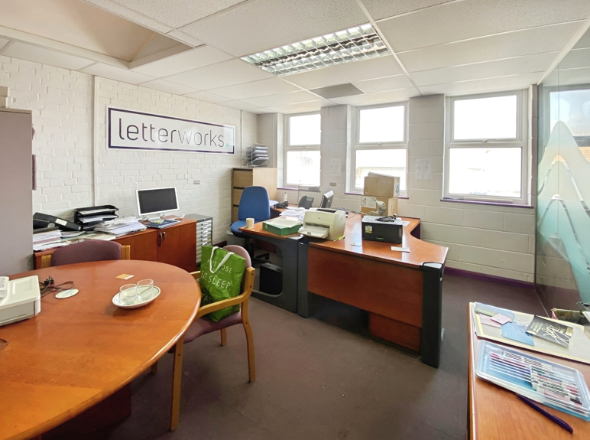
All uses are subject to planning. Interested parties should make their own enquiries with Reading Borough Council to confirm suitability.

Viewing - Strictly by prior arrangement with Messrs A H Lansley - 0118 959 0271.

REF:- DR.1653

NOTE: Particulars are as supplied by Vendor and verified as far as possible but we cannot accept responsibility for any inaccuracy. *Any dimensions quoted are for guidance only. the acceptance of this order constituting a contract to this effect. 170825

