EAST MAIN CENTER
Leasing Opportunities
Russellville, Arkansas

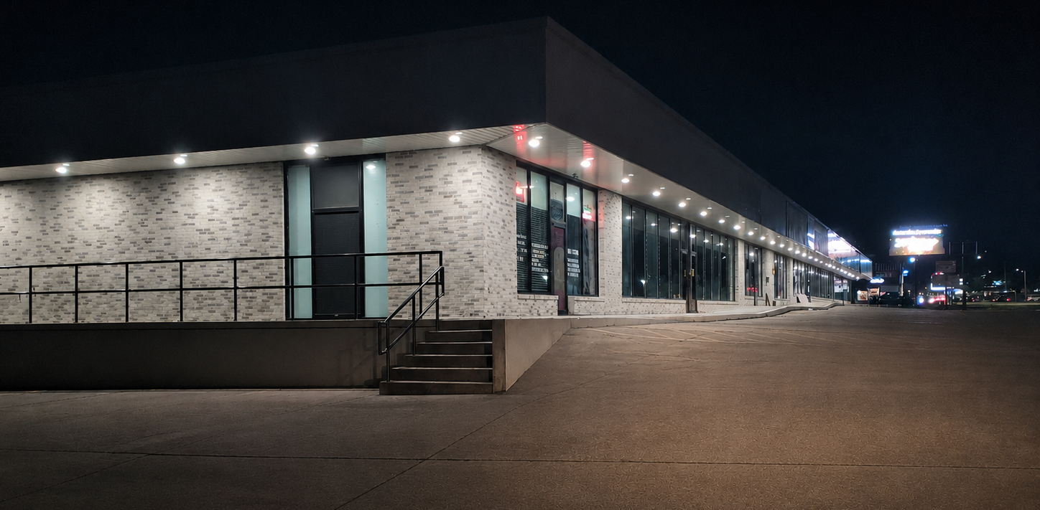

Welcome to East Main Center

Property Overview
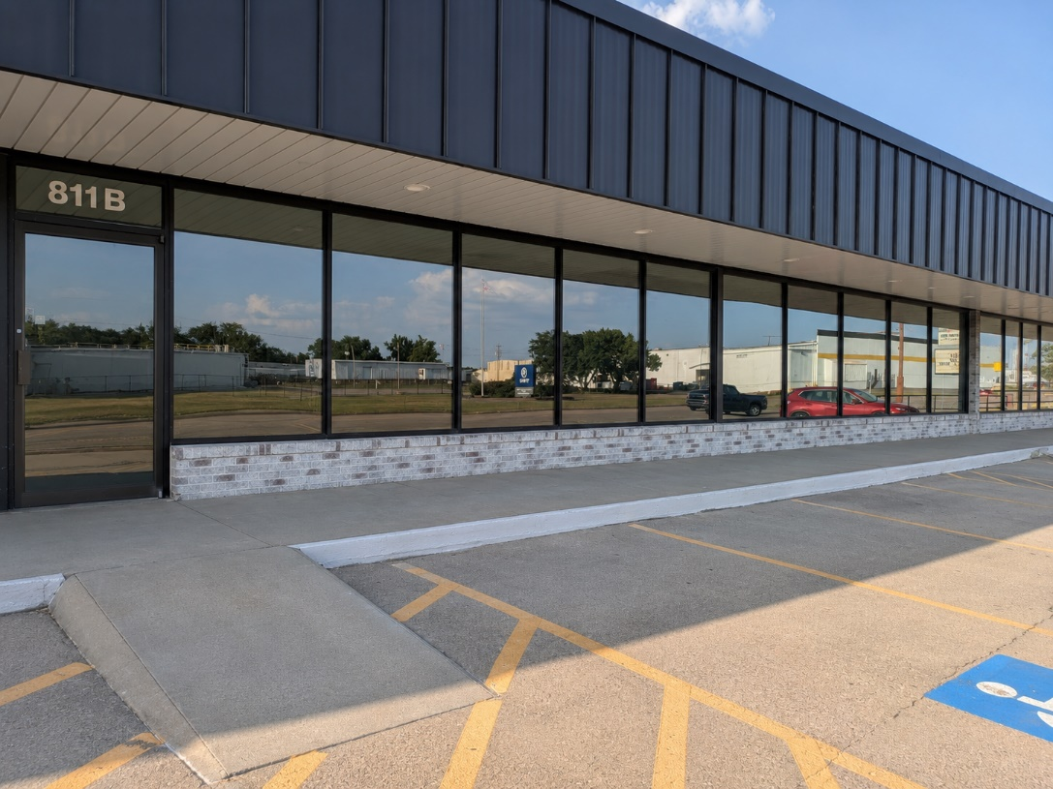
East Main Center is a thoughtfully renovated neighborhood retail center located along one of Russellville's established commercial corridors. Conveniently situated on East Main Street, the center offers flexible commercial space designed to meet the needs of retailers, professional offices, and service businesses.
Whether you're opening your first location or expanding an existing business, East Main Center provides a clean, professionally maintained environment where your business can make a strong first impression.

Property At a Glance
Available Suites | 803 3,000 square feet
 | 811B 3,000 square feet
Lease Rate | $1750 per month
Lease Type | Gross Lease
CAM Charges | None
Parking | Ample On-Site Parking
Zoning | C-2
Utilities | All Electric

A Convenient Location for Your Business
East Main Center is conveniently located along East Main Street, one of Russellville's primary commercial corridors. The property offers easy customer access, excellent visibility, and is surrounded by established retailers, restaurants, professional services, and residential neighborhoods.
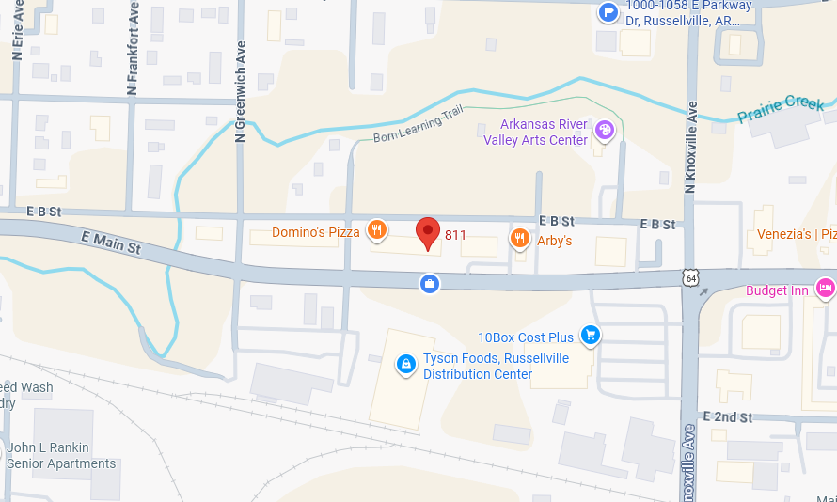
Traffic Counts
14,000 VPD
Nearby Destinations
- Russellville High School
- Hughes Community Center
- Tyson Foods
- Arkansas Tech University (distance)
- Downtown Russellville
A Space Ready for Your Vision
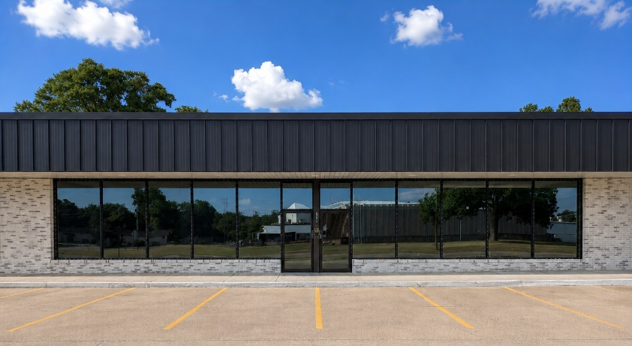
Suites 803 and 811B each offer approximately 3,000 square feet of flexible commercial space ready to be tailored to your business. Whether you're creating a retail showroom, professional office, studio, or service business, the open floor plan allows you to design a space that reflects your brand and supports your day-to-day operations.
Each suite includes storefront windows providing natural light, a private restroom, suspended acoustic ceilings, and convenient customer parking immediately outside the entrance.
The open layout provides maximum flexibility for future tenant improvements, allowing you to create a space that works for your business today and grows with you tomorrow.
Stewardship Matters
Places are where life happens.
Omabonneus Investments acquires, improves, and responsibly stewards income-producing real estate that creates lasting value for tenants, investors, partners, and the communities we serve.
We believe thoughtful stewardship creates places where businesses can grow, families can flourish, and communities thrive. Our objective is to cultivate enduring relationships that strengthen our portfolio, support local businesses, and contribute to vibrant communities.

Leasing Information
For leasing information please contact:
Omabonneus Investments, LLC
Phone: 479-567-9910
Email: Omabonneus@gmail.com

We receive with gratitude.
We improve with purpose.
We pass on with integrity.

Welcome to Omabonneus.

