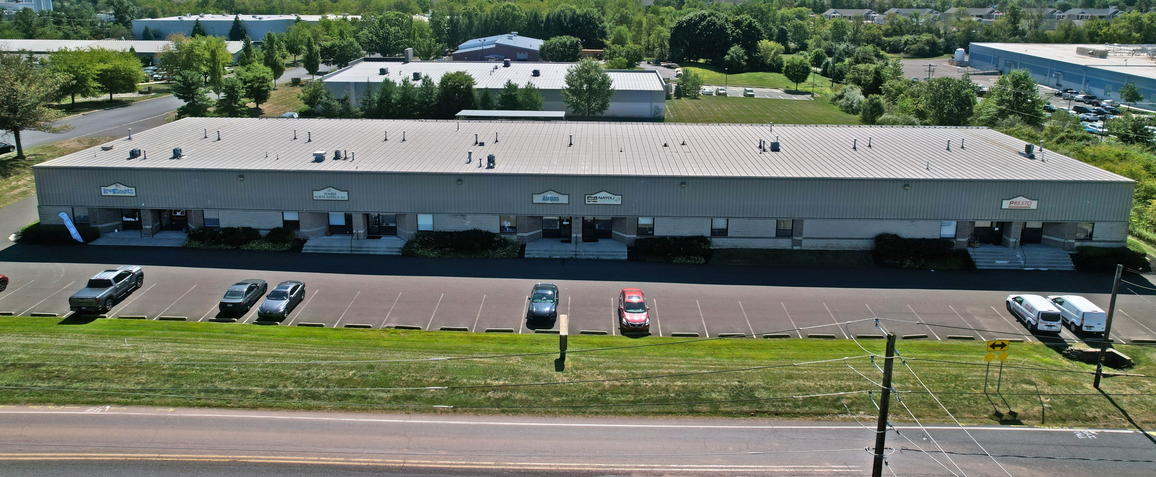

100 EMLEN WAY – UNIT 118
EMLEN WAY BUSINESS CENTER
TELFORD BOROUGH

BUCKS COUNTY, PA

DESCRIPTION: Modern, multi-tenant industrial and office building

TOTAL BUILDING SIZE: 24,000 sq. ft.

AVAILABLE AREA: Unit 118 - Total Area - 2,400 sq. ft.

SIZE OF AVAILABLE AREA: 30' x 80'

NUMBER OF FLOORS: One

TOTAL LAND AREA: Approximately 2.340 acres

FLOORS: Reinforced concrete

EXTERIOR WALLS: Combination split, and rib-faced block and metal insulated panels

COLUMNS: Steel 30' x 40'

ROOF: Metal standing seam roof with interior vinyl face blanket 6" insulation with an R-25 rating.

CEILING HEIGHT: 16' average ceiling height under bar joist in loading area.

LOADING: (1) 8' x 8' drive-in door

LIGHTING: Fluorescent

HVAC: Front Area - Fully air conditioned and heated
Loading Area - Ceiling mounted gas fire heater

SEWER SERVICE: Supplied by Telford Borough Authority

WATER SERVICE: Supplied by Telford Borough Authority

GAS SERVICE: Supplied by PECO Energy Co.
Each unit is metered separately for gas service.

ELECTRIC SERVICE: Supplied by PPL
Each unit is metered separately for electric service.

PARKING: Macadam surface accommodating approximately 40 cars

ZONING: Industrial

