NOW LEASING 2,067 SF

Ideal for Sandwich, Subs, Salad Shop- Outdoor Patio included

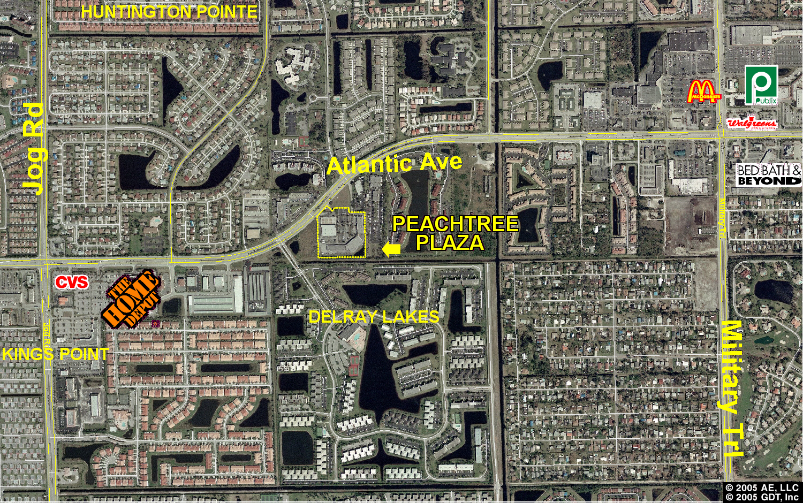
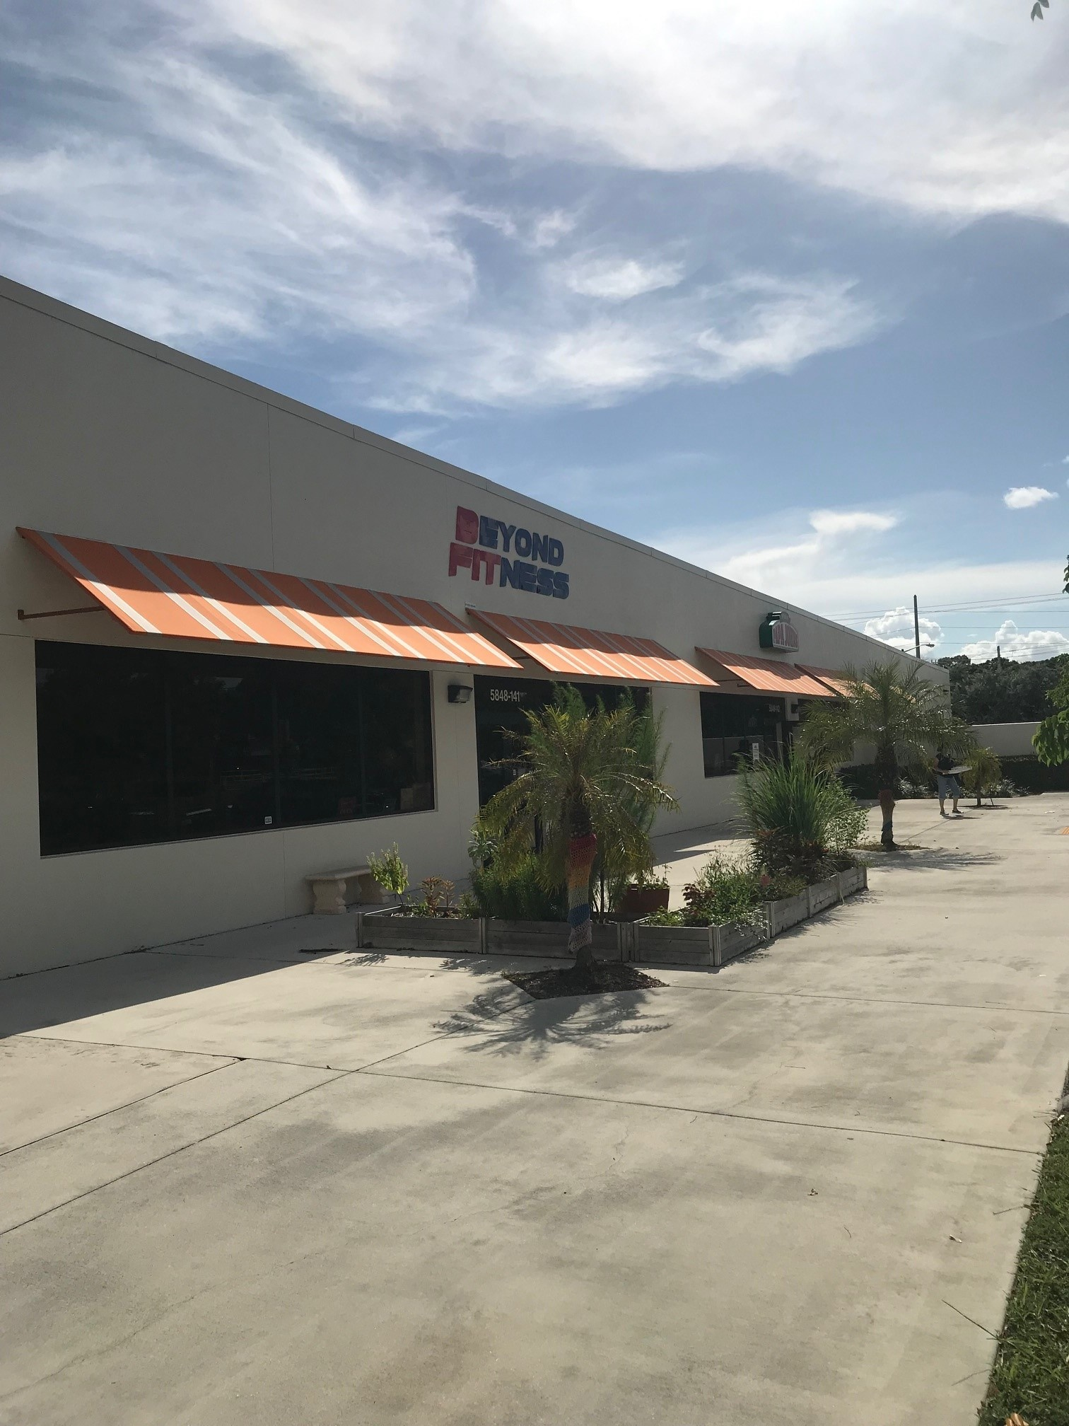

~ PEACHTREE PLAZA ~

5850 West Atlantic Avenue, Delray Beach, Florida
- Located on Atlantic Avenue midway between Military Trail & Jog Roads
- Anchored by Dedicated Senior Medical Center, Galaxy Furniture
- Stable center with rare vacancy. Established neighborhood both residential and commercial. Best location in center with large (2,000 SF +/-) patio (free).
- Five-mile radius: population = 207,054, Ave. household income = $58,614
- Traffic count over 45,000 ADT on Atlantic Avenue
- $31.00 per sq. ft., NNN. CAM is $7.55 per sq. ft.

For leasing information contact:

Harry Zuker, Broker/Owner

ComNet Realty, Inc.

Phone (561) 999-0006 x102
hzuker @ comnetrealty.com
The above information is subject to errors, omissions or withdrawals at anytime without notice
