for Lease

Office/Warehouse space
Location: Intersecting Roads of  Tracy Road/Hawthorne Bloom Drive  New Whiteland, IN 46184 | - A rare find!  - New office/warehouse  - For Lease
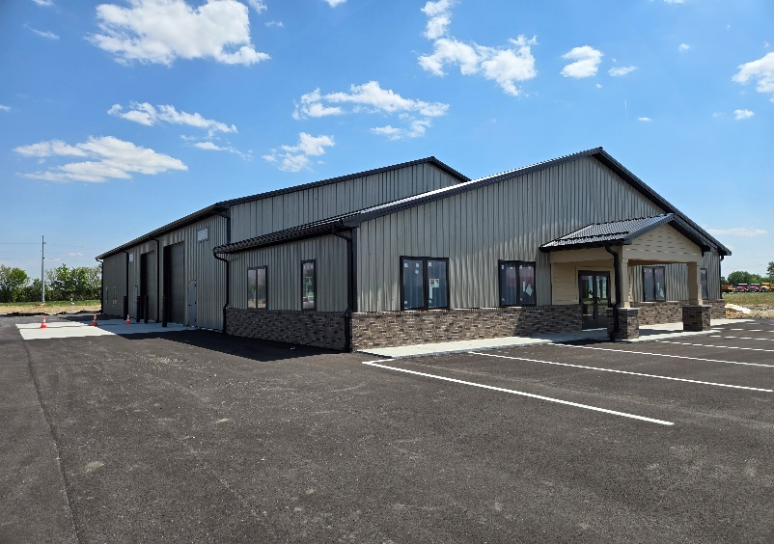  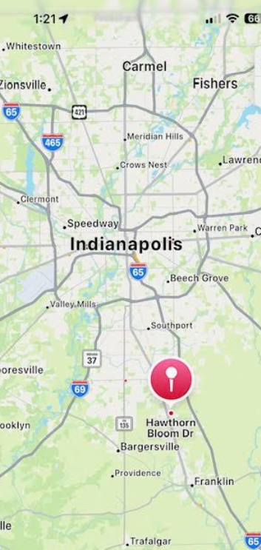 | Ideal for contractor office/storage, business storage, equipment repair, distribution center, light manufacturing, etc.  Customize the interior space to meet your needs:  - Min of 4250 sf  - Max of 8500 sf  Features include:  - 16 ft clear ceiling height  - (3) 12’ x 14’ overhead doors  - Separate entrances  - Interior buildout to suit  - Outside storage space available  - Easy in/out with plenty of parking  - Long-term lease opportunity  Minutes from I-65, I-465, I-69, and U.S. Hwy 31  More parcels available to Build-to-suit  Contact:  City Farms LLC  Tony Biasi  317-224-7949  Tony@scenicwork.com

