Retail Space Available For Lease
TDK Realty LLC
470 Ridgedale Avenue
East Hanover, NJ 07936

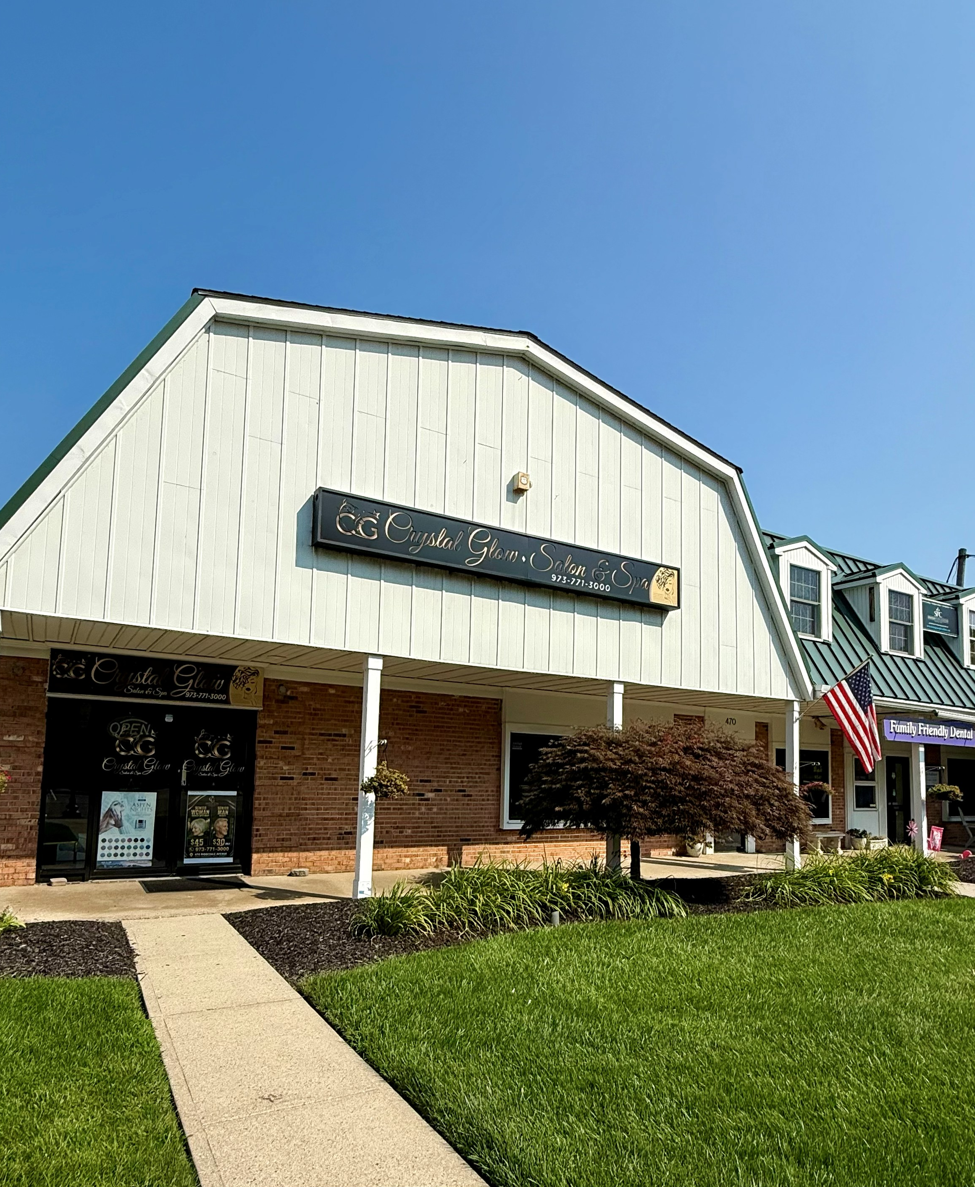
2nd Floor Unit

- 2nd Floor Unit
- Available Immediately
- Unit is separated into 3 separate spaces.
- Newly renovated bathrooms.
- Prime location on Ridgedale Ave directly across from the Middle School.
- Join Tenants:
Family Friendly Dental
Crystal Glo Salon
Strategy, People & Culture
State Farm Insurance
Paul Spiessbach CPA

For More Information Contact
Dr Lina Koffman
(973) 884-1046 / Familyfriendlydental@gmail.com

