Prime Pediatric Dental Office Opportunity in Aloha Medical Dental Square
Prime Location, Dental Community, Tenant Support
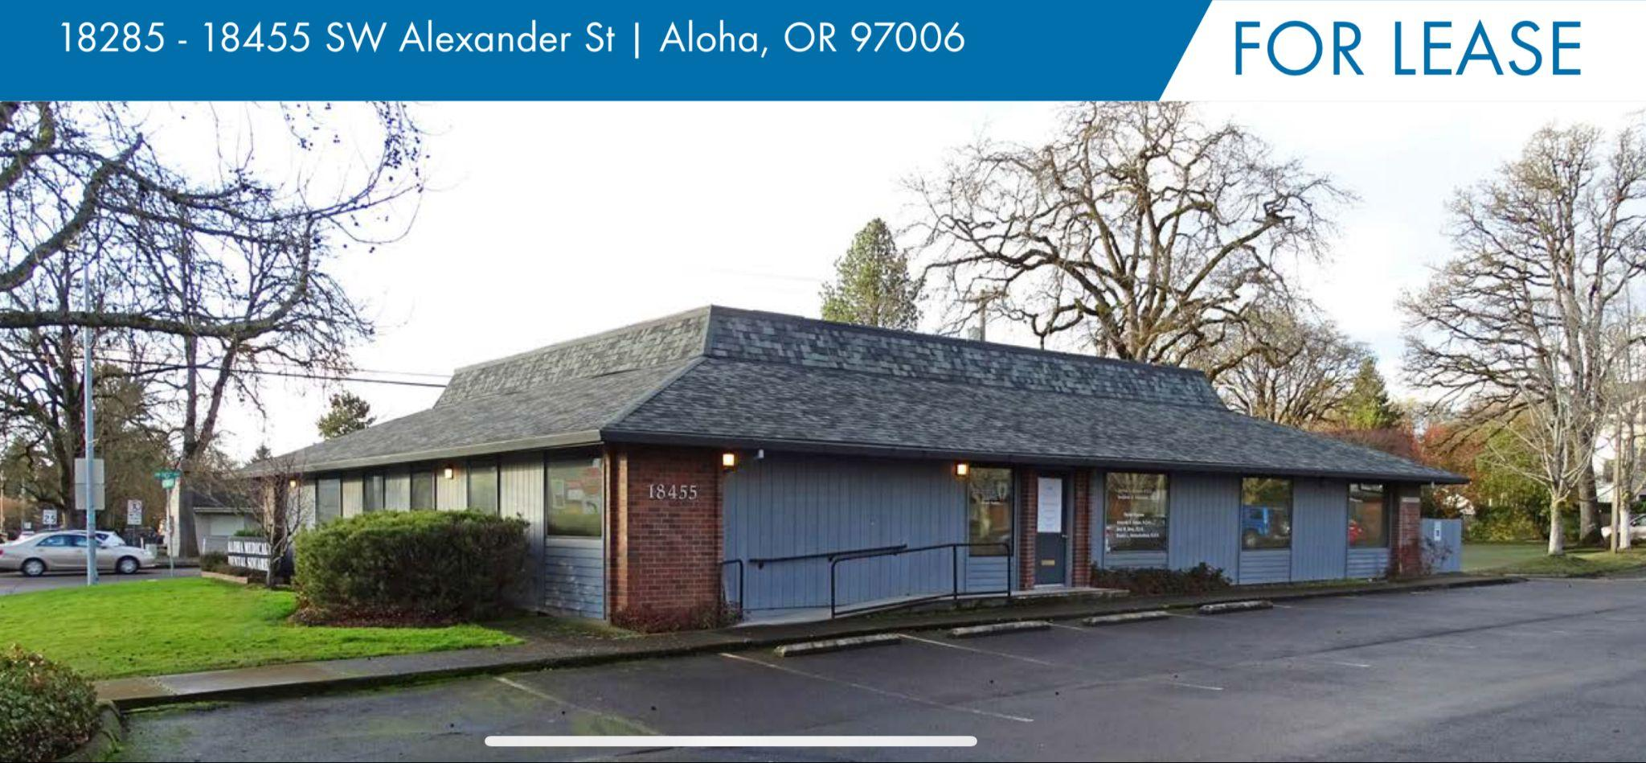
2,327 SF Suite Available – Ideal for Pediatric Dentistry!
18285 - 18455 SW Alexander St | Aloha, OR 97006
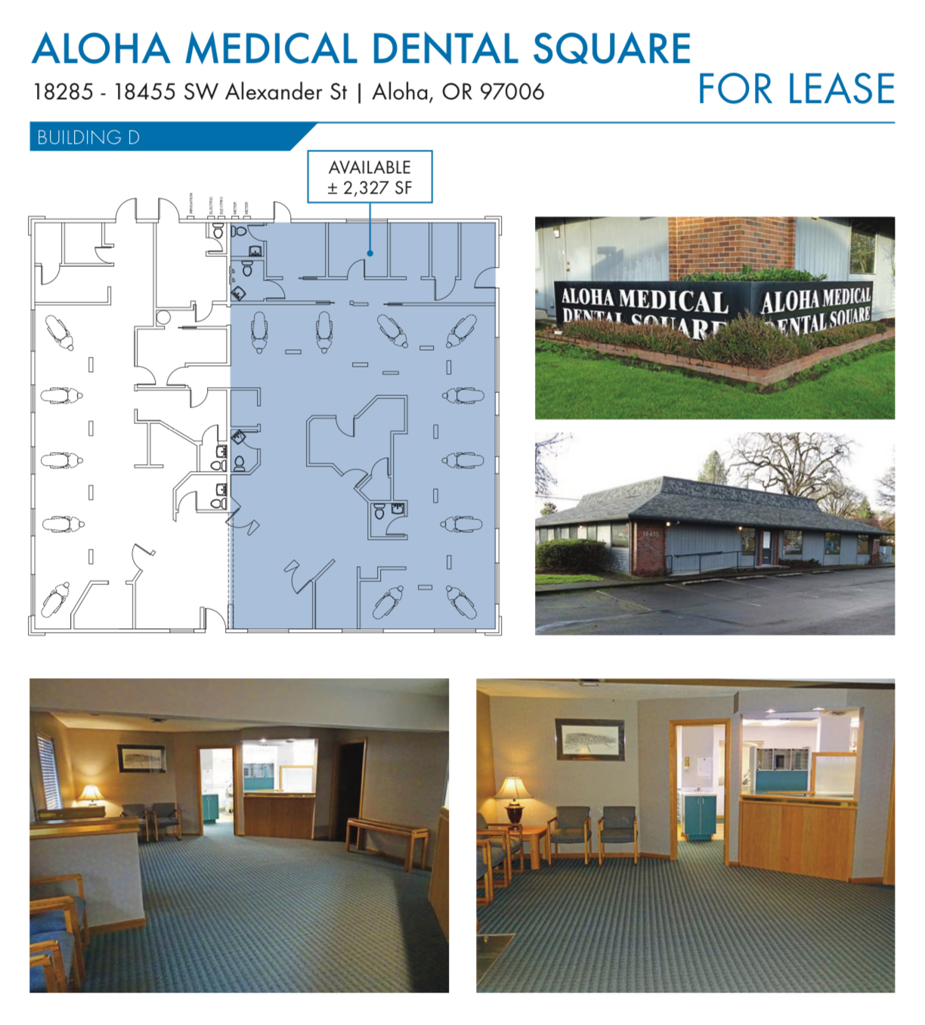
Welcome to Aloha Medical Dental Square – A Premier Dental Destination in Aloha!
Now available: a 2,327 SF move-in ready space in Aloha Medical Dental Square, the area’s leading hub for Dental and Medical services. Perfectly suited for a pediatric dentist ready to expand or establish a practice, this suite is part of a vibrant, dedicated dental and medical community. Located at a high-traffic intersection between Hillsboro and Beaverton, with easy access to Portland and Tigard, Aloha Medical Dental Square is the prime choice for your practice’s growth and success!

Why Choose Aloha Medical Dental Square?
- Central Location & High Visibility:
Conveniently positioned between Beaverton and Hillsboro, with direct access to Portland and Tigard. Located at a high-traffic corner with over 50,000 cars passing daily, this spot provides unmatched visibility and accessibility, ideal for patient growth.
- Dedicated Dental & Medical Community:
Aloha Medical Dental Square is a one-stop location dedicated to dental and medical practices, especially dental specialties. Current tenants include general dentistry, orthodontics, endodontics, Pet Dentistry, and an oral surgery & implant center. Adding a pediatric dentist will complete this comprehensive offering, attracting families and ensuring an easy referral network among tenants.
- Prime Referral Network & Collaboration:
Join a thriving network of dental specialists. This environment fosters patient referrals within the square, allowing for a seamless experience for patients needing multiple services in one convenient location.
- Landlord Support & Vision for Tenant Success:
The landlord is committed to helping tenants grow, including online promotion and a digital monument sign to get even more exposure to 185th Street and TV Highway. This signage will feature tenant advertising, including before-and-after images, to maximize public exposure and capture attention from the tens of thousands passing by every day.
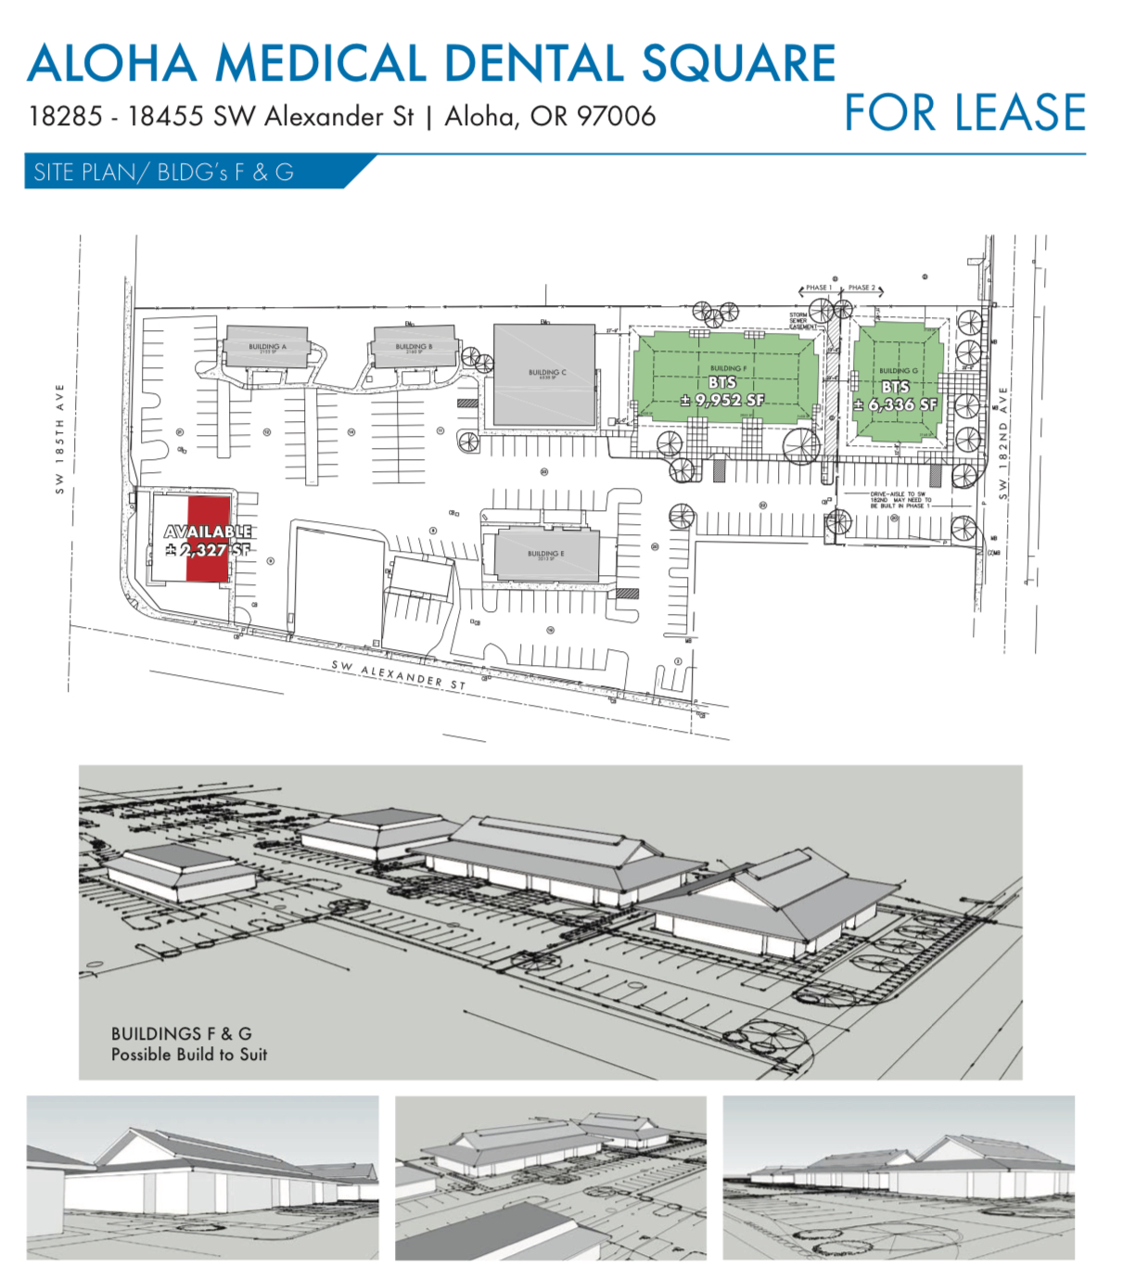

Property Highlights & Features
- Move-In Ready for Dental Use :
Suite B is equipped with existing dental equipment, cabinets, plumbing, and electrical systems for up to 9 dental chairs—perfectly set up for a busy pediatric practice.
- Generous Tenant Improvement Options:
The landlord is open to assisting with remodeling to create a kid-friendly, welcoming environment tailored to pediatric dentistry needs.
- Flexible Build-Out Choices:
Work with your own licensed contractor for any additional improvements, with prior landlord approval. This flexibility allows you to design a space that reflects your brand and meets your specific needs.
- Ample Parking & Patient Convenience:
More than 170 parking spots are on site, making appointments easy and convenient for busy families.
- Professional & Attractive Environment:
Aloha Medical Dental Square offers a welcoming, professional atmosphere that patients and families can trust, with modern, clean facilities designed for patient comfort.
- Prime Exposure with a Dedicated Pediatric Space:
Few options in the area offer such a prime, highly visible location dedicated to dental and medical practices. With low competition in the pediatric dental space locally, this suite provides an excellent opportunity to capture a growing patient base.
- Landlord's Long-Term Vision for Tenant Success:
Beyond just leasing a space, the landlord is actively invested in tenant success. From digital signage for advertising to promoting tenant businesses online, you'll have the backing to help your practice thrive and expand its reach within the community.

Contact Information
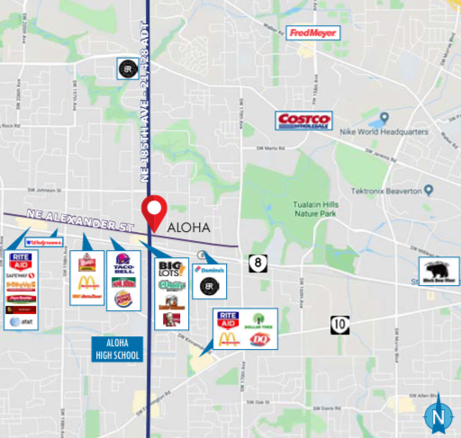
Bring Your Pediatric Practice to Aloha's Premier Dental Square!
Secure your place in this prime location and connect with a network of dental specialists dedicated to excellent patient care. Be part of a dental destination that families will return to and recommend.
Contact Us Today:
Email: AlohaMedicalDentalSquare@gmail.com
Location: 18285 - 18455 SW Alexander St
Aloha, OR 97006.

Disclaimer:This flyer is intended for information purposes only. All terms and conditions are subject to lease negotiation.

