Wellness Center Office Suite 402/403 for Rent
Beautiful top floor suite is available to rent at The Charlottesville Wellness Center. A secure building with private parking lot, near downtown.
Suite 402/403 has high ceilings and lots of light. The suite consists of 3 offices; the reception office features custom built in cherry desk, shelving unit and glass cabinet. There are 2 spacious treatment rooms, a waiting room, private bathroom and outdoor roof deck.
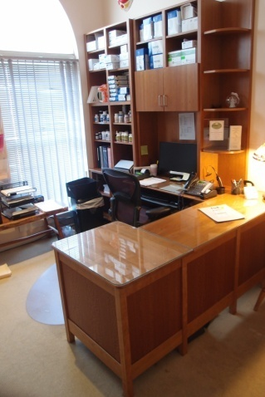 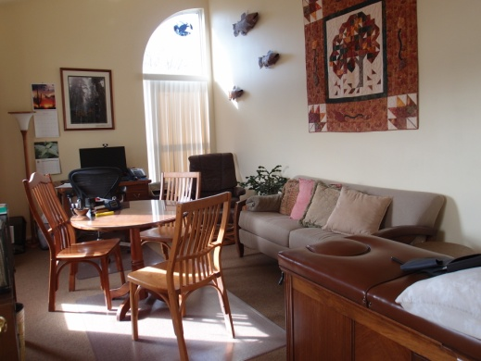 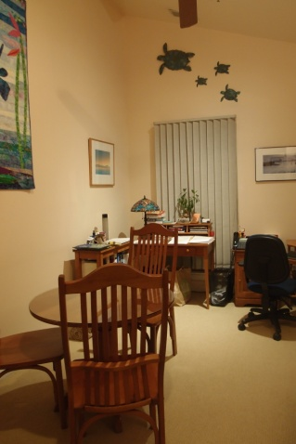Reception Office Office 2 Office 3

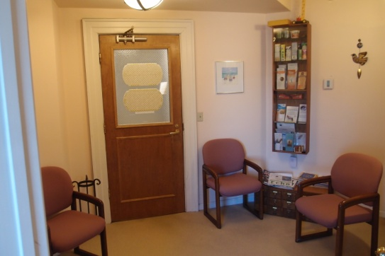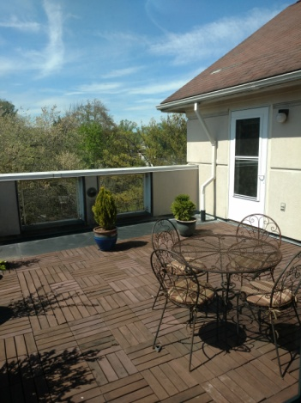
Waiting Room Roof Deck
Entire Suite is 817 sq ft; rent is $2,100 per month utilities included.
Available November 1, 2025, please contact: clairelinden@comcast.net

