1981 Granville Pike, Lancaster
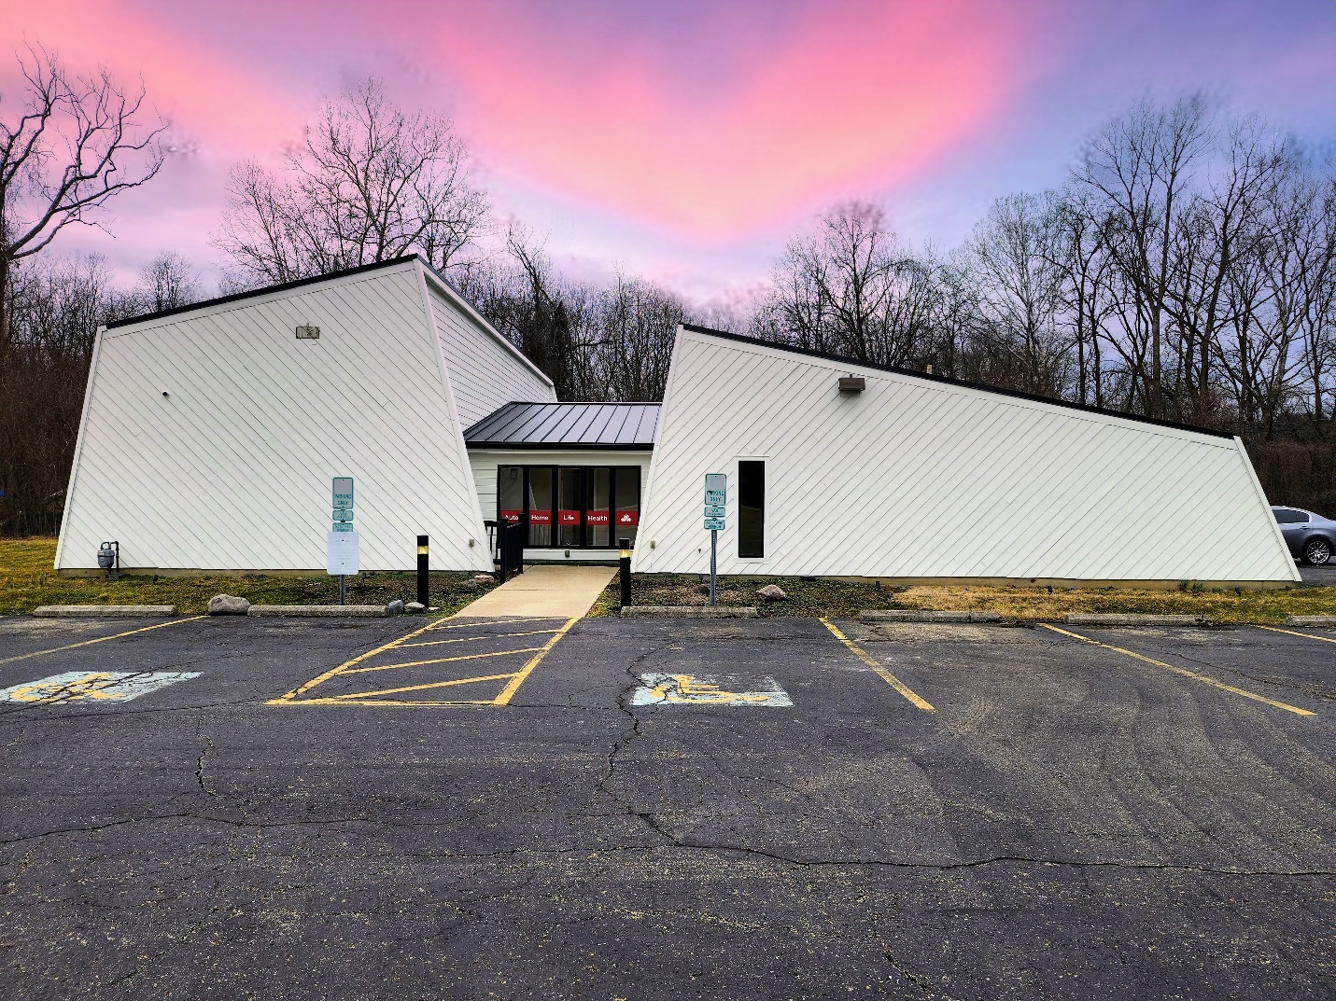
Your beautifully renovated commercial office in prime Lancaster location is awaiting!
Summary:
This building was formerly Prime MD urgent care in Lancaster and was purchased and renovated in 2024. It has been split into two commercial spaces for lease. One side has been remodeled and is occupied by a State Farm office. The pictures in the listing are of the remodeled side of the office. The other side is pending remodeling upon signing a lease with a tenant. The owner is willing to offer a build out budget for light remodeling for a long term lease agreement with a tenant.
Features:
- The private office space includes front & back entrances, private half bath and is currently framed out for 5 private offices and a large lobby/reception area.
- The common space includes a full-service kitchen, break room, separate half bath for customers, a conference room in the entryway.
- 22 parking spaces available (shared)
Requirements:
Background check, credit report & financials will be required prior to lease agreement. The ideal tenant is an established business in the professional services industry that compliments a State Farm office. If you have interest in touring the property please contact us to schedule a time.
The Details:
- 1,658 – Total sq ft available (1,350 + 616/2)
  - 1,350 sq ft – Private Office Space
  - 616 sq ft – Common Space
- $15/sq ft for lease ($24,870/yr)
- $7/sq ft for CAM ($11,606)/yr)
- Contact: 614-551-2034

