For Sub
LEASE
Asking rate:
$4.75 per sq. ft.
Full service gross
Suite 208-1,460 CONTIGUOUS SUITES CAN BE COMBINED TO
2,104 SQ. FT.
200 Newport Center Drive, Suite 206-208
Newport Beach, CA 92660 – CALL TO SHOW


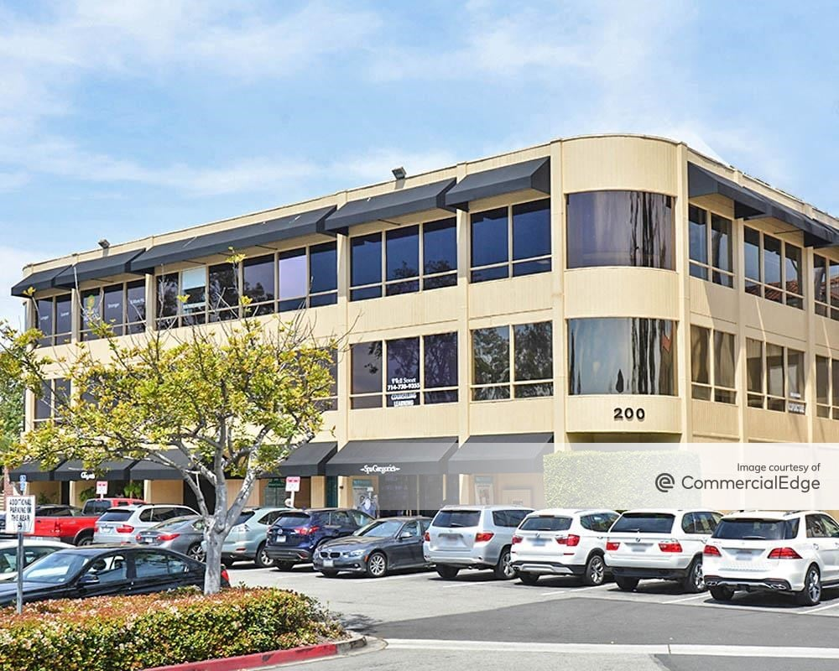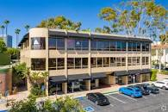

.

AVAILABLE IMMEDIATELY- BUILDING SIGNAGE AVAILABLE
Medical space for Lease in Newport Center – Fashion Island Newport Beach
Suite for lease or shared space- for medical- LL will write a new lease for tenant.
LEASE FOR 4 YEARS REMAINING- NEW LEASE WILL BE IN PLACE
ASKING RENT: $4.75 FT FULL SERVICE GROSS- 4 YEARS REMAINING
CALL

Hoag Hospital
HHospitFashion Island-Newport Center Office Suites
Suite Availability
Suite 208 configuration :
Reception, waiting room, up 7 exam roomssuite has a lot of light corner suite in the bldg., has sinks and ocean view .
Free Parking in the surface parking lot for tenant anvisitors. Common area restrooms- no restroom in the suite.

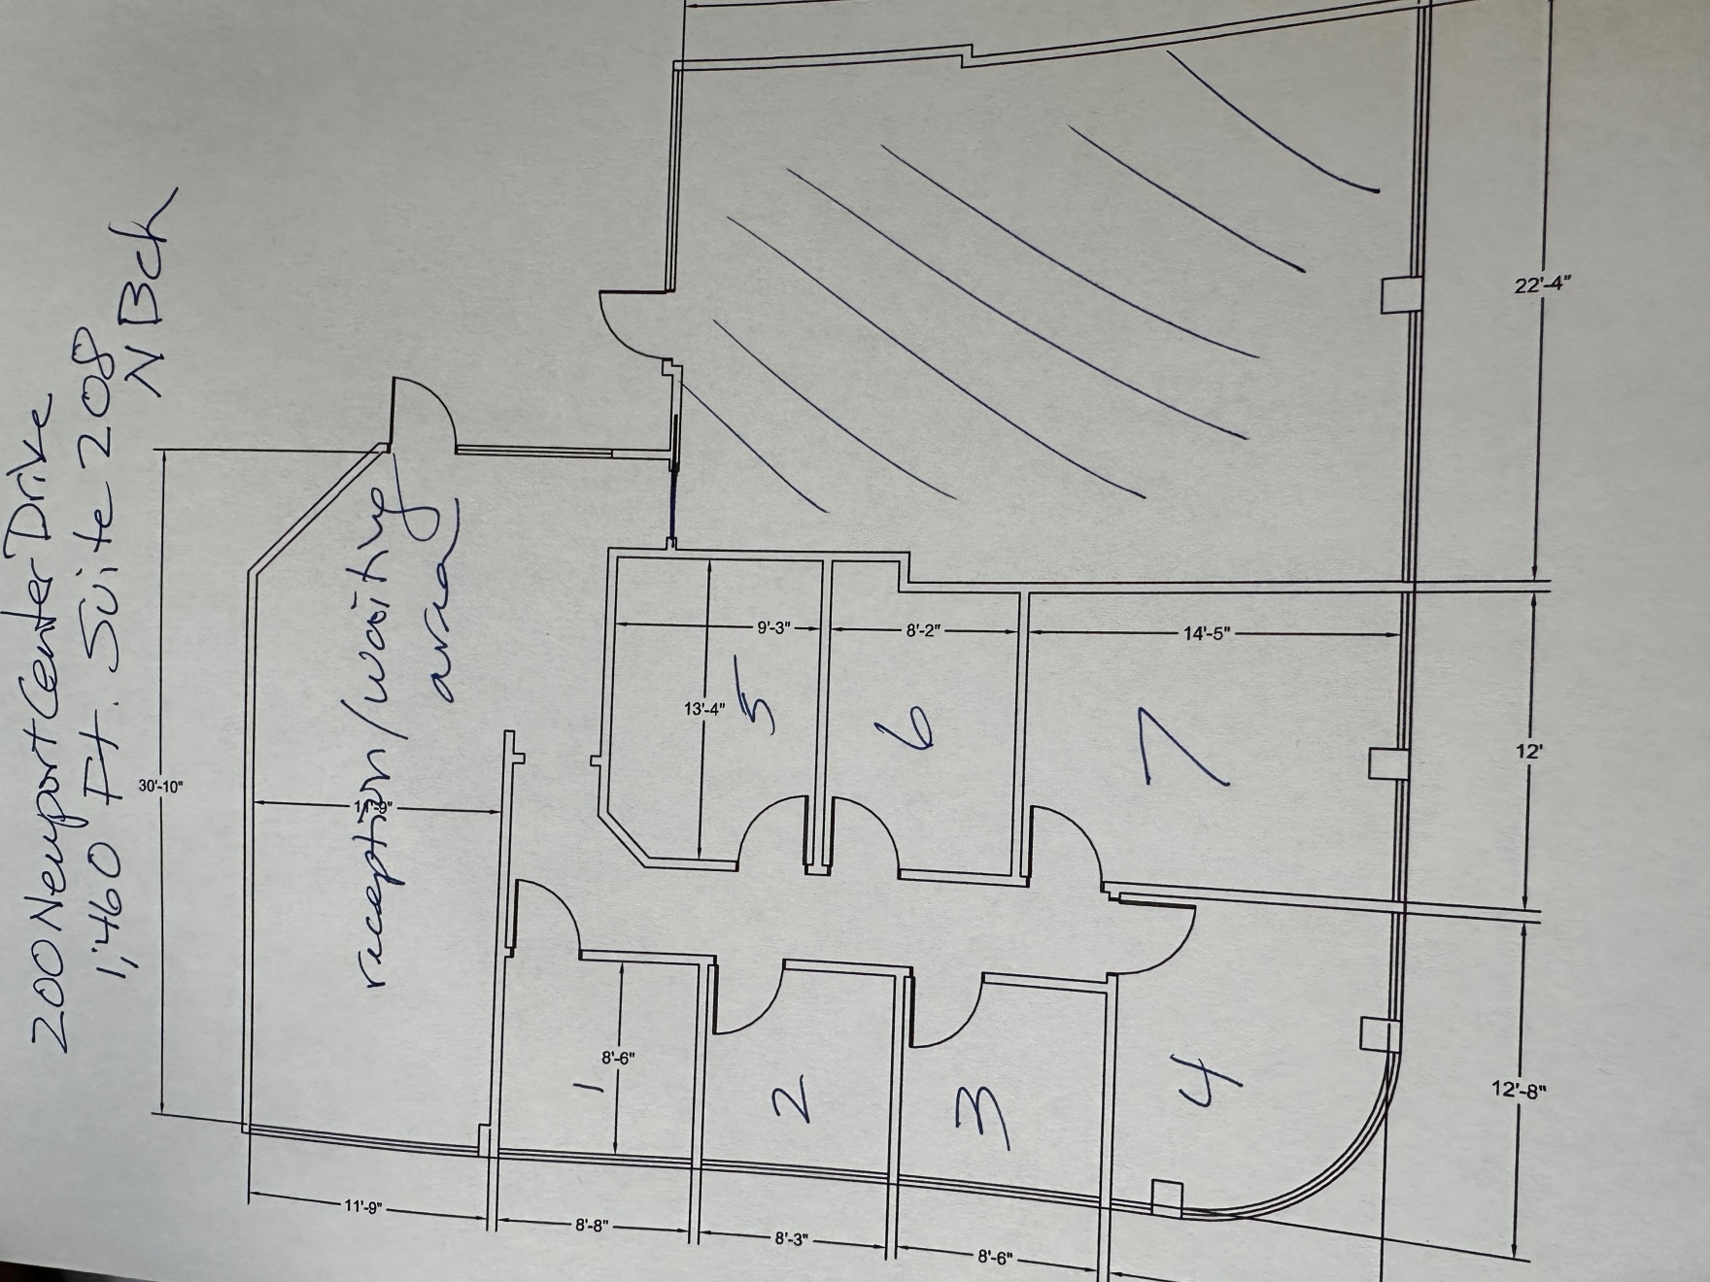

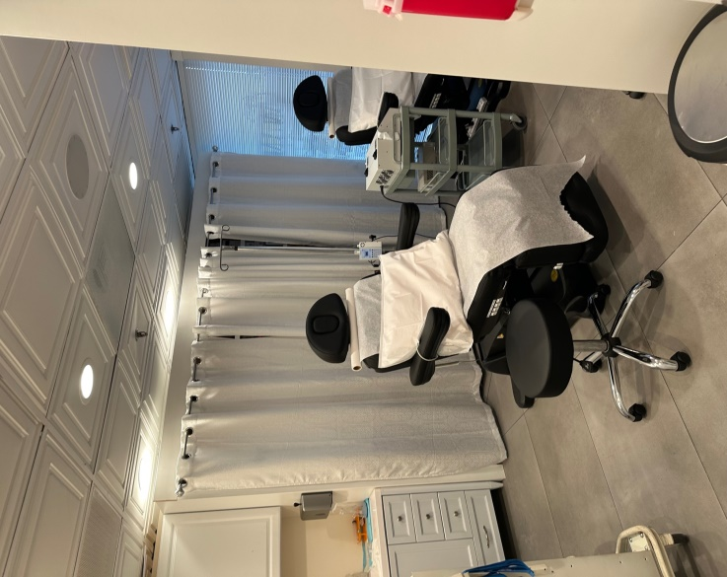200