Park House 1-4 Park Terrace, Worcester Park, Surrey KT4 7JZ
Zara – 07868711014 / 02089613211
zara@cygnetproperties.co.uk

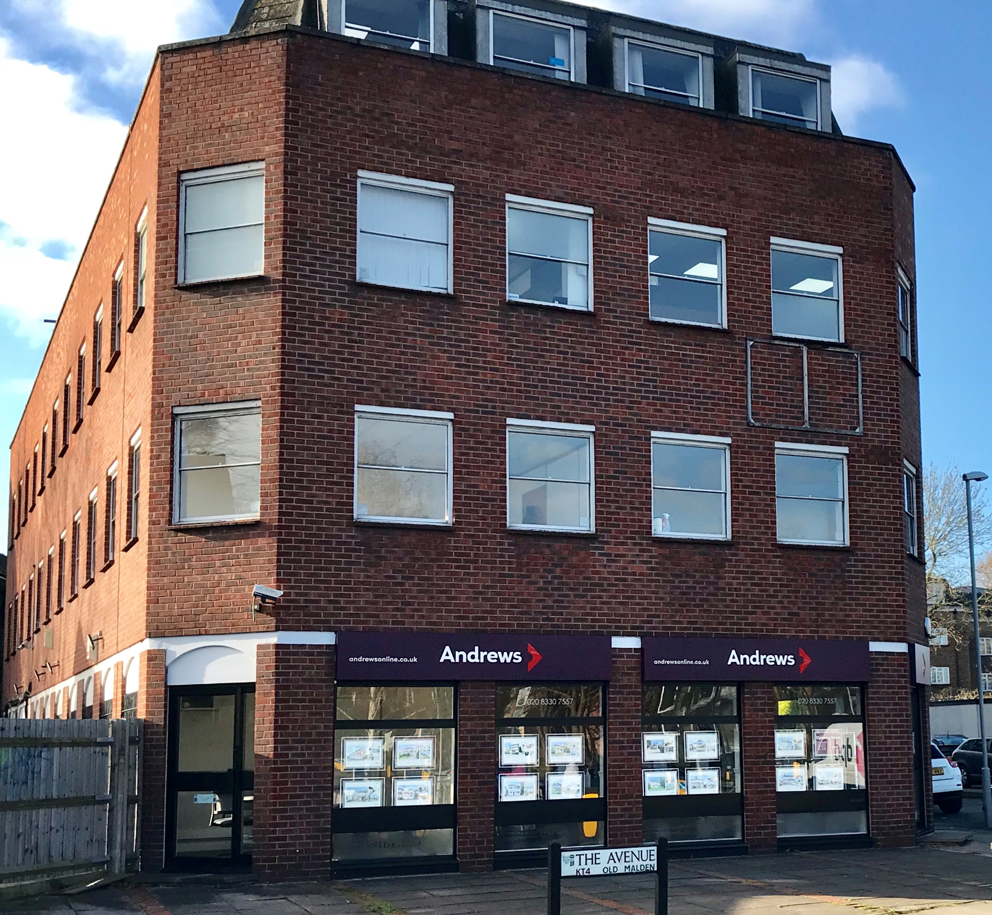

Available Space | Approx size (sq ft) | Desk Recommendation | Price Per Month ex VAT
Second floor suite 1 (suite 5) | 150 | 3 | £500.00

Description: This property has a local feel accommodating a range of small and larger businesses and charities from the area. There is a lift serving the building as well as a car park to the rear. The floors are partitioned to provide a combination of open-plan accommodation as well as a number of cellular offices and communal kitchens.

Transport: The building is prominently located on the junction of The Avenue with the A2043 Central Avenue / Malden Road immediately opposite Worcester Park mainline station.

What does the above price include?
- Rent
- Electricity
- Service & Maintenance Charges
- Communal cleaning

Additional Costs
- Business rates are not included although many offices should qualify for 100% rates relief but please rely on your own enquiries

