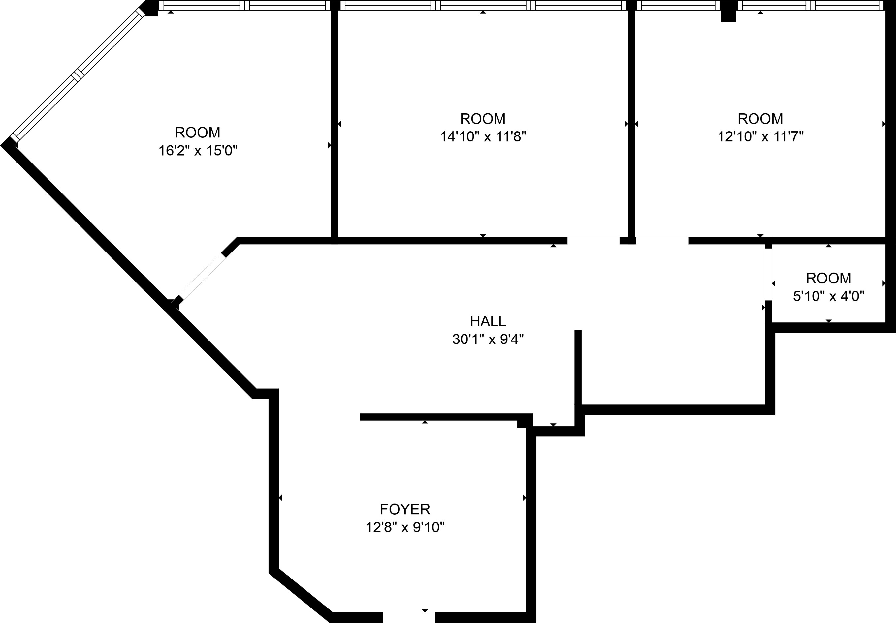
MEASUREMENTS ARE CALCULATED BY CUBICASA TECHNOLOGY. DEEMED HIGHLY RELIABLE BUT NOT GUARANTEED.

