Office Space Available
Irondale and Leeds Area
Up to Five Small Individual Offices
Gambrell Financial Building
1512 Alex Drive 35210

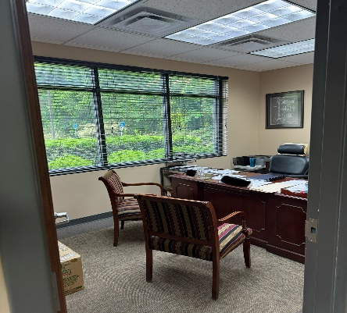
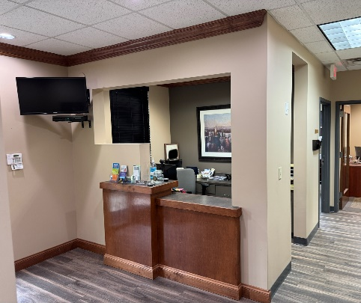
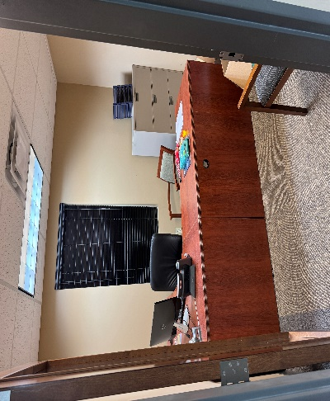
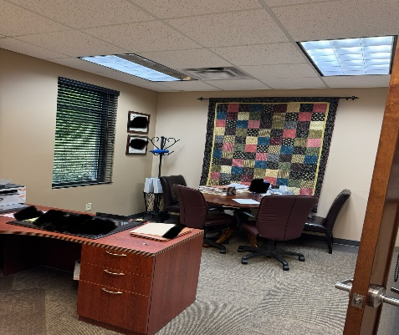
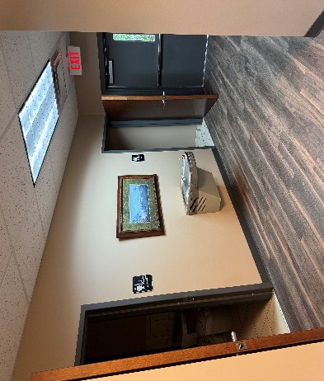

- Small Professional Space Ideal for Attorneys, Accountants, Brokers, Financial, Insurance, or other sales agents.

- Shared Reception waiting room, conference room, kitchen, restrooms , and attic storage.

- Ample Parking, Janitorial , maintenance and all Utilities other than telephone and internet are included.

Call Dean Gambrell
205-914-8046

