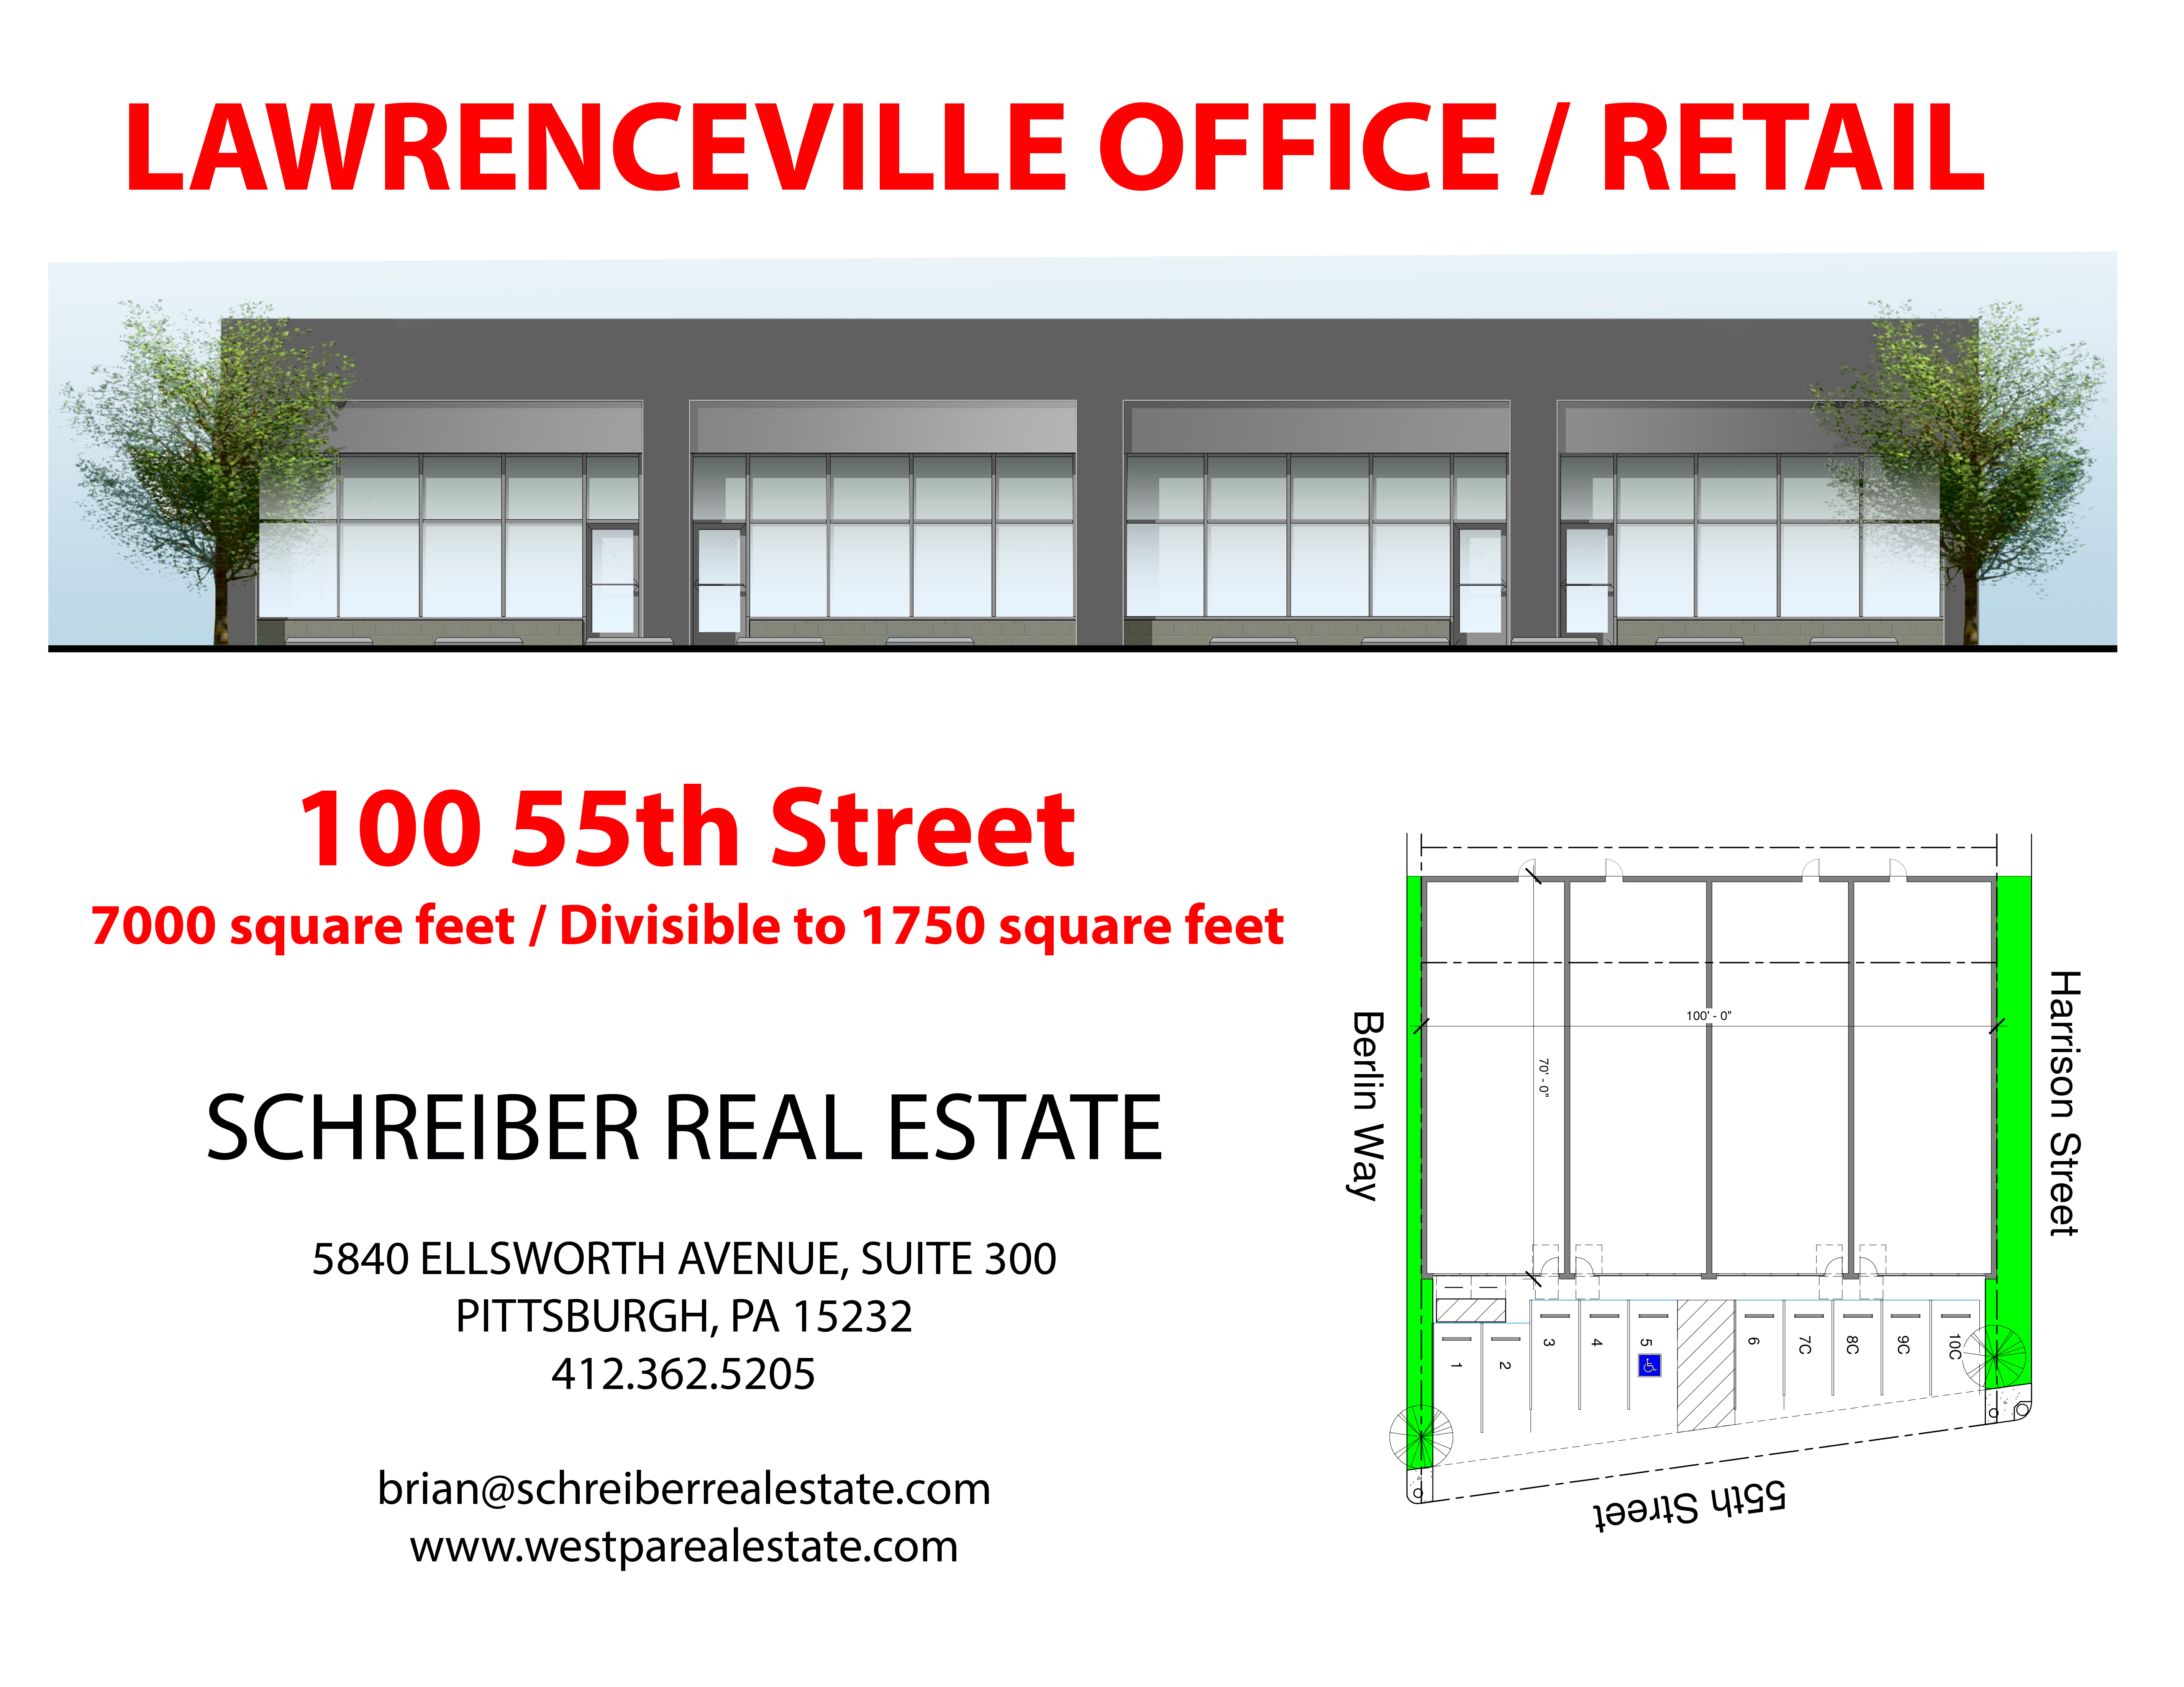
LAWRENCEVILLE OFFICE / RETAIL

100 55TH Street
7000 Square Feet / Divisible to 1750 Square Feet

SCHREIBER REAL ESTATE

5840 ELLSWORTH AVENUE, SUITE 300
PITTSBURGH, PA 15232
412.362.5205
brian@schreiberrealestate.com
joshua@schreiberrealestate.com
www.westparealestate.com

