PRIME OFFICE SUITE FOR SALE
230 ROUTE 206, BLDG. # 1, FLANDERS NJ 07836
4,150 SF OFFICE CONDO
BUY FOR $3,148 PM
INVESTMENT OR OWNER OCCUPIED
MEDICAL, LAW, PHYSICAL THERAPY, GENERAL OFFICE, ETC.

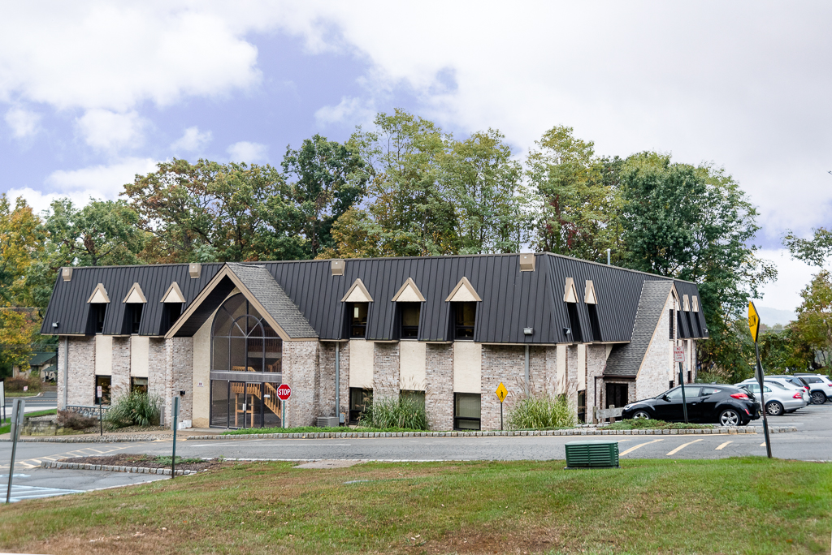

TWO DEEDED OFFICE CONDOS (1,100 SF & 3,050 COMBINED)

PROPERTY FACTS
LIST PRICE $ 622,500 PRICE PER SF: $ 150
UNIT SIZE: 1,100 SF, & 3,050 BLDG. CLASS A
BUILDING SIZE: 15,600 SF ELEVATOR YES
ZONING: C2 YEAR BUILT 1988
PARKING: AMPLE PARKING RATIO 4.5/1,000 SF
HEAT: NATURAL GAS WATER CITY WATER
SEPTIC SYSTEM ELECTRIC SEPARATE
HIGH SPEED FIBRE OPTIC

OFFICE LAYOUT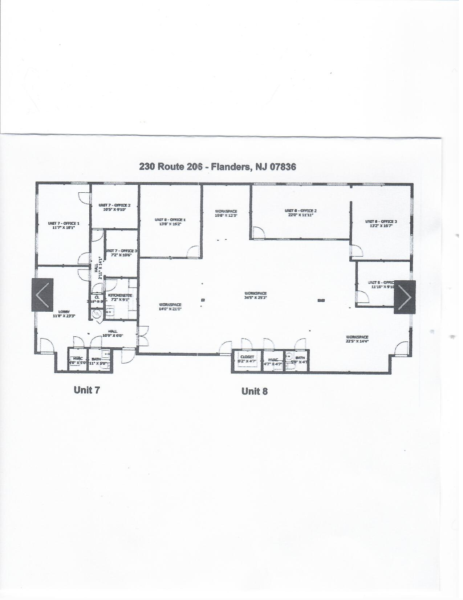
ESTIMATED PRICE TO PURCHASE (FINANCING)

Total purchase: $ 622,500
Down payment: 20 % $ 124,500
Balance: $ 498,000

Amount to finance: $ 498,000

PER MONTH
Principle & interest $ 3,148 *
Condo dues: $ 1,195 **
Taxes $ 1,117
Total COST : $ 5,460 PM

INVESTMENT: ESTIMATED INCOME TO LEASE 4,150 SQ FT
4,150 sq ft $ 16 PSF = $ 5,533 PM NNN
NET COST TO OWN: NONE
BUILD YOUR EQUITY BY OWNING CLASS A OFFICE CONDO
FINANCING AVAILABLE

- Based upon 30 years mortgage at 6.5 %

** CAM CHARGES: Landscape, snow & garbage removal, roadways, lights etc.

PLEASE CALL OR TEXT: TARIQ MAHMOOD
TEL. 908 625 3199 OR EMAIL: TMTARIQ7@GMAIL.COM

