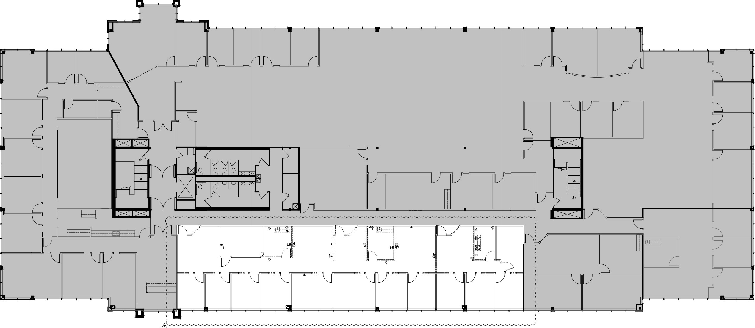
W
E
S
T

E
A
S
T
N O R T H
YOU ARE HERE

S O U T H

