
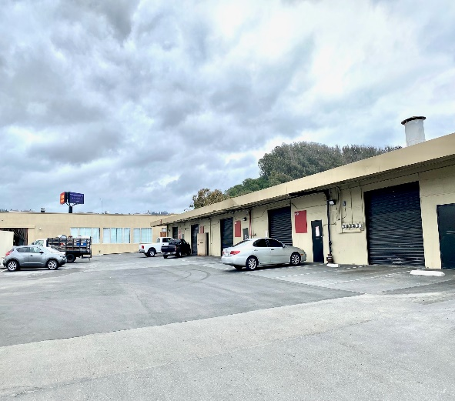
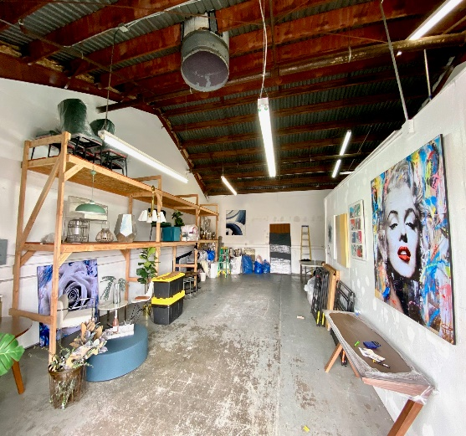
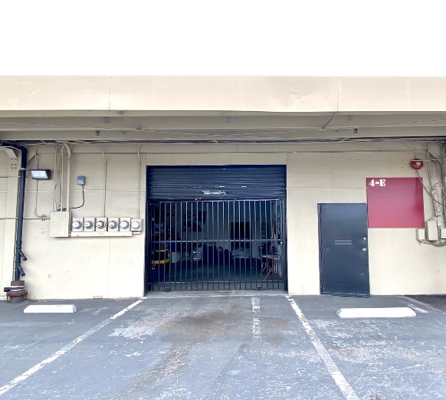

Roll-Up Door + Iron Gate Open Parking Storage Shelving
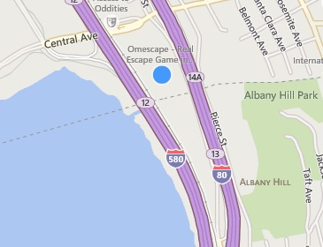
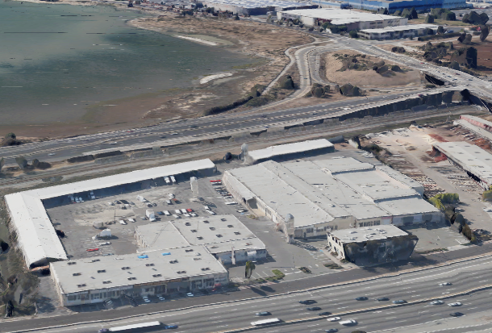
Site
Site
S.F. Bay


Shop Here



Facing 255,000+ Captive Cars/day Convenient Location

I-80 SHOP SPACE FOR LEASE

5327 Jacuzzi Street #4-E: ± 1,109 Sq. Ft.

Shop or Business Service Suite with roll-up door featuring:

- Light Power
- Off Street Parking
- Direct Freeway Access

- Open Space
- Restroom Access
- Secure Iron Gate

$1.49/Sq. Ft. Monthly Industrial Gross + 42¢ CAMS.

Available Now!
FOR FURTHER INFORMATION PLEASE CONTACT Peter McNally 510/848-6007
CITY | Richmond Bayside | LISTING CO. | McNally Realty Advisors
ADDRESS | 5327 Jacuzzi Street#4-H | LISTING AGT. | Peter McNally
CROSS ST. | Interstate 80 | PHONE # | 510/848-6007
SPACE AVAIL. | 1,109 Sq. Ft. | LIST DATES | 10/23
PRICE | $2,115/ month all-in | DRE # | 982919
PROP. TYPE | Warehouse/Storage | FEE TO S.O. | 3% gross rents

Information Herein Deemed Reliable but not Guaranteed.

