2752 EAST PONCE DE LEON AVE (Unincorporated Dekalb County)
Move-In Ready Office Space

2752 I East Ponce De Leon
Ave, Decatur, Ga 30030
2560 sq ft

$17.00 psf NNN approx. $5.42 Tax, INS, CAM, and HVAC Tenant responsible for Electric; Water sub metered Landlord bills flat rate


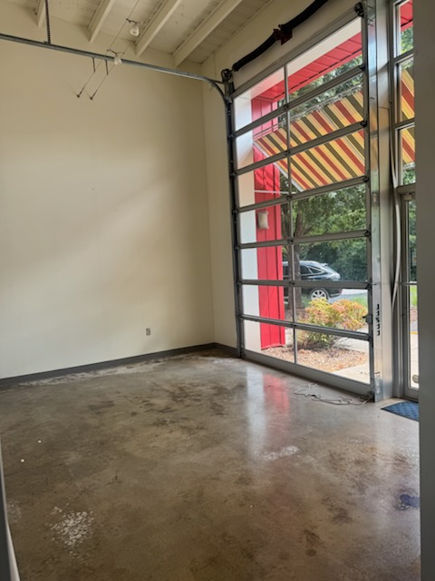

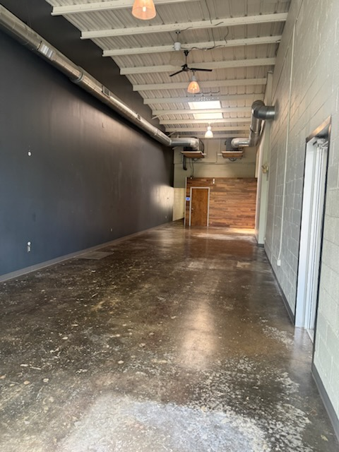

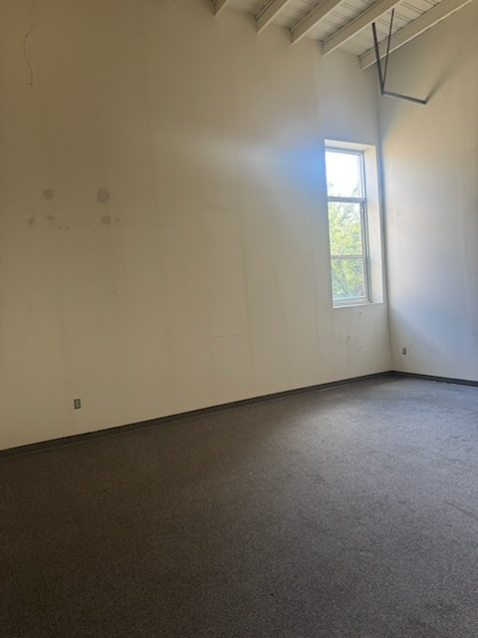
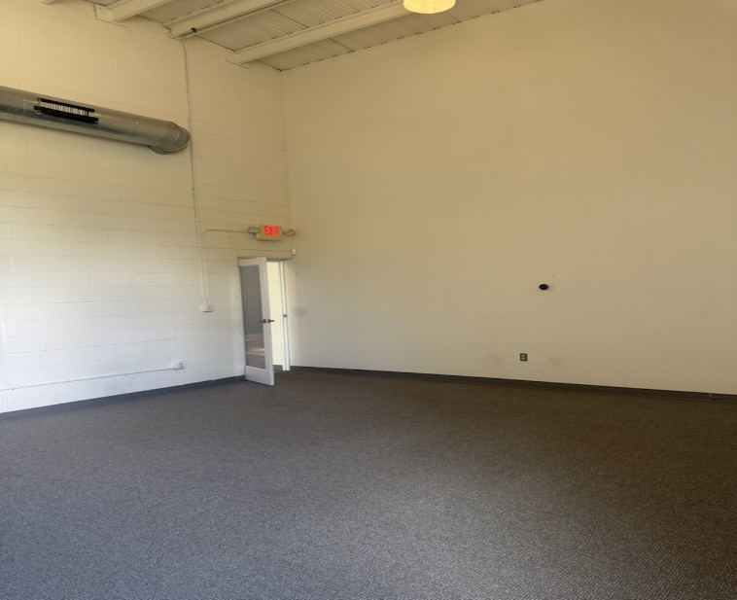
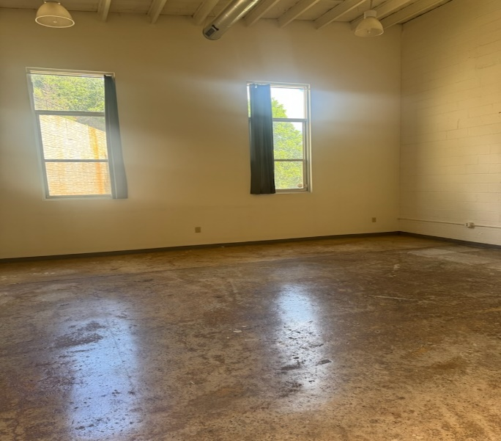
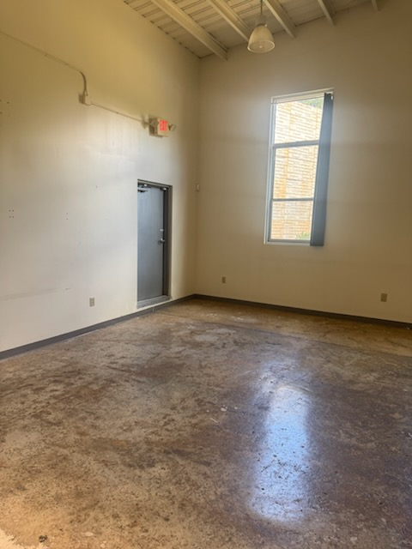

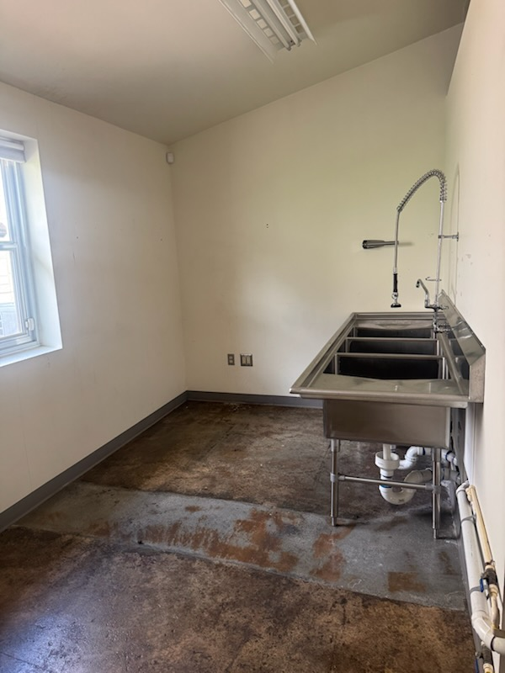
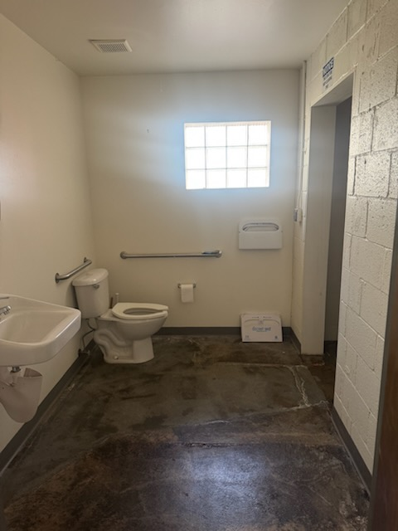

- Industrial look, 4 large separate open areas
- 1 restroom with shower and kitchen area
- High exposed ceiling, cement floors, front entry floor to ceiling windows, sklylights, abundant natural light, functioning Overhead roll up door
- End Unit and Parking at the immediate front of space
- Building: Environmental focused design; rain barrels, bike racks
- Close proximity to Downtown Decatur and Avondale shopping and restaurants and Dekalb Farmers Market
- Close to Avondale MARTA Train Station

Leasing requirements:
- Personal guarantee required
- Personal credit score of 675 or more required
- First month’s rent and security deposit due at lease signing
- RENT + CAM + TI + WATER+HVAC replacement fee= monthly payment
- $55 application fee

Broker Commission:
- Brokers to be paid ½ of first month’s rent with 5% residual.
- Brokers must make first contact with EDS Leasing office for commission to paid on executed leases by EDS. If EDS shows the tenant the property first, tenant will be responsible for Broker’s commission.

