WAREHOUSE SPACE FOR LEASE
Logistics | Warehousing | Indoor Recreation | Immediate Possession

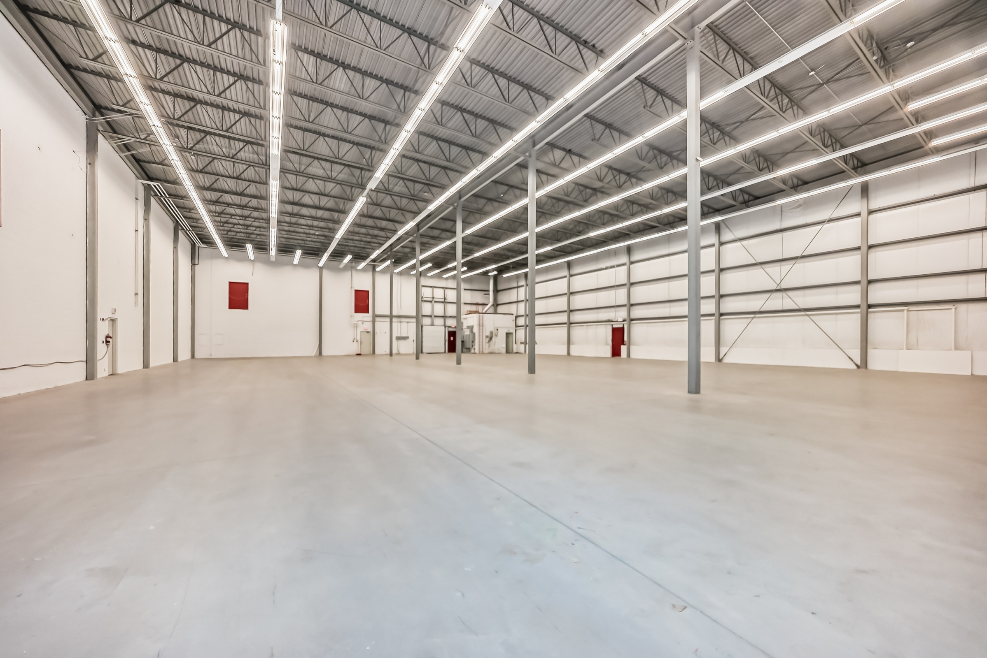 |  | 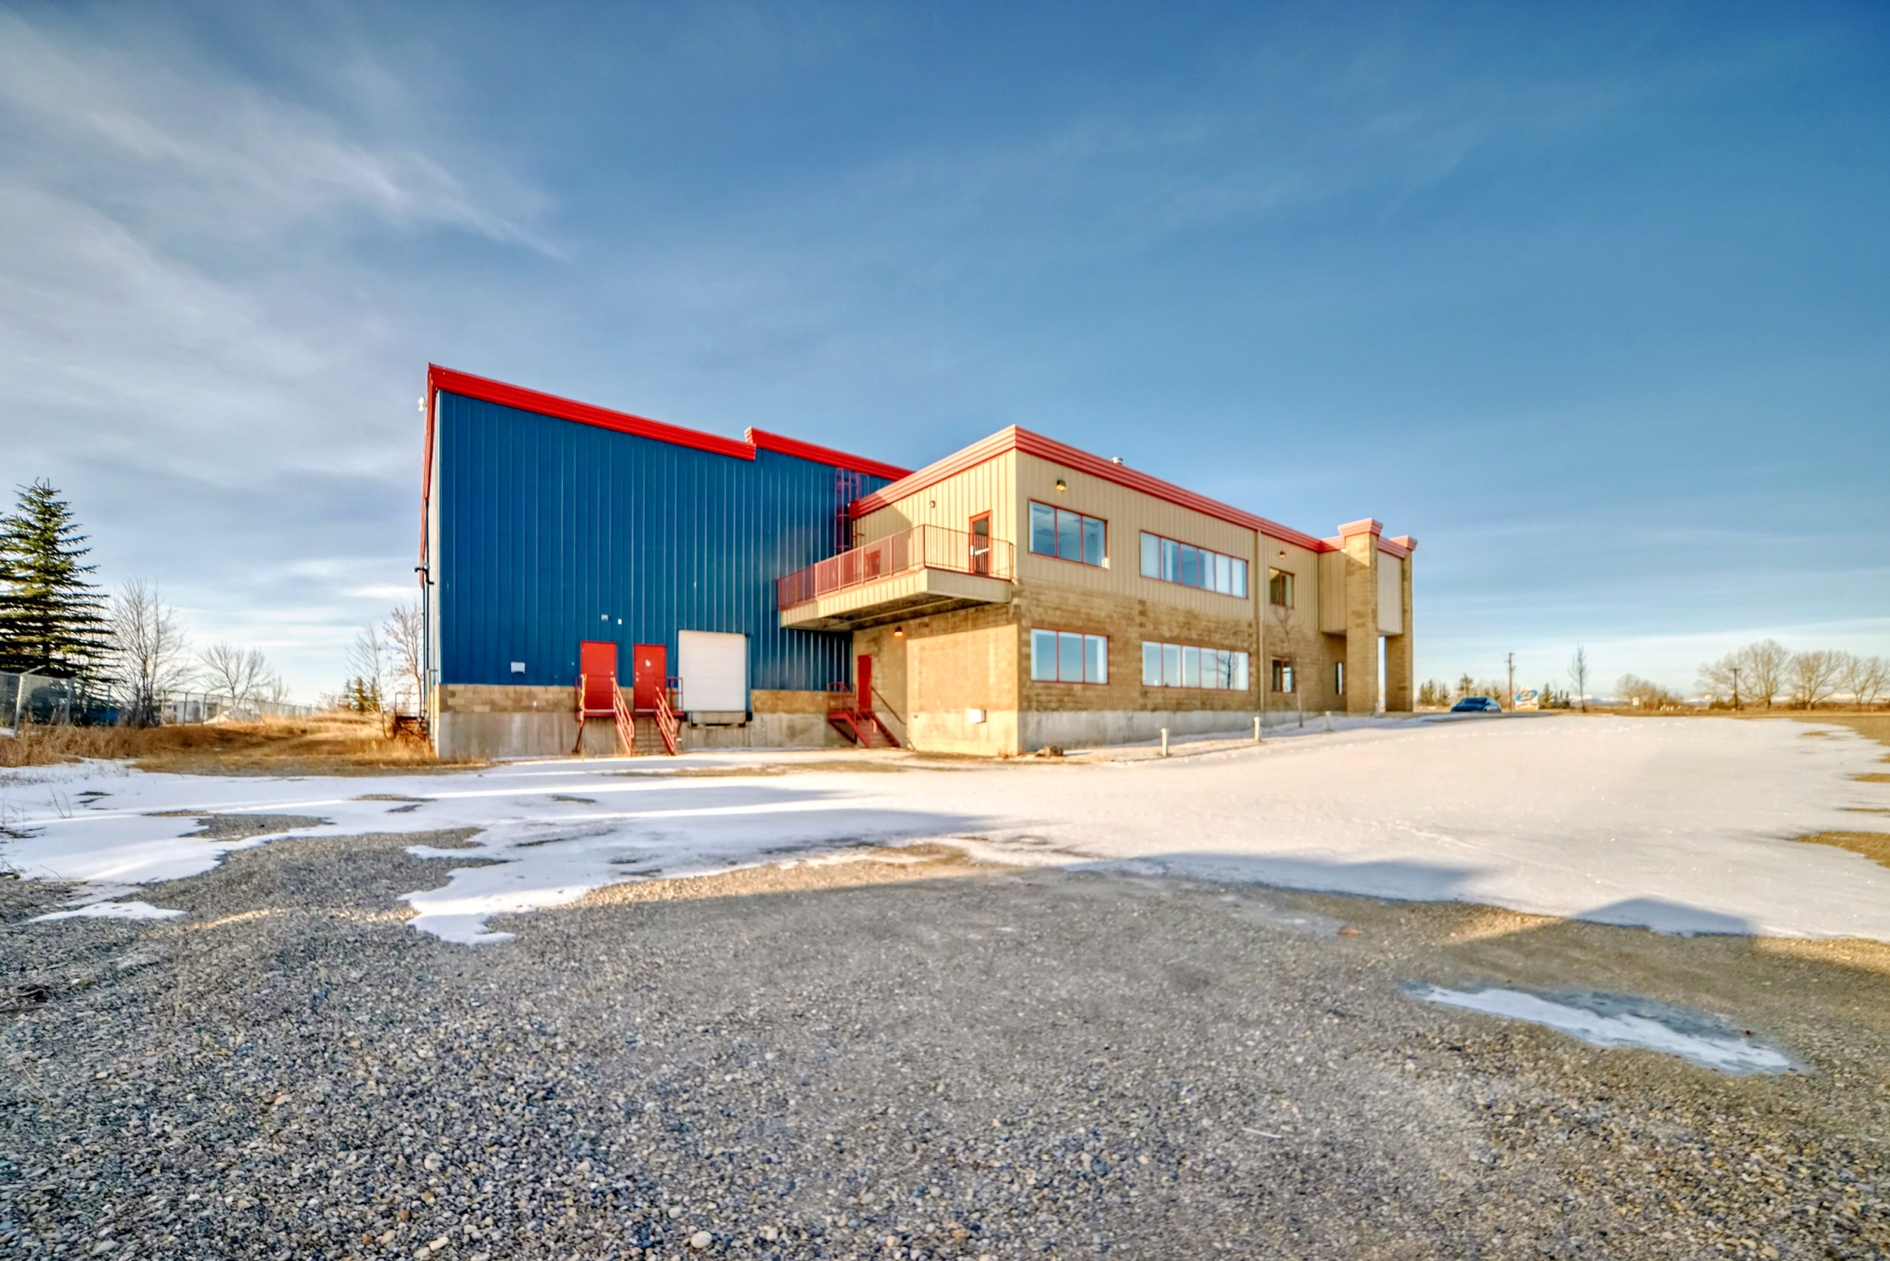

PROPERTY OVERVIEW

Clean, functional warehouse space at 16 Commercial Drive, Calgary — ideally suited for logistics, warehousing, indoor recreation, and a wide range of commercial users. The space features an efficient 30' × 20' column grid, 24' clear ceiling height to steel deck, and a reinforced concrete slab floor — ideal for racking, equipment, or open-floor activities.

KEY FEATURES

✔ ±10,192 SF Warehouse |  | ✔ 24' Clear Ceiling Height (to Steel Deck)
✔ Brick & Steel Exterior Construction |  | ✔ 1 Dock Loading Door (8' × 9')
✔ Reinforced Concrete Slab Floor |  | ✔ 1,200A / 120-208V / 3-Phase Electrical
✔ 2-Piece Washroom Included |  | ✔ Move-In Ready Condition

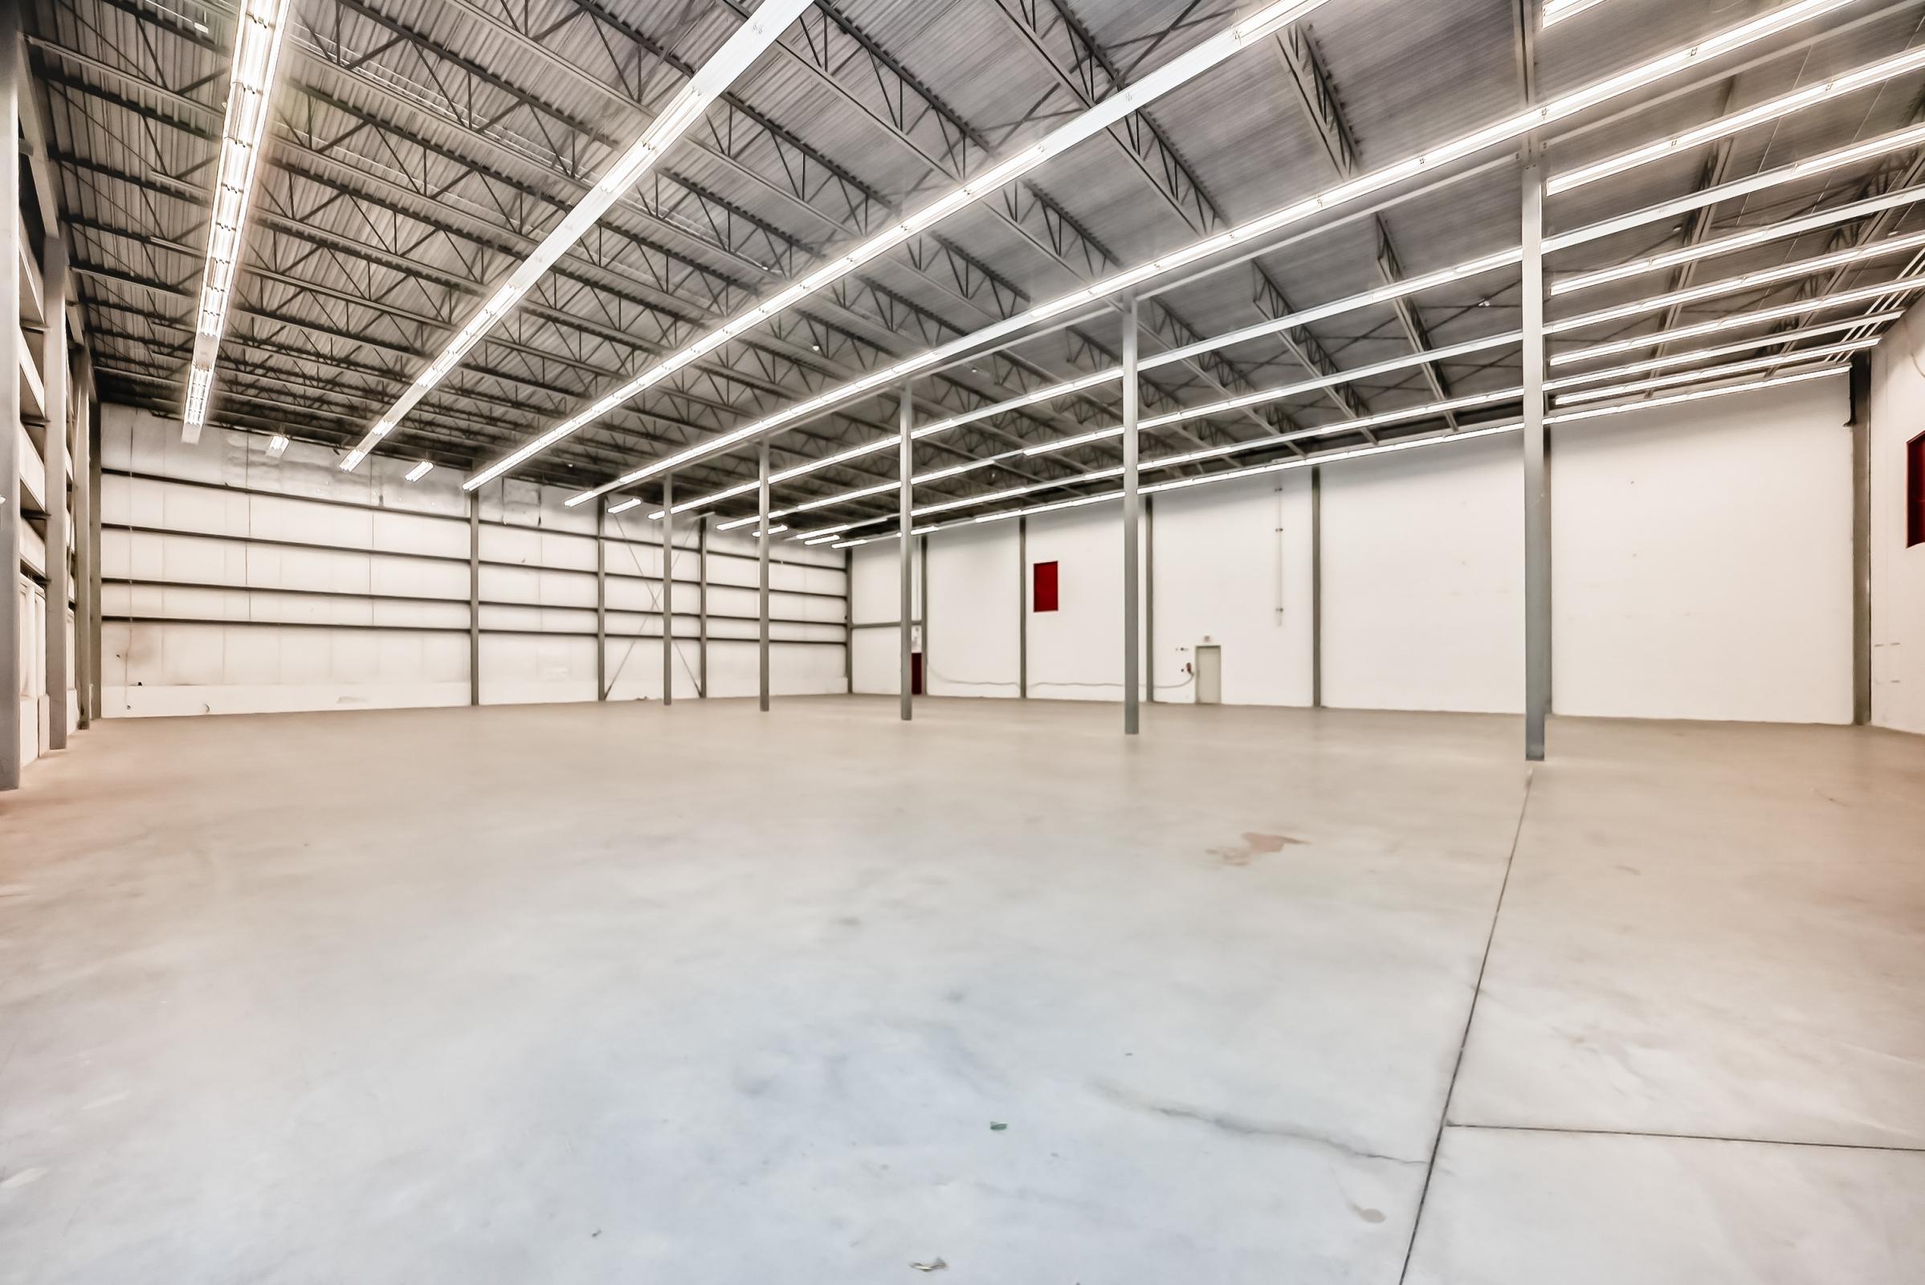

FINANCIAL SUMMARY

Component | Rate (PSF/yr) | Notes
Base Rent (Year 1) | $13.00 | Escalates $0.25/yr from Year 2
TMI (Op. Costs) | $3.28 | Property taxes, insurance, maintenance
Utilities | Proportionate Share | $6,600/yr + 27% of remaining balance
GST | 5% | Applied to base rent + TMI
Security Deposit | ~$45,997 | Equivalent to 3 months gross rent

4-YEAR LEASE BILLING SCHEDULE ILLUSTRATION

Based on 10,192 rentable SF. Base rent at $13.00 PSF/yr (Year 1), escalating $0.25 PSF annually. TMI at $3.28 PSF/yr. Utilities allocated as $6,600/yr + 27% of remaining building balance. GST (5%) on base rent and TMI.
Year | Months | Base Rent /mo | TMI /mo | Utilities /mo | GST (5%) | Total /mo
Year 1 | 1 – 3 | Free | $2,785.81 | $775.00 | $178.04 | $3,738.85
Year 1 | 4 – 12 | $11,041.33 | $2,785.81 | $775.00 | $730.11 | $15,332.25
Year 1 | 13 – 24 | $11,041.33 | $2,785.81 | $775.00 | $730.11 | $15,332.25
Year 2 | 25 – 36 | $11,466.00 | $2,785.81 | $775.00 | $751.34 | $15,778.15
Year 3 | 37 – 48 | $11,678.33 | $2,785.81 | $775.00 | $761.96 | $16,001.10

* Months 1–3: Base rent-free period (TMI, utilities and GST payable). Security deposit equivalent to approx. 3 months gross rent (~$45,997).

Versatile high-clear warehouse — ideal for logistics, warehousing, or indoor recreation. Rare availability in this size range. Contact us today for a showing.

FOR LEASING INQUIRIES
16 Commercial Drive, Calgary, Alberta | ±10,192 SF | Immediate Possession
Jun Xiao 肖俊 REALTOR®  Professional. Trusted. Built on Relationships.  Residential | Commercial  📞 403.479.4467  ✉ jun.xiao@exprealty.com  🌐 www.exprealty.com | 

