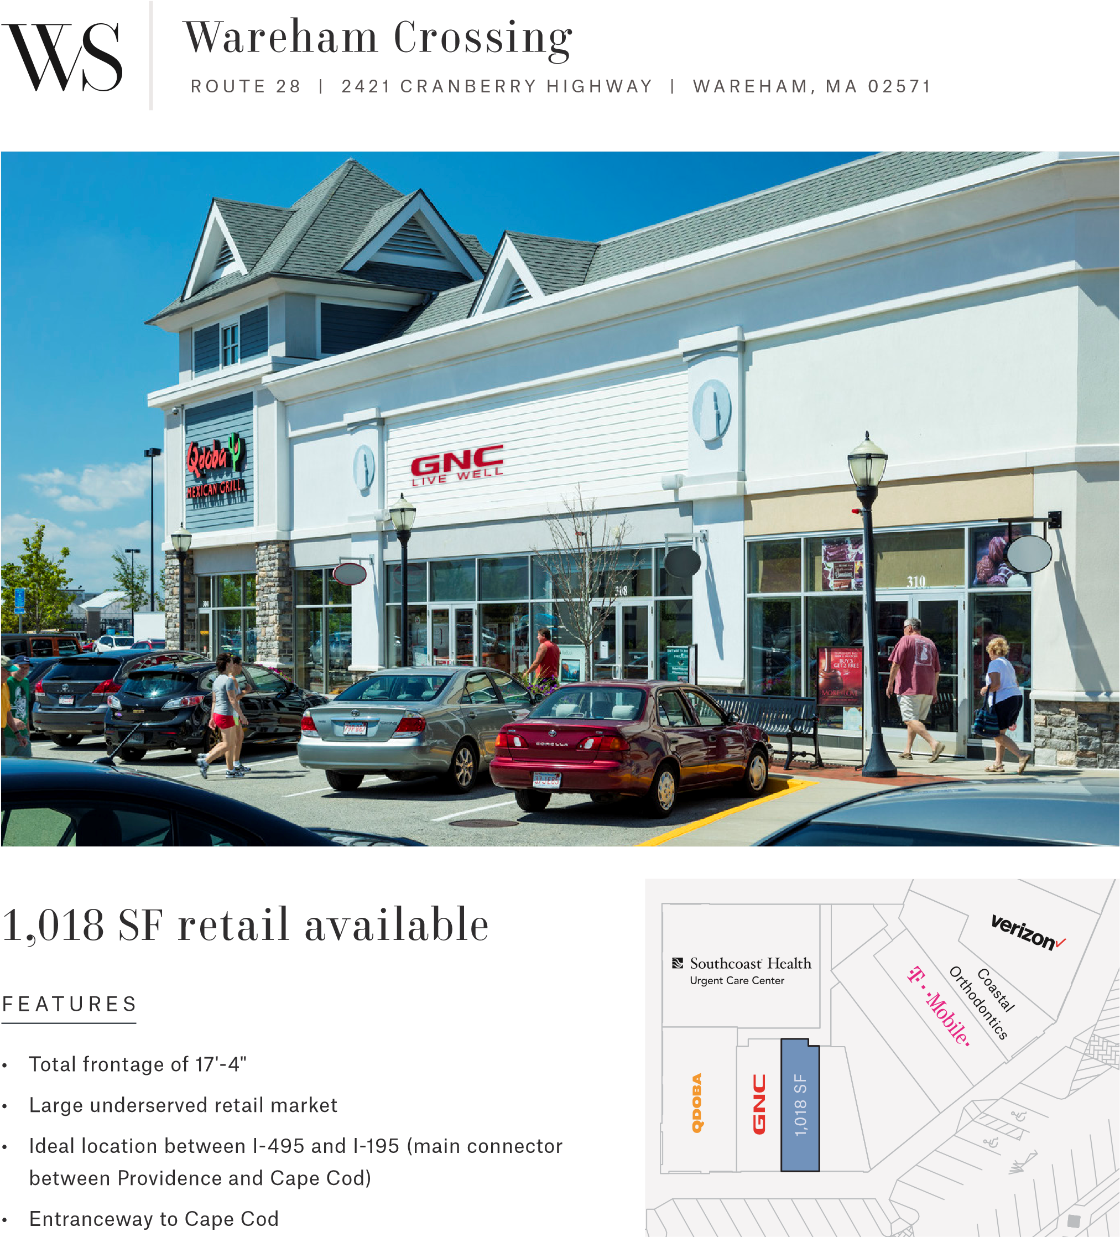
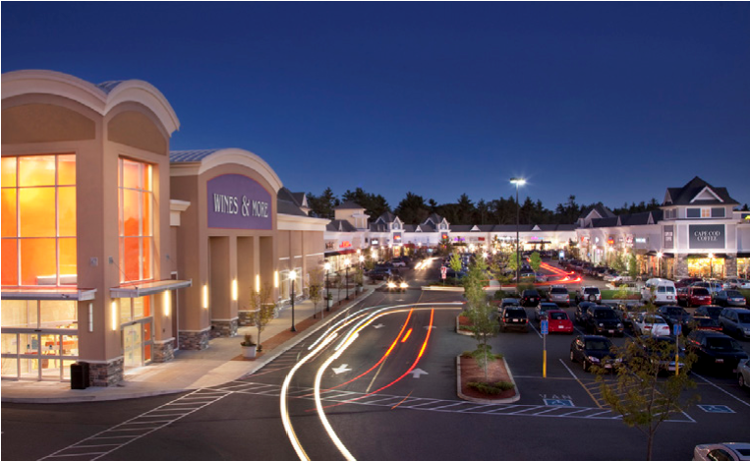
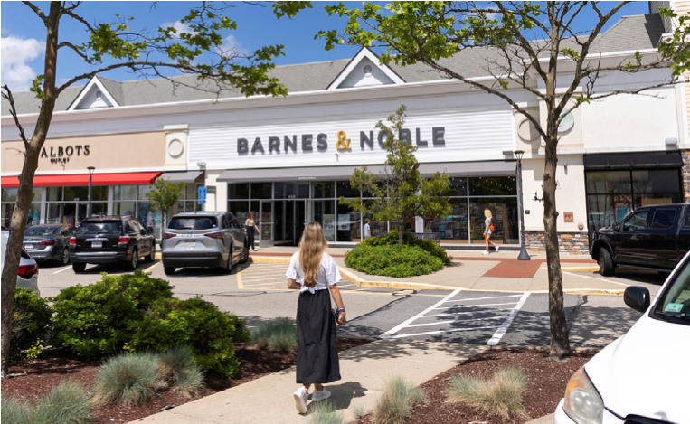
L E A S I N G I N Q U I R I E S : Wyatt Myers | 315 484 8200 | wyatt.myers@wsdevelopment.com
G L A :
675,000
SF
K E Y T E N A N T S :
Target, Lowe’s,
Old Navy, Barnes & Noble, L.L.Bean Outlet,
Michaels, HomeGoods, T.J. Maxx
POPULATION

436,633
HOUSEHOLDS
181,967
AV E R A G E H H I N C O M E
$119,270
P R O P ER T Y FAC T S
T R A D E A R E A D EM O G R A P H I C S
I N T E R S TAT E 4 9 5
64
,000 ADT
I N T E R S TAT E 1 9 5
24
,460 ADT
R O U T E 2 8
12
,244 ADT
T R A F F I C & AC C ES S

